**The University of Texas at Tyler College of Engineering and Computer Science**

**Tyler, TX 75799**

**Final Design Report Draft #3 For**

**Wireless Charger Project**

**A design project to fulfill the requirements of Senior Design in the Department of Electrical Engineering**

**at The University of Texas at Tyler**

The individuals whose names and signatures appear below certify that the narrative, diagrams, figures, tables, calculations, and analyses contained within this document are their original work except as otherwise cited.

|  |  |  |  |  |
| --- | --- | --- | --- | --- |
| Flory, David |  |  | March 25, 2021 |  |
| Fran¸ca, Natasha |  | Signature | Date  March 25, 2021 |  |
| Franulovic, Franci |  | Signature | Date  March 25, 2021 |  |
| Gibbons, Chad |  | Signature | Date  March 25, 2021 |  |
| Sosa, Francisco |  | Signature | Date  March 25, 2021 |  |
|  |  | Signature | Date |  |

ACKNOWLEDGMENTS

We as a team wish to thank Indus Instruments and Dr. Sridhar Madala for being the benefactors and sponsors of our Project. Indus Instruments develops and creates electronic devices and software to meet the needs of various industries; for instance, they provide Baylor College of Medicine critical equipment for medical research. Dr. Sridhar Madala has been generous with our time and was critical in the initial planning phase of the project. Dr. Madala’s familiarity with FCC and international wireless transmission regulations gave clear constraints and direction to this project. Thus, we especially thank Dr. Sridhar Madala for agreeing to be HEC-2’s technical advisor.

EXECUTIVE SUMMARY

The team has designed and is prototyping a managed, 30 watt wireless resonant charger for use with lithium-ion battery packs. It shall be a versatile solution to the problem of powering autonomous mobile devices fitted with moderately sized battery packs of approximately four to six 18650 cells configured for 7.4 to 14.7 volts nominal output. With an estimated cost around $300, it fills a gap between inexpensive inductive chargers in the 5 watt range and custom 90 watt robotic power systems that have an entry level price of $2000.

Our charging system is made with two essential components: a transmitter and re- ceiver. The transmitter is supplied by standard line voltage and will be responsible for safely delivering up to 30 watts of resonant power to the receiver when in range and appropriately positioned. It shall communicate status with the receiver over a Bluetooth link and shall enable or disable power transmission when requested.

The receiver shall communicate with the transmitter and to a user GUI over Bluetooth links, and optionally with the user’s own application (i.e. a robot microcontroller) over a serial link. It will be capable of delivering requested power transmission and charging status information and beginning or ending the charging process. It shall cease charging on receipt of an error status from the charging circuit and will notify the user to take corrective action. Under normal conditions it will deliver power to the charging control IC, which shall charge the attached battery pack.

The charger may be configured to charge 7.4 to 14.7 nominal Li-Ion battery cells, which must have internal protection circuitry in accordance with UL1642 and IEC61960. Optimal configurations would include a 7.4V pack rated for 3.2A charging, a 11.1V pack rated for 2.2A charging, or a 14.8V pack rated for 1.7A charging.

To best demonstrate the full potential of our project, the team is pursuing optional deliverables that should be completed if time permits once the core project is completed. These stretch goals include a mobile robot capable of charging itself for continuous wire- less operation and integration with a smart Li-ion battery for detailed fuel gauge and battery health status.

**Contents**

##### Project Description 1

* 1. Software Team’s Focus for Project . . . . . . . . . . . . . . . . . . . . . 2
  2. Hardware Team’s Focus for Project . . . . . . . . . . . . . . . . . . . . 3

##### Final Design Specifications 4

II.A Feasibility Study . . . . . . . . . . . . . . . . . . . . . . . . . . . . . . 6

II.B Microcontroller . . . . . . . . . . . . . . . . . . . . . . . . . . . . . . . 7

II.C Transmitter Coil . . . . . . . . . . . . . . . . . . . . . . . . . . . . . . . 7

II.D Transmitter . . . . . . . . . . . . . . . . . . . . . . . . . . . . . . . . . 7

II.E Receiver . . . . . . . . . . . . . . . . . . . . . . . . . . . . . . . . . . . 8

* 1. Thermal Considerations for 3.3V and 5V Voltage Regulators . . . . . . 9
  2. Charging Subsystem 11
  3. Battery Considerations 11
  4. Microcontroller Considerations 13
  5. Firmware Requirements: Transmitter 14
  6. Firmware Requirements: Receiver 14
  7. Software Requirements: GUI 15
  8. Coil Considerations 16
  9. Specification Summary 17
  10. Ethical and Professional Considerations 18
  11. Public Health: 18
  12. Safety and Welfare: 18
  13. Global Factors: 19
  14. Societal factors 19
  15. Environmental factors: 19
  16. Economic factors: 19

##### Design Solution 20

* 1. Product Architecture 20
  2. Hardware Subsystems 23
  3. Transmitter Subsystem 23
  4. Receiver Subsystem 27
  5. Planar Coil Inductor 30
  6. Software Architecture 31
  7. Firmware Architecture 31
  8. GUI Software Architecture 32
  9. Software Modules 33
  10. Firmware Modules 33
  11. GUI Software Modules 34
  12. Hardware Off The Shelf Items 36
  13. Software Off The Shelf Items 37
  14. Schematics / Wiring Diagrams / Technical Drawings 38
  15. Custom Software 38
  16. Firmware Main Program 38
  17. GUI Software Main Program 39

##### Prototype Design and Fabrication 40

* 1. Transmitter Subsystem Prototype Production 40
  2. PCB Manufacturing 40
  3. Transmitter Prototype Board Assembly 41
  4. Post Assembly Inspection 43
  5. Receiver Subsystem Prototype Production 43
  6. PCB Manufacturing 43
  7. Receiver Prototype Board Assembly 44
  8. Post Assembly Inspection 46
  9. Coil Production 47
  10. Expenditure Report 47
  11. Budget 51
  12. Current Manufacturing Abilities 52

##### Testing and Validation 53

* 1. Transmitter Power Supply Tests 54
  2. Transmitter Coil Driver Tests 55
  3. Transmitter Firmware Tests 57
  4. Transmitter Firmware Tests 58
  5. Receiver Power Supply Tests 59
  6. Receiver Wireless Power Rectifier Tests 60
  7. Receiver Battery Charger Tests 60
  8. Receiver Firmware Tests 61
  9. Coil Test 63
  10. System Level Firmware Tests 64
  11. Test Results Summary 65
  12. Transmitter Evaluations 65
  13. Receiver Evaluations 67

##### Broader Impacts of the Project 69

##### Conclusion 70

##### References 72

##### Appendices 72

##### Codes, Standards, and Constraints 73

##### User’s Manual and Instructions 74

##### Coursework Related Knowledge and Skills 75

|  |  |  |
| --- | --- | --- |
| **D** | **Receiver PCB Schematics** | **76** |
|  | D.1 Receiver Controller . . . . . . . . . . . . . . . . . . . . . . . . . . . . . | 77 |
|  | D.2 Receiver Battery Charger . . . . . . . . . . . . . . . . . . . . . . . . . . | 78 |
|  | D.3 RF/DC Converter . . . . . . . . . . . . . . . . . . . . . . . . . . . . . . | 79 |
|  | D.4 DC/DC Converter . . . . . . . . . . . . . . . . . . . . . . . . . . . . . . | 80 |
|  | D.5 Top Copper Layer . . . . . . . . . . . . . . . . . . . . . . . . . . . . . . | 81 |
|  | D.6 Top Silk Layer . . . . . . . . . . . . . . . . . . . . . . . . . . . . . . . . | 82 |
| **E** | **Transmitter PCB Schematics** | **83** |
|  | E.1 Transmitter Controller . . . . . . . . . . . . . . . . . . . . . . . . . . . | 84 |
|  | E.2 DC/DC Converter . . . . . . . . . . . . . . . . . . . . . . . . . . . . . . | 85 |
|  | E.3 Coil Driver . . . . . . . . . . . . . . . . . . . . . . . . . . . . . . . . . . | 86 |
|  | E.4 Top Copper Layer . . . . . . . . . . . . . . . . . . . . . . . . . . . . . . | 87 |
|  | E.5 Top Silk Layer . . . . . . . . . . . . . . . . . . . . . . . . . . . . . . . . | 88 |
| **F** | **Receiver BOM** | **89** |
| **G** | **Transmitter BOM** | **93** |
| **H** | **Wireless Power Transfer Module BOM** | **97** |
| **I** | **Dimensional Coil Drawing** | **98** |
| **J** | **GUI Wireframe Diagram** | **99** |
| **K** | **Experimental Data Collection Sheets** | **100** |
|  | K.1 Transmitter Subsystem Data . . . . . . . . . . . . . . . . . . . . . . . . | 100 |
|  | K.2 Receiver Regulators Subsystem Data . . . . . . . . . . . . . . . . . . . | 100 |
|  | K.3 Receiver Rectifier Subsystem Data . . . . . . . . . . . . . . . . . . . . . | 101 |
|  | K.4 Charger Subsystem Data . . . . . . . . . . . . . . . . . . . . . . . . . . | 101 |
|  | K.5 SMBus Subsystem Test Data . . . . . . . . . . . . . . . . . . . . . . . . | 102 |
|  | K.6 Coil Subsystem Test Data . . . . . . . . . . . . . . . . . . . . . . . . . | 102 |

**List of Figures**

* 1. Operation Story Block Diagram . . . . . . . . . . . . . . . . . . . . . . . 2
  2. Power Supply of Transmitter and Receiver Subsystems . . . . . . . . . . 3
  3. Transmitter and Receiver Block Diagrams . . . . . . . . . . . . . . . . . 3 4 Thermal Resistance vs. PCB Area [](#_bookmark17)[5](#_bookmark132)[] 10

1. System Level Block Diagram 21
2. GUI Wireframe Diagram 22
3. Transmitter Subsystem Voltage Regulator 23
4. Transmitter Subsystem Block Diagram 24
5. Coil Driver Subcircuit 25
6. SMPS Subcircuit 26
7. Transmitter Subcircuit 26
8. Receiver Subsystem Block Diagram 27
9. Receiver Coil Subsystem Block Diagram 28
10. Receiver Voltage Regulator 28
11. Rectifier and Power Sensor Subcircuit 29
12. Planar Coil CAD Drawing 30
13. Controller Flow Chart 31
14. High Level GUI Software Architecture Example 32
15. Transmitter Top Silk Layer 42
16. Transmitter Top Copper Layer 42
17. Receiver Top Silk Layer 45
18. Receiver Top Copper Layer 46
19. Transmitter Voltage Regulator Circuits 54
20. Oscillator and Buffer Subcircuit 55
21. Transmission Signal Class E Amplifier Subcircuit 56
22. Received Power vs. Distance Test Setup 57
23. Reference Layout for Part and Pin Numbers 57
24. Receiver Coil Terminal Subcircuit 59
25. Receiver RF-DC Converter Efficiency Test Setup 60
26. VNA Test Setup 63
27. Class E Amplifier Driver Output 65
28. Q1 Drain Voltage Waveform 66
29. Q1 Drain Voltage Waveform 66
30. VNA TX/RX Coil Impedance Measurement 68
31. Isometric Image of Receiver PCB 76
32. Isometric Image of Transmitter PCB 83
33. Dimensional Coil Drawing 98
34. GUI Wireframe Diagram 99

**List of Tables**

1 Receiver Specifications . . . . . . . . . . . . . . . . . . . . . . . . . . . . 4

2 Transmitter Specifications . . . . . . . . . . . . . . . . . . . . . . . . . . 5

3 Communication Link Specifications . . . . . . . . . . . . . . . . . . . . . 5 4 GUI Specifications . . . . . . . . . . . . . . . . . . . . . . . . . . . . . . 5

1. Final Design’s Charging Subsystem Specifications 13
2. Final Design’s Coil Tubing Specifications 16
3. Final Design’s Receiver Coil Specifications 16
4. Final Design’s Receiver Specifications 17
5. Final Design’s Transmitter Specifications 18
6. Final Design’s Communication Link Specifications 18
7. Final Design’s GUI Specifications 18
8. Ethical and Professional Considerations 20
9. Off The Shelf Items Utilized in Prototype 36
10. Off The Shelf Software Items 37
11. Summary of Expenditures 48
12. Man-Hours Expenditure Report in Development and Prototyping 49
13. Development and Prototyping Summary of Man-Hours 50
14. Development and Prototyping Budget 51
15. Prototype Production Timetable 52
16. Transmitted Power vs. Distance Test 67
17. Received Power (DC) vs Distance Test 67
18. Relevant Codes and Standards 73
19. Coursework Related Knowledge and Skills Table 75
    1. PROJECT DESCRIPTION

Our team noted a need for users to charge medium power devices via wireless charging. After further investigation we also determined that there is a shortage of cost effective medium power wireless chargers on the market.

Our project is a 30 watts nominal resonant wireless charger prototype for use with 4 to 6 cell lithium ion battery packs. It is managed by a microcontroller. It may be monitored and controlled by a user GUI or directly by the target application. Unlike existing customized and proprietary robotic charging systems, our product will charge a standard battery type and be suitable for both stand-alone operations and integration into the user’s own design.

The team has been unable to discover any equivalent products to our own for retail. The most comparable product is Wibotic’s Standard High Power System[1], a 90 watt magnetic resonance device that is marketed to businesses designing commercial drones and robotic systems. On the lower end, nearly all unbranded, low-cost wireless chargers that are available from mass online retailers supply no more than 5W via inductive charging. For a single industrial unit, we have received a price quote for approximately

$2000 USD. Individuals and small R&D teams that search for suitable devices through online retailers will find that these low-end transmitters are not modular and are limited to one specific purpose such as charging cell phones or key-fobs.

Our charging system employs magnetic resonance coupling to charge a lithium ion battery pack, delivering between 15 and 30 watts of power. The power transmitter and receiver communicates as a unified system that can provide battery management, protect against overcharging, and provide both diagnostic and telemetric information to the user and to an optional serial connection with the powered application’s control circuitry. The charging system may be monitored and controlled by the user either through an attached LCD interface or a GUI from either a Bluetooth connected PC or smartphone.

This wireless charging alternative’s intended market consists of hobbyists and proto- type designers considering a self-docking direct electrical connection solution. This is the charging method used by the Roomba[2], which engages with a custom dock and charges using metal contacts. While this is a cost-effective solution for a mass-produced product, wireless charging is a superior choice for autonomous mobile devices that might have a wide variety of sizes and shapes. The benefits offered by our product’s wireless charging include flexible placement of the charger, a compact charging area, greater tolerance for misalignment between the charger and the target device, and the absence of exposed electrical connections. Additionally, this product would solve the same need for OEM producers who are interested in a “turn-key” wireless charging solution.

To best demonstrate the full potential of our project, the team has specified optional deliverables that include a mobile robot capable of charging itself for continuous wireless operation, fully integrated with a smart Li-ion battery for detailed fuel gauge and battery health status.

The team holds that a moderate power, low cost wireless charger with accessible telemetry is useful to a small but important market of robotics hobbyists and developers, who at present, are not being served by either costly, proprietary business-to-business solutions or the low power and poorly documented inductive chargers available on the hobby market.

Below in Figure 1, the general flow of power from the AC to DC Wall Converter to the end user’s device and information from the user is shown.

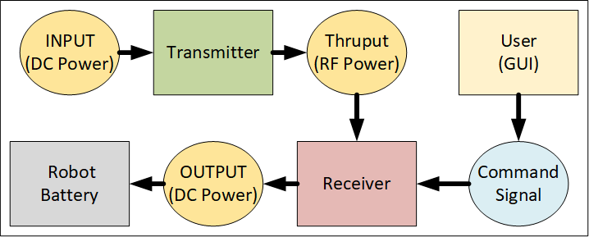

Figure 1: Operation Story Block Diagram

The project is divided between two teams: the hardware team and the software team.

1. *Software Team’s Focus for Project*

The software team is focused on two programs: the microcontrollers’ firmware and the graphical user interface (GUI) software application. The firmware operates the trans- mitter or receiver while the GUI allows for the user to readily monitor and interact throughout the charging process.

1. *Hardware Team’s Focus for Project*

The hardware team is focused on producing three modular components: the receiver PCB, the transmitter PCB, and the coil module. The image below displays how these modules operate together.

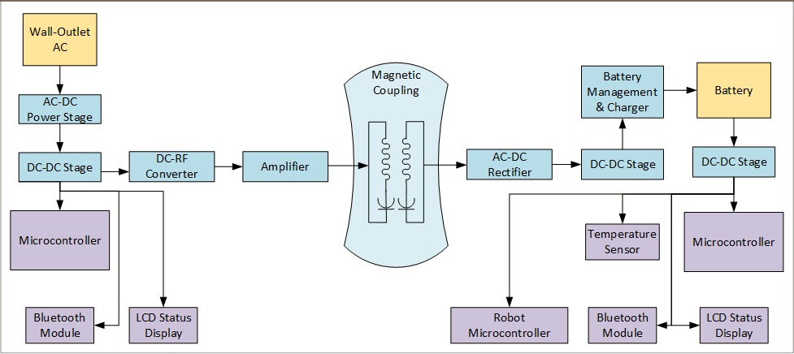

Figure 2: Power Supply of Transmitter and Receiver Subsystems

While the image below explicitly separates out the receiver and transmitter modules. Note that the completed PCB boards have a power transferring coil module affixed to them individually.

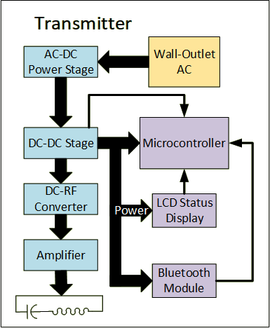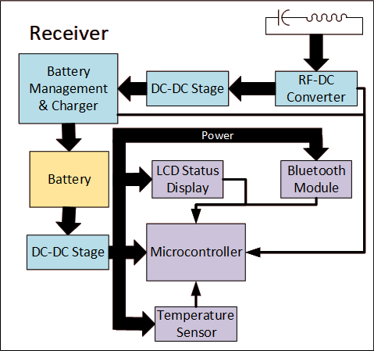

Figure 3: Transmitter and Receiver Block Diagrams

* 1. FINAL DESIGN SPECIFICATIONS Table 1 below shows the specs of the receiver subsystem.

Table 1: Receiver Specifications

|  |  |
| --- | --- |
| Charge time (Per 4Ah Battery  Packs) | 5 Hours Max |
| Battery pack voltage | 14.2 V |
| Coupling Efficiency Transmitter to  Receiver | 90% |
| AC-DC  Conversion Efficiency | 80% |
| Charging Controller DC-DC converter | 85% |
| Overall Receiver Conversion Efficiency | 61.2% |
| Maximum Battery Charging Current | 1.25 A (14.7 V  battery pack) |
| Charger Subsystem Charge Protocol | Constant Current Constant Voltage (Li-ION Battery) |
| Battery Type | Lithium-Ion  (4 x18650 in Series or 2P4S Configuration) |
| Power Negotiation | Bluetooth 5 LE |
| Transmitter Locator  Method | RF Localization [Bluetooth] |
| Deliverable Demo | Self-Moving Device (Robot) |
| Telemetry | Report State to GUI Device |
| LCD display | Diagnostic Character String Display |

Table 2 below shows the specs of the transmitter subsystem.

Table 2: Transmitter Specifications

|  |  |
| --- | --- |
| Operating frequency | 13.56 MHz |
| RF power output | 30 W |
| Max operating range | 5 cm |
| DC Power supply | 48 V 1.25 A max. |
| Conversion Efficiency  DC-AC | 80% |
| Telemetry | Report State  to GUI Device |

Table 3 below shows the communication specifications.

Table 3: Communication Link Specifications

|  |  |
| --- | --- |
| Communication  Medium | Bluetooth 5 LE |
| Protocol | L2CAP (RFCOMM) |

Table 4 below shows the GUI software specifications.

Table 4: GUI Specifications

|  |  |
| --- | --- |
| GUI OS | WinOS, IOS,  Linux, & Android |
| License | LGPL 3.0 |
| Software Architecture | Model-Controller- View (MCV) Architecture |
| Delivery Model | Open Source (Free App Download) |

1. *Feasibility Study*

The design consists of two subsystems: the transmitter and the receiver. This prod- uct is expected to be used by hobbyists and prototype designers for different applications that require contactless charging. There is no similar device available in the price range from $200 to $400. The expected cost of the charger system is $300. There are some commercial chargers available right now and the cost of that system is $2000. The price of $300 per system will make wireless charging affordable for hobbyists and freelance hardware developers.

The design tools such as Altium designer and Multisim simulator are available free of charge to all group members using the provided UT Tyler license. Also, parts manufac- turers are providing free simulation and evaluation tools for development. In addition to the software evaluation kits may be required for testing certain parts of the system such as the microcontroller, Bluetooth module, and the battery charger controller. Most of those evaluation modules are already purchased and they are available to team members. Evaluation kits are purchased by Indus Instruments.

The system is designed such that it uses standard components that are available at any electronic components store and they can be purchased without restrictions. PCB fabrication will be given to a company located in China that is offering quick turnaround PCB fabrication and fast shipping. Components purchasing and printed circuit board assembly will be done at Indus Instruments. Indus Instruments have all the necessary equipment that can handle surface mount components.

All test equipment required for development and testing will be available. Indus Instruments will provide space and necessary test equipment for the wireless charging system prototype evaluation and testing.

The final product cost is estimated at around $300 (for small quantities). Most likely for larger quantities, it is possible to decrease the cost even more.

1. *Microcontroller*

There are four aspects to analyze: economics, technical, legal, and scheduling. A sin- gle MSP430FR5994 part costs about $3 to $4, while the MSP-EXP430FR5994 Launch- Pad kit costs $16.99. Considering the team only needs two of these microcontrollers (one for the transmitter and one for the receiver), this is an economic and reasonable cost. [3] [4]. On the technical side, this microcontroller’s memory, voltage supply lim- itations, UART and I2Cmode specifications, and overall low power consumption makes it the ideal model for our project needs [3]. Some of the most important standards TI’s MSP430FR5994 complies with include ANSI, JEDEC, and ESDA [3]. Lastly, the team already has in hands the LaunchPad kit for the microcontroller. The individual micro- controllers are also ready-to-purchase items with delivery times of less than 7 days. More testing will be done once the team has the first PCB design in hands.

1. *Transmitter Coil*

The circular planar coil was the most inexpensive approach, the copper tubing to make the coils has an approximate value of $15.99. The design properties also signif- icantly contributed to reducing the complexity of acquiring the main coil parameters. It was important to take this factor into account because of the time constraint of two months. In order to reduce the complexity in our project, the spiral planar design was the best option.

The calculation of the inductance formula in the planar spiral design was easier to acquire than the other two proposed solutions. This was crucial because it significantly gave the project a higher chance of matching the predestined inductance of the circuit requirement of .909 *µ*H.

The economical and ethical considerations did not affect our decision making as much, due to the fact that there were not many differences. Furthermore, this design was ap- propriate for our project and the team does have the budget, resources and time to successfully to implement this design.

The planar spiral coil design allows the project to more reduces the complexity of the formulas implemented in the calculations.

1. *Transmitter*

The transmitter class-E amplifier circuit was simulated at an efficiency of 98%. The actual transmitter efficiency would be around 90%. In the simulation, it was determined that the current required to power the class-E amplifier is 0.9 A at 30 V. The power for the transmitter will be supplied by using an external 48 V AC to DC converter followed by a step-down converter in the transmitter subsystem.

The main concern in this subsystem is the immunity of the supporting circuits to the RF electromagnetic field generated by the transmitter coil. The transmitter coil placement must be done such that the electromagnetic field has minimal effects on the electronic circuits in the transmitter. The transmitter sensitive electronic parts may re- quire EMI shields.

During the simulation, the high voltage across the coil was observed. The highest volt- age observed was 320 Vpp. That voltage poses a serious electric shock hazard. Therefore, the transmitter coil insulation must be capable of withstanding voltages that are in the 500V to 1kV range to provide a safety margin for the design. One way of achieving this is to make a plastic box that would contain the transmitter coil and have insulation that is capable of withstanding voltages in the 500 V to 1000 V range.

Heat dissipation in the Class E amplifier circuit is expected to be around 3W (based on the efficiency of 90%). That dissipation will occur in inductors, capacitors (due to ESR), and the amplifier transistor. The transistor will have a proper heatsink to prevent overheating. Since the dissipation in the transistor is very small (on-resistance is 50 mD) the proper thermal management will be achieved on the printed circuit board. Coils used in the transmitter will be designed such that the col resistance is minimized which also will decrease the heat dissipation in the transmitter circuit.

1. *Receiver*

There is a possibility that the receiver RF to DC stage performs with higher losses than the losses that were determined in the simulation. According to the simulation data, the RF to DC conversion will be 81% efficient. In the system specification, the conversion efficiency is set to 80%. It is important to keep efficiency above 80% to prevent excessive heat generation. If received power is 25W and efficiency is 80% then power dissipation is 5 W.

The excessive heat may have adverse effects on battery life and the speed of charging [5]. A higher temperature environment requires lower charging currents to prevent fur- ther temperature rise and damage to the battery cells. Also, excessive heat generation must be minimized to avoid the use of fans and large heat-sinks. Heat-sinks and fans would increase the cost and the size of our product. If during the prototype test phase efficiency drops below 80% the circuit must be redesigned to achieve the target specifi- cation efficiency.

One problem that is likely to occur is the interference in the battery charging and communication link circuits caused by a strong electromagnetic field generated by the transmitter coil. Even though all good practices will be followed for the circuit board design the electromagnetic interference still may not be prevented. Charging circuit disruption can cause battery failure due to overcharging or overheating. If this problem occurs the additional EMI shielding will be required. The shielding includes placing metal boxes over sensitive electronic subcircuits and placing additional filters in series with DC power supplies for sensitive parts such as a microcontroller, Bluetooth module, and charger controller.

1. *Thermal Considerations for 3.3V and 5V Voltage Regulators*

According to the simulation data both parts have small power dissipation. The largest power dissipation is 0.18 W (5.0V regulator).

The graph below provides thermal resistance junction to ambient as a function of the printed circuit board. The equation below can be used to find the required thermal resis- tance junction to ambient (Θ*JA*). The estimated ambient temperature in the transmitter is 45*◦*C.

Θ = 125*◦C − TA*(*max*) *◦C* (1)

Θ*JA* = 125*−*45

0*.*18

*JA*

= 444.44 1 *◦C* l

*W*

*PD*(*max*) *W*

The estimated transmitter PCB area will be around 100cm2. Given the board size and thermal resistance vs. board size, those regulators will have a proper heatsink.

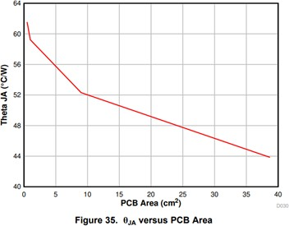

Figure 4: Thermal Resistance vs. PCB Area [5]

Thermal considerations(for class E amplifier voltage regulator (30V, 1.0A buck converter)

*TA*(*max*) = *TJ*(*max*) *− RTH · PTOT* (2)

* P*TOT* is the total device power dissipation in [W]
* T*A* is the ambient temperature in [*◦*C]
* T*J* is the junction temperature in [*◦*C]

1 l

* R*TH* is the thermal resistance of the package *◦C*

*W*

* T*A*(*max*) is the maximum ambient temperature in [*◦*C]
* T*J*(*max*) is the maximum junction temperature in [*◦*C]

The expected ambient temperature is 40*◦*C (that is temperature inside the transmitter enclosure).

Thermal resistance for a standard board (Θ*JA*) is 62.51 l [6].

*◦C*

*W*

From the simulation the total power dissipation is 1 W.

From the recommended operating conditions the maximum junction temperature is 150*◦*C [6].

Based on the data from the simulation and the datasheet the maximum ambient tem- perature can be determined

T*A*(*MAX*) = T*J*(*MAX*) - R*TH* *P*TOT* T*A*(*MAX*) = 150 – 62.5*1 = 87.5*◦*C

The expected ambient temperature is lower than the maximum temperature cal- culated based on simulation data. Therefore, this part will operate within specified recommended conditions in the datasheet.

1. *Charging Subsystem*

The LTC4162-L is designed to manage a power path between an external input power source Vin, an output power V*out*, and an installed battery pack. When external input power greater than the battery voltage is available at V*in*, the LTC4162 will route V*in* to V*out* and charge the connected battery. If external power is interrupted or falls below V*bat*, battery power will be automatically routed to V*out*. As long as the battery has charge or a power source exists at V*in*, V*out* will be supplied with power, but the voltage will range from V*bat* to V*in*. In order to provide consistent voltage to the target device output power should be drawn directly from the battery. Leaving V*out* unused allows the maximum power point tracking feature to operate with optimal efficiency.

The LTC4162 draws power directly from Vout and has its own internal LDO lin- ear regulators. All other components of the wireless receiver PCB must be powered by an appropriate DC-DC stage at V*out* that can convert any potential input voltage (i.e. 7.4-35 V) to the required operating voltages of 5 V and 3.3 V. In the event that the bat- tery is severely depleted and cannot power the microprocessor and Bluetooth interface, it will be necessary for the transmitter to be capable of initiating charging independently.

Since the LTC4162 has only an internal buck voltage regulator, the wireless power receiver subsystem must provide power to Vin that is higher than the voltage of the battery but below the maximum input voltage of 35V.

The LTC4162 approaches 95% efficiency at recommended switching frequency when the input voltage is no more than approximately 5V above battery charging voltage, and surpasses 90% in less ideal configurations. Heat losses will be in the range of three watts or less. It has a Θ*JC* of 3.4 *◦C* and will be soldered to a four-layer PCB. The team

*W*

1 l

does not anticipate any thermal management issues with this circuit.

1. *Battery Considerations*

Li-Ion batteries offer superb performance and high energy density, but require special attention to safety. Under normal circumstances the LTC4162-L will monitor battery voltage and avoid overcharging. A NTC thermistor will allow the LTC4162 to monitor local charging temperatures and limit current in accordance with JEIDA recommenda- tions.

For safety reasons, the team requires stricter battery specifications than originally planned. While our charger’s thermistor can limit charging current in response to ambi- ent temperature extremes, it cannot monitor individual cells–particularly if the battery pack is intended to be modular. While it can recognize and respond to abnormal battery voltages or short conditions, it cannot automatically determine maximum safe charging current. Any battery pack used must have a maximum charge current greater than the maximum current delivery of the charger. Battery packs must also meet UL1642 and IEC61960 standards and contain internal protection circuitry to limit charge and dis- charge currents and protect against thermal runaway.

The LTC4162 can deliver a maximum of 3.2 amps and has an efficiency of up to 95%. Assuming optimal efficiency and 26 W output from the wireless receiver, the charging

voltage must be at least 25*W*

3*.*2*A*

= 7.8 V in order to fully utilize the available power. Since

the voltage of a typical Li-Ion cell is 3.7 V and the charging voltage is 4.2 V, the target battery pack should consist of two or more cells in series. The LTC4162 supports 1 to 8 cell series arrangements provided the input voltage is adequate. Optimal arrangements would include a 7.4V pack rated for 3.2 A charging, a 11.1 V pack rated for 2.2 A charg- ing, or a 14.8 V pack rated for 1.7 A charging. The number of cells is set by selection pins and may be configured by a DIP switch or jumpers. It is not necessary to specify a specific number of cells for suitable battery packs, provided that they meet UL1642 and IEC61960 standards. The optimal balance of safe charging rates and performance will likely be found with packs utilizing six to eight 18650 cells or the equivalent. The power delivery estimates above are optimistic and actual power delivery from the charger may not reach these levels. As prototyping progresses, it will be possible to refine battery recommendations and expected charging times.

Ideally, up to 25 W will be delivered to the battery pack, making the battery the largest potential source of heat in our system. Since the battery pack is intended to be a modular, removable component with flexible specifications, it will not necessary for it to be enclosed with the wireless receiver PCB and receiving coil. It will be connected by an appropriate low-loss cable and connector, and exact placement will be determined by the user application. For this reason, the team has specified that only battery packs with internal temperature monitoring and protection circuitry should be used with this charger.

Our original specifications suggested that the charging subsystem would be capable of detailed monitoring of battery health and charge state. The team has learned that this type of information must be obtained at the individual cell level by a specialized controller which is usually integrated into the battery pack itself. Our charge subsys- tem can only recognize an approaching low-battery condition by a drop in voltage, and cannot estimate battery capacity except by calculation using charging voltage, charge times and currents, and such data would be of limited use considering battery aging and user-replaceability. It will be possible to notify the user and target device of a drop in battery voltage, but more detailed fuel gauge and battery health information will require an SMBus enabled smart battery. An I2C line on the MSP430FR5994 will be reserved for

communication with an optional SMBus capable smart battery pack. If feasible, optional battery pack telemetry may be polled by firmware and reported to the user along with the data already available from the LTC4162.

All the parts and design resources needed to complete the charging and power subsys- tem are readily available. Constructing this subsystem within the projected time-frame is feasible.

Table 5: Final Design’s Charging Subsystem Specifications

|  |  |
| --- | --- |
| DC-DC stage from wireless receiver to V*in* | May not be necessary, pending further determination of wireless receiver output voltage |
| DC-DC stage from V*out* | 5V at 100mA; 3.3V at 100 mA |
| Battery Requirements | UL1642 and IEC61960 compliant Li-Ion packs with 7.4-15 V*DC* nominal output voltage |
| Maximum Charging  Current | 3.2A (7.4V); 2.2A (11.1V); 1.7A (14.8V) |
| Provision for optional smart battery health and fuel gauge monitoring | Reserved I2C line from MSP430FR5994 with buffering |

1. *Microcontroller Considerations*

The MSP430FR5994 has a body size that ranges from 6mm by 6mm to 12mm by 12mm depending on the package the group purchases, 8KB RAM, 68 GPIO pins, 4 I2C, 4 UART, up to four serial communication ports, and 20 ADC channels. The MSP430 series include limitations that range from safety to performance [3].

Relevant limitations to the project include:

1. ESD (Electrostatic discharge) ratings. For a human-body model, safe discharge rat- ings are around 500 V to 1000 V, while for a charged-device model, safe discharge ratings are around 250 V. These regulations are taken from JEDEC JS-001 and JESD22-C101 respectively [3].
2. Absolute maximum ratings: voltage applied to any pin must be within -0.3 V to 4.1 V, voltage difference between DVCC and AVCC pins must stay within -0.3 V to 0.3 V (if not, writing errors could occur to RAM and FRAM), and current at any device pin must have a maximum of -2 to 2 mA [3].
3. Supply voltage applied should be within 1.8 V to 3.6 V, maximum ACLK frequency should be 50 kHz, and maximum SMCLK frequency should be 16 MHz [3].
4. For the eUSCI I2C, eUSCI (enhanced universal serial communication interface) input clock frequency should not exceed 16 MHz, SCL clock frequency should not exceed 400 kHz [3].
5. *Firmware Requirements: Transmitter*

The Wireless Power Transmission Stage (Transmitter) will be controlled by an MSP430FR5994 running custom firmware. The firmware must meet the following requirements:

1.) Activate or deactivate wireless transmitter.

2.) Respond to commands received from a Bluetooth link with the Wireless Power Re- ceiver Stage (Receiver), which may include requests for power delivery measurements or instructions to initiate or cease charging.

3.) Continuously monitor wireless power transmitter current and voltage and calculate delivered power.

4.) Automatically cease power transmission when the Receiver requests a shutdown or if severe interference is detected.

5.) Communicate operating status to the Receiver via Bluetooth, and directly to the user via fault LED’s or an installed LCD.

1. *Firmware Requirements: Receiver*

The Wireless Power Receiver Stage (Receiver) will be controlled by an MSP430FR5994 running custom firmware. The firmware must meet the following requirements:

1.) Link to the Transmitter over Bluetooth. 2.) Link to user GUI device over Bluetooth.

3.) Link to an optional UART connection with the target device.

4.) Respond to queries or instructions from the Bluetooth connection to the user GUI or from the optional UART connection.

5.) Monitor charging state and battery status though I2C connection with LTC4162 and optional SMBus link with smart battery.

6.) Recognize low voltage state or optional low capacity battery warning and notify the user and target device.

7.) Signal the Transmitter via Bluetooth to initiate charging when instructed by the user or target device.

8.) Continuously monitor wireless power receiver current and voltage and calculate de- livered power.

9.) Monitor reported power transmission from the Transmitter, compare it with received power, and recognize excessive power losses that could indicate unsafe interference con- ditions

10.) In the event of excessive transmission losses, instruct the Transmitter to cease power transmission. Notify the user and target device of the error condition.

The Transmitter and Receiver firmware will be developed with Texas Instruments Code Composer Studio. The team has suitable Launchpad development boards and access to all necessary documentation and libraries are available. The team is composed of multiple experienced programmers in our group. The firmware requirements are limited and well-defined and completing it within our scheduled time-frame is feasible.

1. *Software Requirements: GUI*

The GUI will be operated on multiple platforms and rely upon QT5 to operate. The software must fulfill the following requirements:

1.) Provide connection to transmitter and receiver for the product’s user that grants sufficient control over the product’s hardware

2.) Serve as a platform for custom messages to and from the user’s device connected to the receiver.

3.) Provide alert system via push notifications and continuous monitoring of the trans- mitter and receiver.

1. *Coil Considerations*

Table 6: Final Design’s Coil Tubing Specifications

|  |  |
| --- | --- |
| Material | 122 Copper |
| Tube Size | 1/8 [in] |
| Outter Diameter (OD) | 1/4 [in] |
| Wall Thickness | 0.049 [in] |
| Inner Diameter (ID) | 0.152 [in] |
| Fabrication | Seamless |
| Bending Method | By hand |
| Temper Rating | Soft |
| Compatible Tube Fittings | Compression, Solder Connect |
| Specifications met | ASTM B75  RoHS 3(2015/863/EU) Compliant |
| Resistivity | 1.68 x 10*−*8 [Ω/m] |
| Conductivity | 5.96 x 107 [S/m] |

This tubing has good corrosion resistance and excellent heat transfer qualities. All tubing meets international standards for copper tubing. Important to note: Tube size is an accepted industry designation, not an actual size [7].

Table 7: Final Design’s Receiver Coil Specifications

|  |  |
| --- | --- |
| Outside Diameter of Coils  (Do) | 90 mm |
| Number of Turns | 4 |
| Length | 729.6 mm |
| Spacing | 4.81 mm |
| Width of Tubing | 3.175 mm |
| Inner Diameter (Di) | 26.12 mm |
| Winding Radius | 29.03 mm |
| Radial Depth | 31.94 mm |
| Inductance | 909.66 nH. |
| Capacitance | 150.55 pF |
| Frequency | 13.6 MHz |
| Resistance (Dc) | 1.5462 mΩ |
| Total Resistance | 69.46 mΩ |
| Quality Factor | 1119.09 |

1. *Specification Summary*

Table 8: Final Design’s Receiver Specifications

|  |  |
| --- | --- |
| Charge time(4Ah Battery  Pack) | 5 Hours Max |
| Battery pack voltage | User Selectable: 7.4V-14.2 V |
| Coupling Efficiency  Transmitter to Receiver | 90% |
| AC-DC Conversion  Efficiency | 80% |
| Charging Controller  DC-DC Converter | 85% |
| Overall Receiver  Conversion Efficiency | 61.2% |
| Battery Requirements: | UL1642 and IEC61960 compliant Li-ion packs. |
| Maximum Battery  Charging Current | 3.2A (7.4V); 2.2A (11.1V); 1.7A (14.8V) |
| Charger Subsystem  Charge Protocol | Constant Current Constant Voltage (Li-Ion Battery) |
| Battery Type | UL1642 and IEC61960 compliant Li-Ion packs; 7.4-15 VDC nominal output voltage. |
| Power Negotiation | Using Bluetooth 5 LE |
| Deliverables | Wireless resonant charger with approximately 30W power transmission capability.  Stretch Goal: a mobile device to demonstrate autonomous  charging. |
| Telemetry | Report State to GUI Device |
| LCD display | Diagnostic Data Character String Display |

Table 9: Final Design’s Transmitter Specifications

|  |  |
| --- | --- |
| Operating Frequency | 13.56 MHz |
| RF Power Output | 30 W |
| Max. Charging Distance | 30 cm |
| DC Power supply | 48V 1.25A min. |
| Conversion Efficiency  DC-AC | 80% |
| Telemetry | Report State to Receiver |

Table 10: Final Design’s Communication Link Specifications

|  |  |
| --- | --- |
| Communication Medium | Bluetooth 5 LE |
| Protocols | GUI: Host Controller Interface (HCI)  Receiver- transmitter: Synchronous Connection-Oriented (SCO) link |

Table 11: Final Design’s GUI Specifications

|  |  |
| --- | --- |
| OS | WinOS, IOS, Linux, & Android |
| License | LGPL 3.0 |
| Software Architecture | Model-Controller-View (MCV) Architecture |
| Delivery Model | Open Source  Free App Download |

1. *Ethical and Professional Considerations*

*1.) Public Health:* Life preserving medical equipment requires concern in the trans- mission of powerful RF charging signals that may interfere with the medical equipment. We will adhere to FCC standards for intentional radiators and ensure that the charger transmitter does not exceed FDA guidelines for RF emission. Our design will be informed by the guidelines of the National Council on Radiation Protection and Measurements (NCRP) and the Institute of Electrical and Electronics Engineers (IEEE).

*2.) Safety and Welfare:* Our design may contribute to public safety and welfare by easing the development of robotic systems intended to handle hazardous materials, work in narrow spaces, high temperature environments, or in vacuum. We will follow industry best practices for safe charging, such as current limiting and temperature monitoring, to minimize the risk of battery failure.

*3.) Global Factors:* The pressures of governing bodies are to be taken into consider- ation in any choice this project takes; however, we are primarily concerned with the US governing bodies and then the EU bodies in order to streamline our development process to hit the largest market base possible. Additionally, Canadian and Mexican regulations would be considered as immediate market options.

In an alternate vein, there are sourcing questions that must be investigated before pro- duction in order to conform with internation laws and prevent being banned from specific global markets whether at home or abroad.

*4.) Societal factors* The source code will be educational as well as providing value to the device itself. The design’s modular intention will permit versatile implementations at work or at home. The product should serve influenceable groups such as teenagers, helping them enter STEM related fields.

The product as a whole should be considered in a way that would encourage further education in the classroom in physics. Likewise, the production of the product should foster a community between the product’s programmers and engineers.

*5.) Environmental factors:* This concern requires continual attention for any anoma- lies concerning the battery cells. The device cannot account for all of these concerns, but should maintain labeling that makes the customer aware of such concerns that may be caused by their device. The project must provide a means of emergency shut off by some interrupt port that is always active. The operating robot, the user via a GUI, and the receiver itself must have this ability to turn off the charging feature of the receiver.

*6.) Economic factors:* The device could fulfill legal requirements for a client, and, in that case, a custom suite would be developed in the software at a premium to satisfy a client’s needs. Additionally, creating a lightweight, low-cost production process is critical in maximizing profits. The open-source market also provides extensive free advertising momentum when capitalized successfully. Additionally, the product would assist in pro- ducing other products, especially in research and development.

Table 12: Ethical and Professional Considerations

|  |  |
| --- | --- |
| Public Health | * Medical Equipment RF Exposure * Electrical Shock * Chemical Exposure |
| Safety and Wellness | * RF Bandwidth Jamming * Electrical Shock * Chemical Exposure |
| Global Factors | * International Governing Bodies * Sourcing Restrictions * Inter-Market Penetrability |
| Societal Factors | * Open-Source Capitalization * STEM Educational Resources * Professional Organizations * Customer Privacy & Security |
| Environmental Factors | * Chemical Pollution * User Environmental Awareness * Emergency Shut Off Cases |
| Economic Factors | * Open-Source Capitalization * Specialty Clientele * Rapid Agile-Deployment * Light-Weight Production |

* 1. DESIGN SOLUTION

1. *Product Architecture*

The wireless charger system consists of two main subsystems, the receiver and the transmitter. The transmitter is powered by an external AC/DC 48 V power supply. The transmitter subsystem converts DC power into RF power to drive the transmitter coil. The transmitter has a microcontroller that communicates with the receiver and controls its wireless power transfer. The receiver has a receiving coil and capacitor that completes a 13.56 MHz parallel LC resonant circuit. The magnetic field generated by the transmit- ter induces an electric current in the receiving coil. The received power is rectified and transferred to the battery charger circuit. Also, the receiver has a microcontroller that communicates with the transmitter and indirectly controls transmitter circuits such as the wireless power transfer circuit. The receiver also communicates with remote devices such as tablets,tw phones, or computers to provide telemetry data.

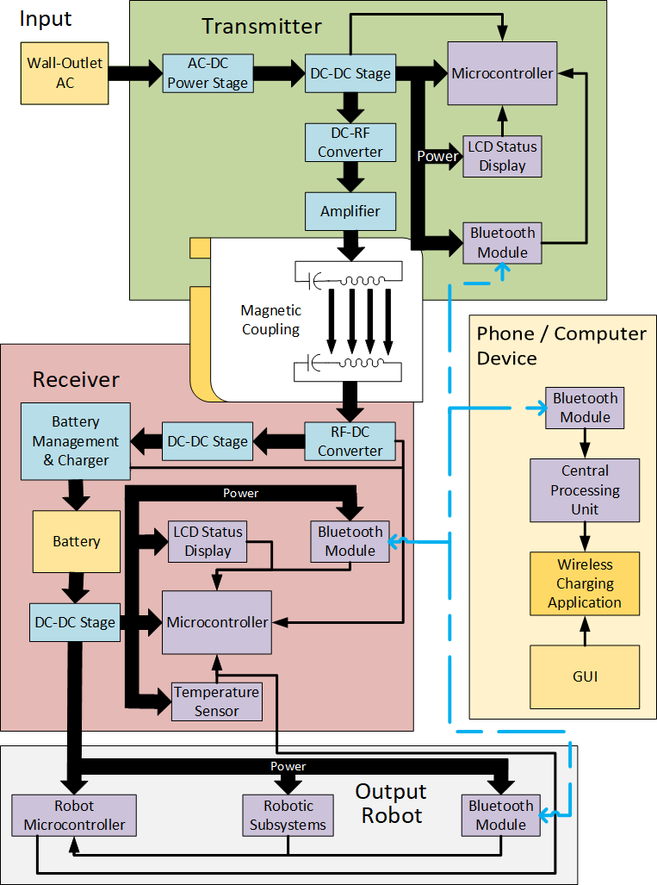

Figure 5: System Level Block Diagram

The graphical user interface (GUI) displays information with lists, data feeds, and visual aids that keep track of the battery’s charge and any information passed along by the receiver to the user’s remote device. The GUI’s information on each device’s connec- tion and charging information allows real-time troubleshooting of each device.

The GUI Wireframe image below provides an example of how the GUI is structured. The selection widget shall be used to select between receiver devices to connect to. The top panel is reserved for battery monitoring. The Info panel utilizes wifi symbols to in- dicate connection status between devices while the lightning bolts reflect their on-going charging status. The bottom text panel is reserved for general warnings and information.

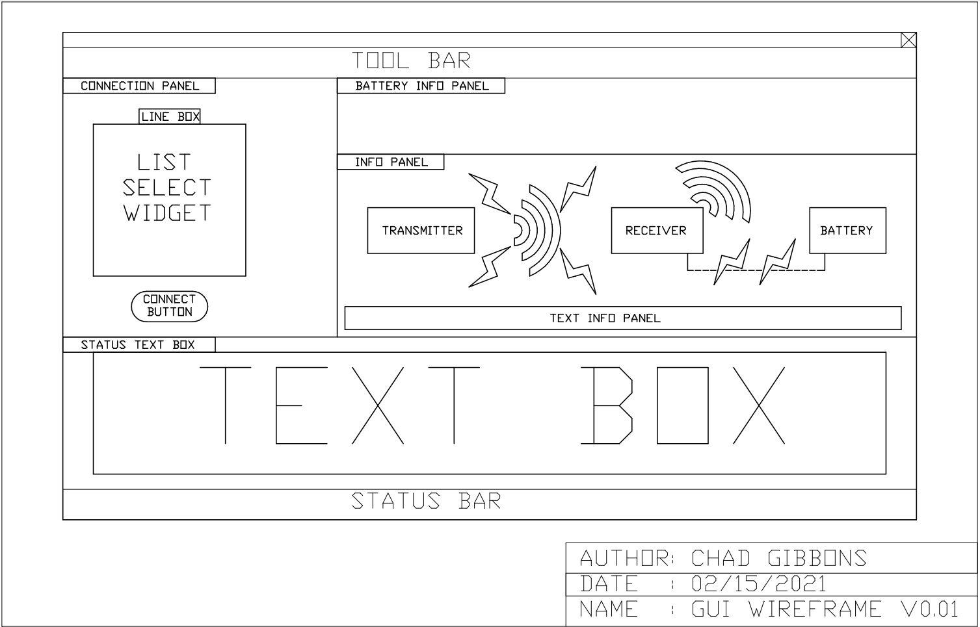

Figure 6: GUI Wireframe Diagram

1. *Hardware Subsystems*

*1.) Transmitter Subsystem* The transmitter circuit requires a 48 V power supply that will be down-regulated to 30V, 5V, and 3.3V. 30V is used by a coil driver (class E amplifier). 5 V supply will be used for the LCD and class E amplifier buffer. 3.3V is used by digital circuits such as microcontroller and Bluetooth.

The block diagram below shows internal voltage regulator connections.

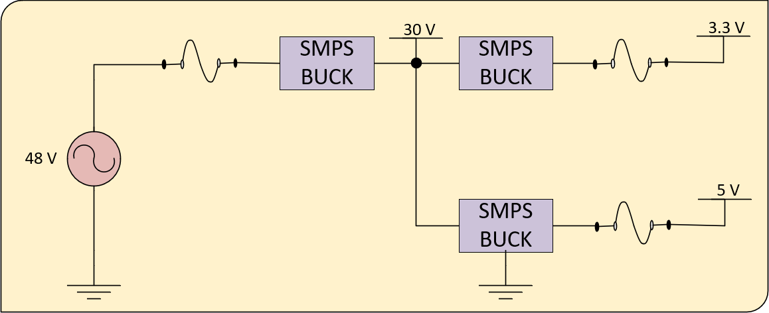

Figure 7: Transmitter Subsystem Voltage Regulator

The transmitter subsystem block diagram below illustrates how transmitter subcir- cuits interact with each other. The microcontroller is used to control most of the circuits in the transmitter subsystem. The Bluetooth module is connected to the microcontroller using the UART interface with flow control (RTS and CTS lines). The Bluetooth module is connected to the circuit that controls display contrast. The display parallel I/O inter- face is connected to the microcontroller through a level shifter. Also, the transmitter has four multipurpose user buttons that can be used to set the different modes of operations.

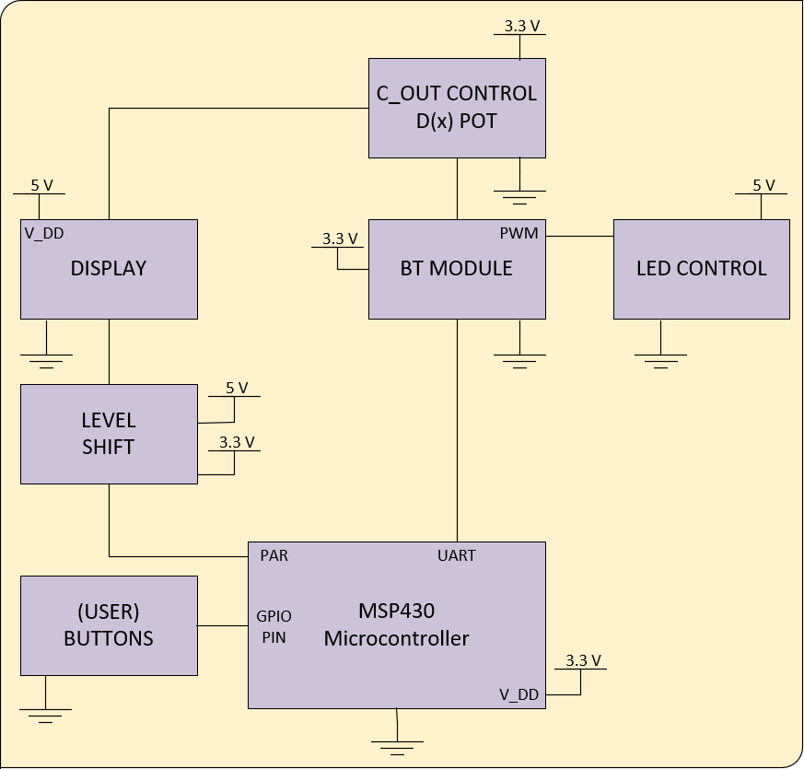

Figure 8: Transmitter Subsystem Block Diagram

The block diagram below illustrates the power transmission or DC to RF converter subcircuit. The subcircuit has an oscillator, buffer, and a coil driver. The 13.56 MHz signal is generated by a temperature-compensated crystal oscillator. The output of the oscillator is buffered using the GaN FET driver. A tuned switching power amplifier, also known as a Class E amplifier, is used to drive the transmitter coil where a GaN FET is used as a single-pole switching element. The transmitter coil and capacitors in series create the resonant LC circuit.

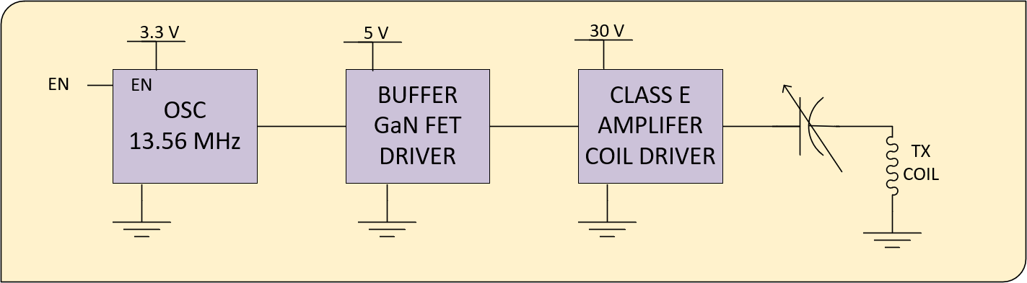

Figure 9: Coil Driver Subcircuit

The schematic diagram for the microcontroller (U2: MSP430FR5994), Bluetooth module (MD1 RN4870) display connector P3, the display illumination control (U5: MCP6001T-I/OT, U6: NUD3112LT1G), and LCD contrast control (U7: MCP4531- 103E/MS) can be found in appendix NN.

The input power is supplied by an external AC/DC SMPS (Switched Mode Power Supply) converter. The power output of the buck SMPS is protected by a PPTC reset- table fuse as short circuit protection. The fuse rating is 2.5A. A 48V power is converted to 30V which is used by the class E amplifier’s 5V buck converter and 3.3V buck converter. Each SMPS module output has overcurrent protection using resettable PPTC fuses. Both fuses are 0.5A rated. Both low voltage regulators (5V and 3.3V) have additional filtering at their outputs using ferrite beads and 0.1 *µ*F capacitors.

Voltage regulators are shown below

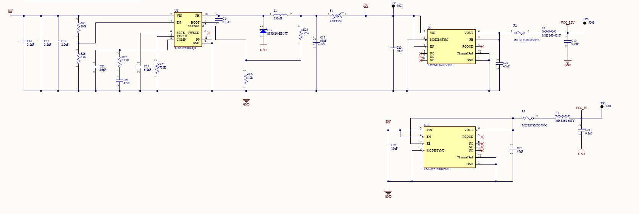

Figure 10: SMPS Subcircuit

The output of the temperature-compensated crystal oscillator (Y2) is connected to the GaN FET driver (U11: LM5112) which is connected to a GaN FET ( Q1: EPC2019). the output of the class E amplifier is connected to the transmitter coil. The amplifier circuit has a peak detector (R30, R35, D20, C36 and R36) to detect the peak voltages of its output. The voltage on the peak detector will be sampled using the microcontroller’s ADC in order to validate the receiver’s presence via loading effects on the coil.

The coil driver circuit is shown below

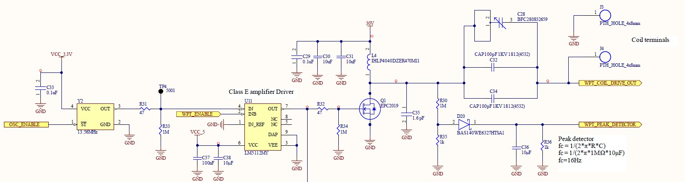

Figure 11: Transmitter Subcircuit

The transmitter subsystem function control and communication circuits schematic diagram shows the microcontroller (U2: MSP430FR5994), Bluetooth module (MD1 RN4870) display connector P5, the display illumination control (U5: MCP6001T-I/OT, U6: NUD3112LT1G), and LCD contrast control (U7: MCP4531-103E/MS). The schematic diagram can be found in appendix NN.

*2.) Receiver Subsystem* The main components in the receiver microcontroller sub- circuit are identical to the transmitter microcontroller subcircuit.

The diagram below shows connections between receiver subcircuits.



Figure 12: Receiver Subsystem Block Diagram

The receiver coil and parallel capacitor are acting as resonant tank circuit at a fre- quency of 13.56 MHz. The received power is rectified using a full wave rectifier bridge and then supplies to the battery charger circuit. The rectifier output voltage and current are constantly sampled by the microcontroller to determine instantaneous received power. The battery pack is connected to the charger for charging and the battery pack SMbus interface is connected to the microcontroller.

The diagram below shows the receiver’s charging subcircuits.

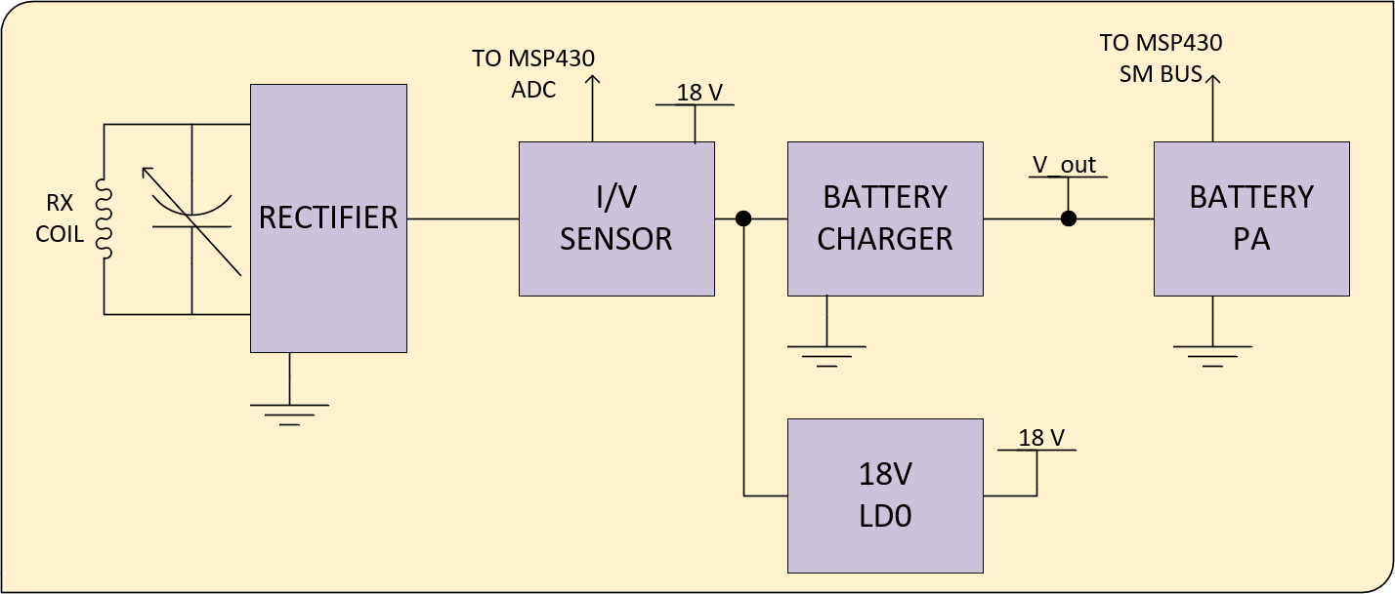

Figure 13: Receiver Coil Subsystem Block Diagram

The diagram below shows the voltage regulators utilized in powering the receiver’s digital circuits and draws power from the battery pack directly.

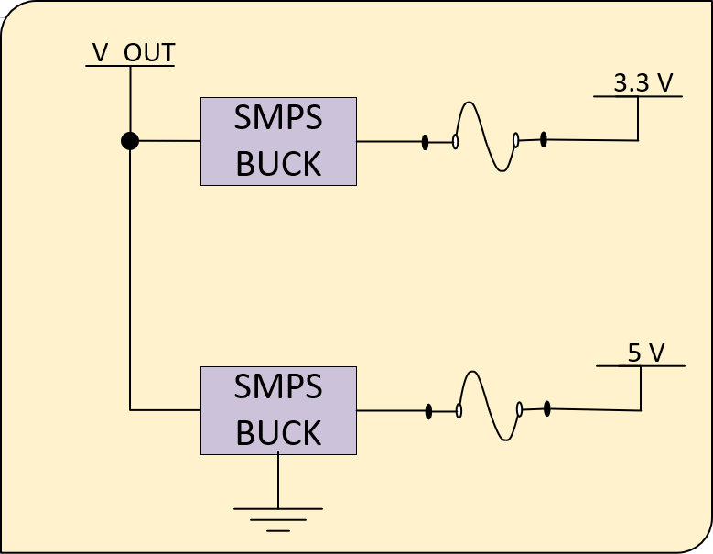

Figure 14: Receiver Voltage Regulator

On the receiver, battery management and power delivery functions are performed by the LTC4162-L monolithic charging controller. It handles many important battery test- ing and safety procedures automatically. Batteries are tested before charging, and should abnormal charging currents or voltages be detected the LTC4162-L will cease charging without firmware intervention. If conditions fall outside the preset limits a microcon- troller interrupt may be triggered via the SMBALERT line for further error handling. The microcontroller firmware may read and change the LTC4162 status over an SMBus interface at any time.

A RRC smart battery will handle cell monitoring, balancing, and charging capacity measurement. It will automatically limit charge and discharge current to ensure safe functioning. Any one of a family of smart batteries may be connected to a keyed cable connector that ensures correct polarity and an SMBus connection. The SMBus interface will communicate with the microcontroller firmware to provide battery charge capacity and health information to the user.

Charger subcircuit is realized using LTC4162EUFD-SAD integrated circuit and may be found in Appendix A.2.

The power receiver subcircuit consists of the receiver coil, rectifier bridge, voltage sensor, and current sensor on the DC side of the circuit and feeds into the battery charg- ing subcircuit. The rectifier bridge is designed using silicon carbide Schottky diodes.

DC Voltage detector and current sensor will be used to determine received power levels which can be used as an indication of transmitter-receiver inductive coupling. DC Voltage levels and current are sampled using the MSP430FR5994 AD converter.

The RF receiver rectifier and power sensor are shown below and can be found in larger print in Appendix A.3.

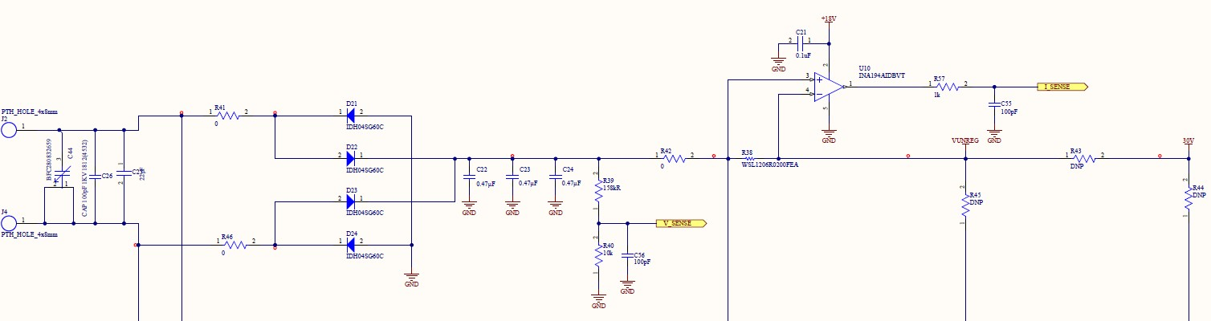

Figure 15: Rectifier and Power Sensor Subcircuit

*3.) Planar Coil Inductor* The transmitter and receiver utilize identical planar coils in the wireless power transfer process with an inductance of 0.909 *µ*H. The coils utilize copper tubing to reduce weight and costs.

The dimensions of the coil are shown below.

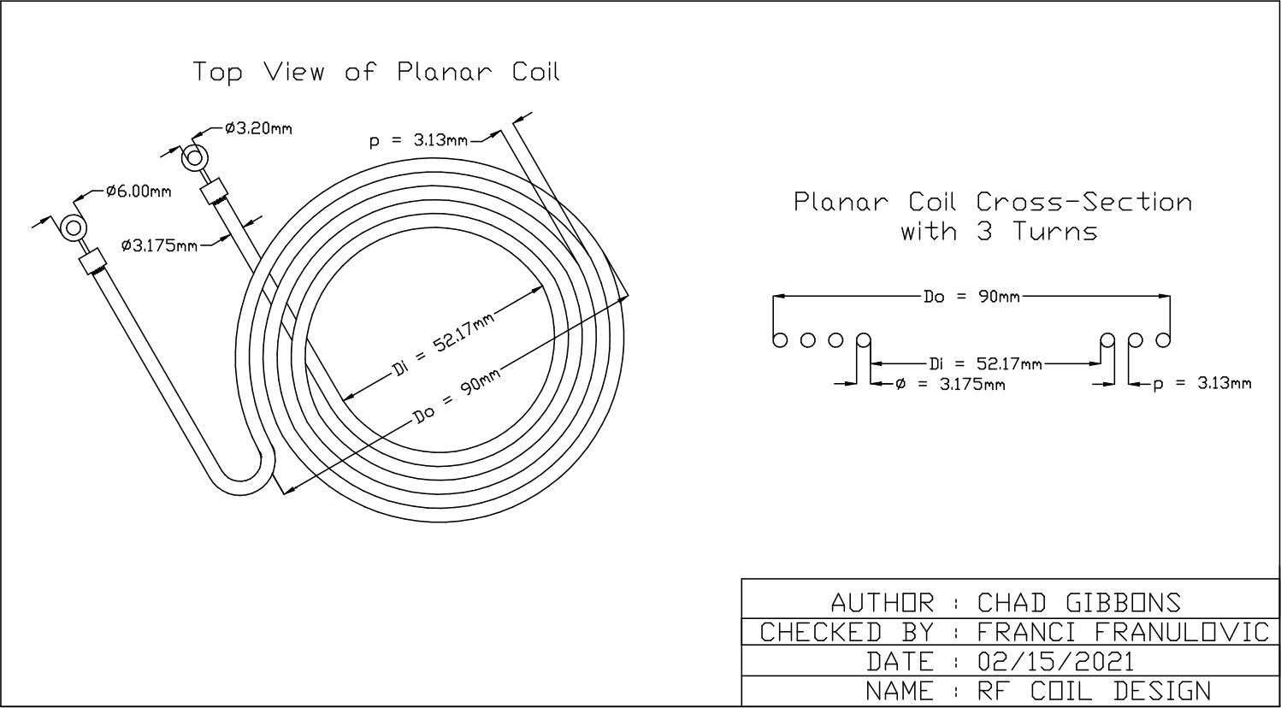

Figure 16: Planar Coil CAD Drawing

1. *Software Architecture*

*1.) Firmware Architecture* The microcontrollers’ firmware architecture is split into two general categories: core functionality that is required for the microcontroller to op- erate and utilities that handle specific tasks that the microcontrollers need to complete. The core functions primarily stem from interrupt calls and setup sequences. The util functions will communicate through the bluetooth, display information, and handle or monitor power transmission.

Below is an example of the firmware architecture.

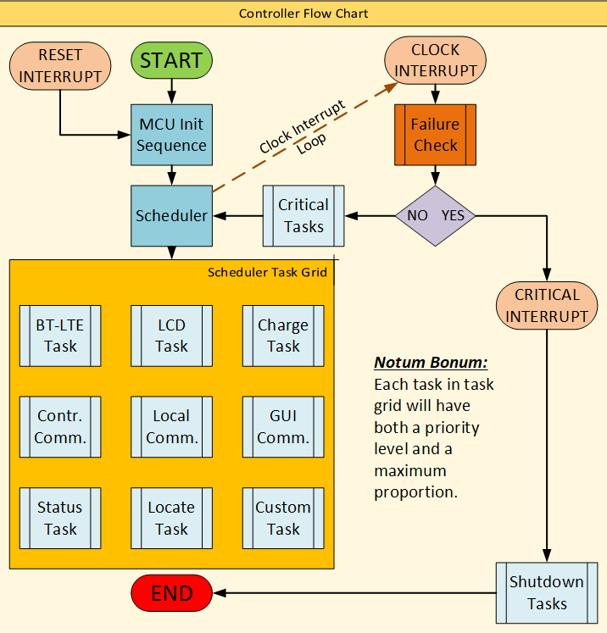

Figure 17: Controller Flow Chart

*2.) GUI Software Architecture* The GUI Software architecture is split into three general categories: Model, Controller, and View (MCV) components. Each general cate- gory is then subdivided into layers of functionality to maintain modularity. The Model is critical for handling data classes and storing data into files. The Controller is responsible for operating the visual components and model objects. The view category is utilized strictly for showing the graphical displays and are passive elements in the design’s archi- tecture.

The figure below shows the GUI ’s Model-Controller-View (MCV) Architecture

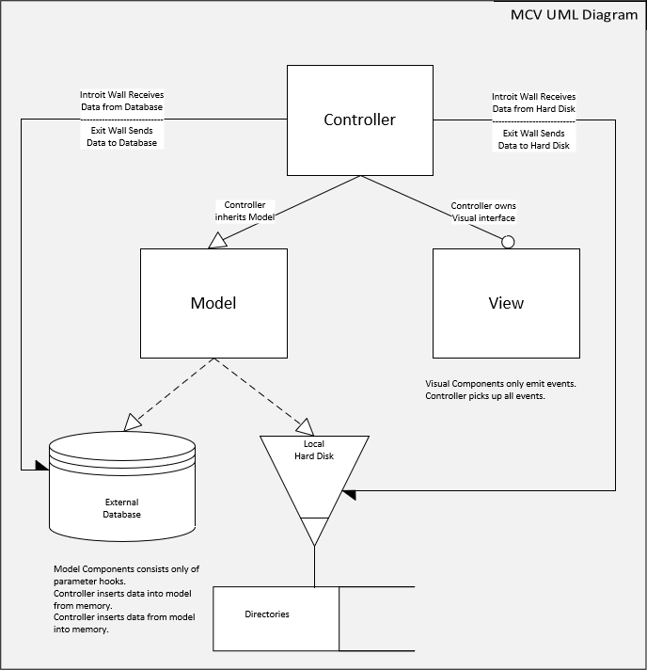

Figure 18: High Level GUI Software Architecture Example

1. *Software Modules*

*1.) Firmware Modules Programmed on TI’s Code Composer software and tested on TI’s MSP430FR5994 Launchpad Kit*

* = confer to both header and C files.

##### Microcontroller Setup

**Location:** Firmware MSP430FR5994 MCU core mcu setup.*

*\ \ *

**Function:** Activates port settings and instantiates utility functions that operate the program.

##### Microcontroller Reset

**Location:** Firmware MSP430FR5994 MCU core mcu reset.*

*\ \ *

**Function:** Resets microcontroller to initial setup configuration.

##### Task Queue Scheduler

**Location:** Firmware MSP430FR5994 MCU util Scheduler scheduler.*

*\ \ \ *

**Function:** Creates and operates the scheduler method class that selects the next task to be run in the main loop based on task priorities.

##### Clock Interrupt

**Location:** Firmware MSP430FR5994 MCU core Interrupts clock interrupt.* **Function:** The code uses Timer A and SMCLK (1 MHz) to test clock interrupt. Once the program starts running, the timer counts up to 4 ticks to emit the clock interrupt signal every 250 ms period. Additionally, it instantiates utility functions considered crit- ical to repeat frequently.

*\ \ \ *

##### Button Interrupt

**Location:** Firmware MSP430FR5994 MCU core Interrupts button interrupt.* **Function:** Four buttons are set up within a port. The code sets up an interrupt service routine to run when a button is pushed, so that their respective function is called.

*\ \ \ *

##### Pin Input Voltage Reader

**Location:** Firmware MSP430FR5994 MCU core Interrupts pins.*

*\ \ \ *

**Function:** The function reads the analog 12 bit ADC input voltage at a port’s pin.

##### Communication Transmission

**Location:** Firmware MSP430FR5994 MCU util Bluetooth bluetooth trans.* **Function:** The code permits the transmitter to communicate directly with the receiver. Alternatively, it permits the receiver to communicate with both the transmitter and a mobile device.

*\ \ \ *

##### Communication Received

**Location:** Firmware MSP430FR5994 MCU util Bluetooth bluetooth recv.* **Function:** The code facilitates the reception and reaction to bluetooth messages re- ceived.

*\ \ \ *

*2.) GUI Software Modules*

= architecture layer ( Abstract - Base - Panel - Page - Window - App )

* = confer to both header and C++ files

##### Controllers

**Location:** Software controller controller.*

*\ *

**Function:** The doer or agent component of the program. Controllers allocate functions to particular events in the UI or manipulations to data models.

##### Widget Constructor

**Location:** Software controller widget setter.*

*\ *

**Function:** The factory class that is dedicated to building widgets in a panel with the proper hierarchy of inheritance in order to give the controller mediate control of all widgets.

##### Bluetooth Low Energy

**Location:** Software core Bluetooth Protocols bt le.*

*\ \ \ *

**Function:** The concrete method class handling Qt5 Bluetooth classes.

##### App Initialization

**Location:** Software core app init.*

*\ *

**Function:** Configure all initial settings and ensure that the program is properly in- stalled.

##### Models

**Location:** Software model model.*

*\ *

**Function:** Data classes that can be pickled into compressed and encrypted binary data files. These models provide the stable memory of the application.

##### Canvas

**Location:** Software ui CanvasTools canvas.*

*\ \ *

**Function:** Concrete instances of Qt5’s QCanvas class for graphical displays of infor- mation.

##### Canvas Shapes

**Location:** Software ui CanvasTools canvas shape.*

*\ \ *

**Function:** Individual images used as graphical displays of information and placed on their respective canvases.

##### Panels

**Location:** Software ui Panels panel.

*\ \ *

**Function:** Concrete instances of movable panels used to hold widgets or canvases in GUI.

##### Toolbar Tools

**Location:** Software ui ToolbarTools win bar tools.*

*\ \ *

**Function:** Flushes out available toolbar icons and functions. Can also expand or limit drop down menu options at top of window.

##### Widgets

**Location:** Software ui Widgets

*\ *

**Function:** Too many individual modules to account for in this document. See GitHub repository [https://github.com/gibbs212521/HEC 2 senior design](https://github.com/gibbs212521/HEC_2_senior_design) for further detail. These modules are Abstract-Concrete constructor classes that build their respective wid- gets with additional custom methods or attributes.

##### Windows

**Location:** Software ui Windows window.*

*\ \ *

**Function:** Abstract-Concrete constructor classes that permit the appearance of various types of windows in the application (restricted in tablet/cellphone device compilation).

##### Power Monitor

**Location:** Software util power monitor.*

*\ *

**Function:** Method class that ascertains whether the transmitter is sending power cur- rently or not. Collects additional ancillary charging data.

##### Ticker Class

**Location:** Software ui Ticker ticker.*

*\ \ *

**Function:** Collects or alters LCD ticker read out on the microcontroller.

**App Configurations Location:** Software config.h

*\*

**Function:** Global variable module. Ideally this file remains blank.

**Application’s Hidden Settings Location:** Software .settings

*\*

**Function:** This file shall operate as a flat file to write or read current or most recent states in the application.

##### Main Program

**Location:** Software app.cpp

*\*

**Function:** The proverbial main.cpp that handles all dependencies of the application’s program.

1. *Hardware Off The Shelf Items*

The table below provides links and information on hardware incorporated in the post- production of the PCB. Further information can be found in the BOM Appendices in Appendix C, D, and E.

Table 13: Off The Shelf Items Utilized in Prototype

|  |  |  |
| --- | --- | --- |
| Description [Name] | Part Number | Link |
| Line Power Adapter: 65W  48V DC | DT62PW480D | [https://product.tdk.](https://product.tdk.com/en/search/power/switching-power/ac-dc-converter/info?part_no=DT62PW480D)  [com/en/search/power/](https://product.tdk.com/en/search/power/switching-power/ac-dc-converter/info?part_no=DT62PW480D) [switching-power/](https://product.tdk.com/en/search/power/switching-power/ac-dc-converter/info?part_no=DT62PW480D)  [ac-dc-converter/info?](https://product.tdk.com/en/search/power/switching-power/ac-dc-converter/info?part_no=DT62PW480D)  [part no=DT62PW480D](https://product.tdk.com/en/search/power/switching-power/ac-dc-converter/info?part_no=DT62PW480D) |
| 74.52 Wh Li-Ion Battery | RRC RRC2040-2 | [https://www.rrc-ps.](https://www.rrc-ps.com/en/battery-packs/standard-battery-packs/products/rrc2040-2/)  [com/en/battery-packs/](https://www.rrc-ps.com/en/battery-packs/standard-battery-packs/products/rrc2040-2/) [standard-battery-packs/](https://www.rrc-ps.com/en/battery-packs/standard-battery-packs/products/rrc2040-2/)  [products/rrc2040-2/](https://www.rrc-ps.com/en/battery-packs/standard-battery-packs/products/rrc2040-2/) |
| LCD Display | NHD-0420DZ-FSW-FBW | [https:](https://www.newhavendisplay.com/specs/NHD-0420DZ-FSW-FBW.pdf)  [//www.newhavendisplay.](https://www.newhavendisplay.com/specs/NHD-0420DZ-FSW-FBW.pdf) [com/specs/](https://www.newhavendisplay.com/specs/NHD-0420DZ-FSW-FBW.pdf)  [NHD-0420DZ-FSW-FBW.pdf](https://www.newhavendisplay.com/specs/NHD-0420DZ-FSW-FBW.pdf) |

1. *Software Off The Shelf Items*

The table below includes all software used to develop hardware and the software for the wireless charger project.

Table 14: Off The Shelf Software Items

|  |  |  |  |
| --- | --- | --- | --- |
| Name and Version | License Type | Restrictions | Link |
| National  Instruments Multisim 14.1 | Commercial | None | [https://www.ni.com/](https://www.ni.com/en-us/shop/software/products/multisim.html)  [en-us/shop/software/](https://www.ni.com/en-us/shop/software/products/multisim.html)  [products/multisim.html](https://www.ni.com/en-us/shop/software/products/multisim.html) |
| Altium 21.0.9 | Commercial | None | [https:](https://www.altium.com/)  [//www.altium.com/](https://www.altium.com/) |
| Altium 365 | Commercial | None | [https://www.altium.](https://www.altium.com/altium-365)  [com/altium-365](https://www.altium.com/altium-365) |
| Gerbv 2.6A | GPL 2.0 | None | [http://gerbv.](http://gerbv.geda-project.org/)  [geda-project.org/](http://gerbv.geda-project.org/) |
| Saturn PCB  Design Inc. – PCB Toolkit ver.7.13 | Commercial Freeware | None | https://saturnpcb.com/ pcb toolkit/ |
| TI Code Composer | Commercial  Freeware | None | [https://www.ti.com/](https://www.ti.com/tool/CCSTUDIO)  [tool/CCSTUDIO](https://www.ti.com/tool/CCSTUDIO) |
| Qt5 | LGPL 3 | Code must be  Open Source and Free to Download | [https://doc.qt.io/](https://doc.qt.io/qt-5/licensing.html) [qt-5/licensing.html](https://doc.qt.io/qt-5/licensing.html) |
| MS Visio | Personal License | No Corporate Use | [https://www.microsoft.](https://www.microsoft.com/en-us/microsoft-365/visio/flowchart-software)  [com/en-us/](https://www.microsoft.com/en-us/microsoft-365/visio/flowchart-software)  [microsoft-365/visio/](https://www.microsoft.com/en-us/microsoft-365/visio/flowchart-software)  [flowchart-software](https://www.microsoft.com/en-us/microsoft-365/visio/flowchart-software) |
| NanoCAD | Personal License | No Corporate Use | [https://nanocad.com/](https://nanocad.com/products/nanoCAD/)  [products/nanoCAD/](https://nanocad.com/products/nanoCAD/) |
| GCC | GPL 2.0 | None | [https://nanocad.com/](https://nanocad.com/products/nanoCAD/)  [products/nanoCAD/](https://nanocad.com/products/nanoCAD/) |

1. *Schematics / Wiring Diagrams / Technical Drawings*

The schematics utilized can be found in appendices A and B with respect to the receiver, transmitter, and battery charger.

The coil design and GUI wireframe can be found in appendices F and G.

1. *Custom Software*

All code is written modularly, to inspect functions or objects individually see repository of [https://github.com/ttgibbs212521/HEC 2 senior design](https://github.com/ttgibbs212521/HEC_2_senior_design).

*1.) Firmware Main Program* msp430 proj.c

#ifndef MC MSP430 H #define MC MSP430 H #include <msp430fr5994.h> #endif

#include "util/Scheduler/scheduler.h" #include "core/mcu setup.h"

short main()

*{*

mc setup(); // Setup Interrupts and Core Functions

struct MCScheduler mc scheduler; // Instantiate Scheduler Class Object buildScheduler(&mc scheduler); // Build Out Scheduler

mc scheduler.run(&mc scheduler); // Begin Utility Function Loop return 1; // Returns 1 since this point should never be reached

*}*

*2.) GUI Software Main Program* app.cpp

#include "Core*\*app init.h" int main()

*{*

AppController MotherController; MainWindow MainWin;

AppModel PrimaryModel;

MainWin.owner = &MotherController; // use only for signaling PrimaryModel.owner = &MotherController; // use only for signaling

AppController.getSettings(); // collect stable memory in .settings file AppController.setModel(&PrimaryModel); // giving control over model AppController.setUI(&MainWin); // giving control over window ui

// AppController.setChildrenControllers() // Currently only one page AppController.runApp();

return 0; // emits 0 on successful closure of application

*}*

* 1. PROTOTYPE DESIGN AND FABRICATION

1. *Transmitter Subsystem Prototype Production*

*1.) PCB Manufacturing* The transmitter boards are manufactured at JLC PCB factory in China. The PCB specification shown below makes this board producible by many manufacturers because it does not require special manufacturing processes.

For the fabrication process, Altium PCB CAD software is used to generate bord manu- facturing files (Gerber X2).

Gerber files include the following files:

Transmitter RevA Copper Signal Top.gbr TOP SIGNAL Transmitter RevA Copper Plane 1.gbr GROUND PLANE Transmitter RevA Copper Signal 1.gbr MID1 SIGNAL Transmitter RevA Copper Signal Bot.gbr BOTTOM SIGNAL Transmitter RevA Soldermask Top.gbr TOP MASK Transmitter RevA Soldermask Bot.gbr BOTTOM MASK Transmitter RevA Legend Top.gbr TOP SILK Transmitter RevA Legend Bot.gbr BOTTOM SILK Transmitter RevA Paste Top.gbr TOP PASTE

Transmitter RevA Paste Bot.gbr BOTTOM PASTE

Reference Drill files

Transmitter RevA PTH Drill.gbr Plated through holes Transmitter RevA NPTH Drill.gbr Non-plated through holes

NC DRILL

Transmitter RevA-RoundHoles.TXT N/C DRILL ROUND HOLES Transmitter RevA-SlotHoles.TXT N/C DRILL SLOT HOLES

The transmitter boards are manufactured using the following specification: Material: FR4 (135degC Tg) RoHS COMPLIANT

Board Thickness: 0.063”

Surface finish: Immersion Gold (Electroless Nickel Gold - ENIG) Solder Mask Color: Green

Silkscreen Color: White Min. Drill: 8 mils

Min. Line Width: 8 mils Min. Spacing: 4 mils

The layers are stacked up as follows:

1. TOP SIGNAL
2. GROUND PLANE
3. MID1 SIGNAL
4. BOTTOM SIGNAL

The transmitter board size is 5.702 inches (144.821 mm) X 4.203 inches (106.76 mm).

*2.) Transmitter Prototype Board Assembly* The group plans to assemble two trans- mitter boards. Parts for two boards are ordered using part numbers and quantities specified in the bill of materials. Quantities for small parts such as resistors, capacitors, some diodes, and some transistors are rounded to the nearest hundred because of the price break.

The assembly is performed manually using solder paste stencil and manual surface mount component placement. The solder paste stencil is custom made and is manu- factured in the same facility as the PCB. Soldering is performed using a reflow oven. Through-hole parts are added after reflow oven soldering and soldered using standard solder pencil. All materials used in the assembly process are RoHS compliant.

For manual PCB assembly the group must provide detailed drawings of the PCB with visible reference designators, the bill of materials (BOM) that includes components reference designators, component description, and part numbers.

Required assembly documentation for the transmitter subsystem includes the following documents:

1. PCB Top silk layer and top copper layer drawings (c.f. Appendix B)
2. Bill of materials (c.f. Appendix D)

The figure below shows the PCB Top silk layer.

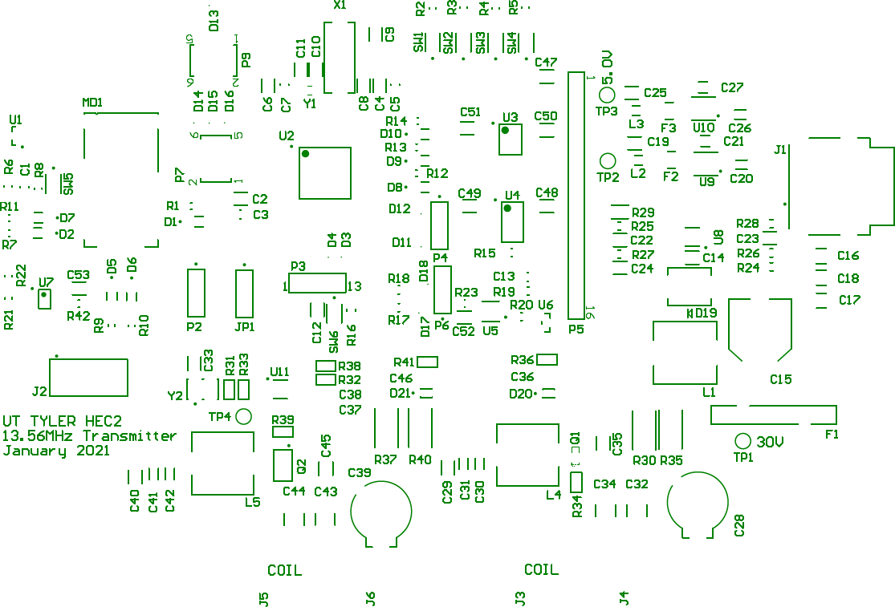

Figure 19: Transmitter Top Silk Layer The figure below shows the PCB Top copper layer.

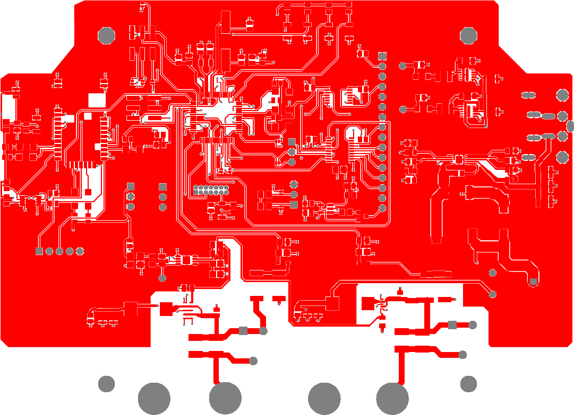

Figure 20: Transmitter Top Copper Layer

The assembly is performed by a professional worker. The assembly process consists of the following steps:

1. Solder paste printing on the PCB
2. Manual placement of surface mount components
3. Soldering using a reflow oven.
4. Through-hole soldering by hand using a solder iron pencil

All materials used in the assembly process are RoHS compliant. Also, all tools used in this process are standard tools used for the PCB assembly process.

*3.) Post Assembly Inspection* After the boards are assembled they must be in- spected for solder quality and possible assembly errors. Components values such as resistance, capacitance, and part numbers must be compared against the BOM and the board drawing. Also, the inspection step includes component polarity and solder quality inspection. After this step, the transmitter boards are ready for electrical verification and tests.

The transmitter prototype design is intended to match the final hardware design. The enclosure selection may change depending on the thermal behavior of the transmitter subsystem. Also, the differences that may exist between the transmitter prototype and the final design solution are not known at this stage because the transmitter electronics performance and efficiency need to be validated. Depending on the test results the group may apply changes in the transmitter circuits.

1. *Receiver Subsystem Prototype Production*

*1.) PCB Manufacturing* The receiver boards are manufactured at JLC PCB fac- tory in China. The PCB specification shown below makes this board producible by many manufacturers because it does not require special manufacturing processes.

For the fabrication process, Altium PCB CAD software is used to generate bord manu- facturing files (Gerber X2).

Gerber files include the following files:

HEC2 Receiver RevA Copper Signal Top.gbr TOP SIGNAL HEC2 Receiver RevA Copper Plane 1.gbr GROUND PLANE HEC2 Receiver RevA Copper Signal 1.gbr MID1 SIGNAL HEC2 Receiver RevA Copper Signal Bot.gbr BOTTOM SIGNAL HEC2 Receiver RevA Soldermask Top.gbr TOP MASK

HEC2 Receiver RevA Soldermask Bot.gbr BOTTOM MASK HEC2 Receiver RevA Legend Top.gbr TOP SILK

HEC2 Receiver RevA Legend Bot.gbr BOTTOM SILK HEC2 Receiver RevA Paste Top.gbr TOP PASTE HEC2 Receiver RevA Paste Bot.gbr BOTTOM PASTE

Reference Drill files

HEC2 Receiver RevA PTH Drill.gbr Plated through holes HEC2 Receiver RevA NPTH Drill.gbr Non-plated through holes

NC DRILL

HEC2 Receiver.TXT N/C DRILL ROUND HOLES

The receiver board is manufactured using the following specification: Material: FR4 (135degC Tg) RoHS COMPLIANT

Board Thickness: 0.063”

Surface finish: Immersion Gold (Electroless Nickel Gold - ENIG) Solder Mask Color: Green

Silkscreen Color: White Min. Drill: 8 mils

Min. Line Width: 8 mils Min. Spacing: 4 mils

The layers are stacked up as follows:

1. TOP SIGNAL
2. GROUND PLANE
3. MID1 SIGNAL
4. BOTTOM SIGNAL

The receiver board size is matching the enclosure recommended board dimensions.

The receiver prototype design is intended to match the final hardware design. The enclosure selection may change depending on the thermal behavior of the receiver sub- system. Also, the differences that may exist between the transmitter prototype and the final design solution are not known at this stage because the transmitter electronics per- formance and efficiency need to be validated and compared to the product specification. Depending on the test results the group may apply changes in the receiver circuits. The receiver board size is 5.702 inches (144.821 mm) X 4.203 inches (106.76 mm).

*2.) Receiver Prototype Board Assembly* The group plans to assemble two receiver boards. Parts for two boards are ordered using part numbers and quantities specified in the bill of materials. Quantities for small parts such as resistors, capacitors, some diodes, and some transistors are rounded to the nearest hundred because of the price break. The assembly is performed manually using solder paste stencil and manual surface mount component placement. The solder paste stencil is custom made and is manufactured in the same facility as the PCB. Soldering is performed using a reflow oven. Through-hole parts are added and soldered after reflow oven soldering using standard solder pencil. All components and materials used in the assembly process are RoHS compliant.

For manual PCB assembly the group must provide detailed drawings of the PCB with visible reference designators, the bill of materials (BOM) that includes components reference designators, component description, and part numbers.

Required assembly documentation for the transmitter subsystem includes the following documents:

1. PCB Top silk layer and top copper layer drawings (ic.f. Appendix A)
2. Bill of materials (c.f. Appendix C)

The figure below shows the PCB Top silk layer.

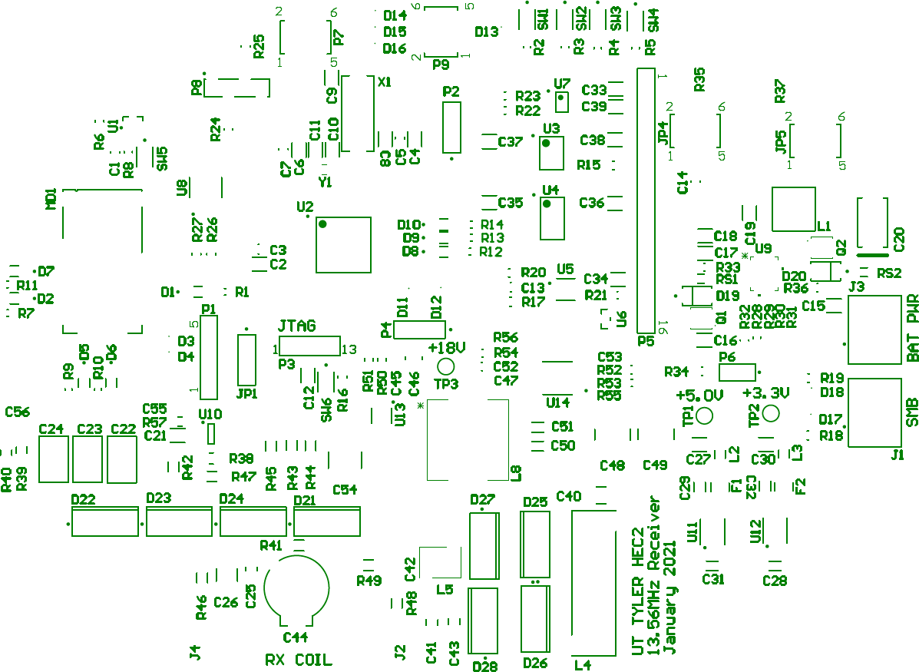

Figure 21: Receiver Top Silk Layer

The figure below shows the PCB Top copper layer.

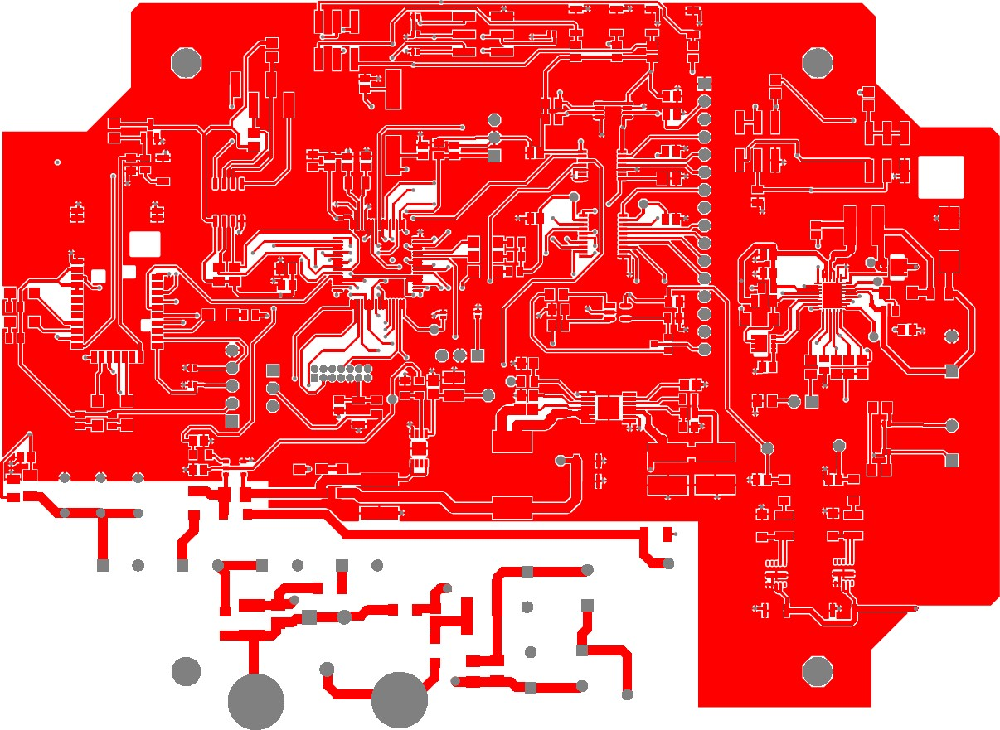

Figure 22: Receiver Top Copper Layer

The assembly will be performed by a professional worker. The assembly process consists of the following steps:

1. Solder paste printing on the PCB
2. Manual placement of surface mount components
3. Soldering using a reflow oven.
4. Through-hole soldering by hand using a solder iron pencil

All materials used in the assembly process are RoHS compliant. Also, all tools used in this process are standard tools used for the PCB assembly process.

*3.) Post Assembly Inspection* After the boards are assembled they must be in- spected for solder quality and possible assembly errors. Components values such as resistance, capacitance, and part numbers must be compared against the BOM and the board drawing. Also, the inspection step includes component polarity and solder quality inspection. After this step, the receiver boards are ready for electrical verification and tests.

The receiver prototype design is intended to match the final hardware design. The enclosure selection may change depending on the thermal behavior of the receiver sub- system. Also, the differences that may exist between the receiver prototype and the final design solution are not known at this stage because the receiver electronics performance and efficiency need to be validated. Depending on the test results the group may apply changes in the receiver circuits.

1. *Coil Production*

The coil development process involves printing a 3-dimensional hollow plastic fixture. The interior of the fixture contains a spiral bas-relief that shall fix the coil in the specified spiral form. The coil shall be connected to the PCB board using stranded copper wire. For ideal performance conditions, the coil must withstand 600V rms as well as possess a resistance of 69.906 mΩ. The coil is encased in a plastic enclosure to prevent electric shock. The plastic enclosure specification will have a size of 130mm x 110mm x 20mm. MFG alpha rated wire will be soldered to the coil and the other end of wire will be terminated with the ring terminal.

1. *Expenditure Report*

The list below shows development tools and assembly tools cost that are used as an aid to design and produce the wireless charger system. This list does not include the cost of components that are part of the system.

##### Evaluation Kits for Firmware

Bluetooth Development Tools (802.15.1) RN4870 Sensor Board Manufacturer part number: RN-4870-SNSR

Mouser part number: 579-RN-4870-SNSR Cost: $91.80

Ordered: 1 unit Total cost: $91.80

Bluetooth Development Tools (802.15.1) RN4870 click Manufacturer part number: MIKROE-2543

Mouser part number: 932-MIKROE-2543 Cost: $33.00

Ordered: 3 units Total cost $99.00

Development Boards & Kits - MSP430 MSP430FR5994 LaunchPad Dev Kit Manufacturer part number: MSP-EXP430FR5994

Mouser part number: 595-MSP-EXP430FR5994 Cost: $20.39

Ordered: 5 units Total cost $101.95

##### Hardware Evaluation Kits

Power Management IC Development Tools LTC4162 DC2038= Li-ion,adjustable, MPP Manufacturer part number: DC2038A-J

Mouser part number: 584-DC2038A-J Cost: $150.00

Ordered: 1 unit

Battery packs for charger controller testing Battery Packs 11.1V, 6.4Ah, 72Wh battery (3s2p) Manufacturer part number: RRC2040-2

Mouser part number: 328-RRC20402 Ordered: 1 unit

Cost: $105.00

##### Solder Stencil Production

Solder paste stencils are ordered for each subsystem. Manufacturer: JLC PCB

Manufacturer part number: Custom order Solder paste stencil $7.05

Total cost $14.10

Table 15: Summary of Expenditures

|  |  |  |  |
| --- | --- | --- | --- |
|  | Expenditure Description | Subsystem | Cost |
| 1 | Hardware development kits | Receiver | $255.00 |
| 2 | Firmware evaluation kits | Transmitter/ Receiver | $226.75 |
| 3 | Solder paste stencils (board assembly) | Transmitter/Receiver | $14.10 |
|  | TOTAL COST |  | $495.85 |

The tables below account for man-hours expended in development and prototyping.

Table 16: Man-Hours Expenditure Report in Development and Prototyping

|  |  |
| --- | --- |
| Task Description | Man-Hours |
| **Coil Production** |  |
| Francsico Sosa worked on coil | 8 |
| Franci Franulovic worked on coil  **Subtotal** | 8  **16 hours** |
| **Schematic design and capture** |  |
| David Flory | 90 |
| Franci Franulovic | 12 |
| **Subtotal** | **102 hours** |
| **PCB Layout Design** |  |
| Franci Franulovic | 10 |
| David Flory | 9 |
| **Subtotal** | **19 hours** |
| **PCB Assembly** |  |
| Estimated time required to assemble four prototypes | 16 |
| **Subtotal** | **16 hours** |
| **Post Assembly Inspection** |  |
| Assembly verification | 1 |
| Solder quality inspection | 1 |
| **Subtotal** | **2 hours** |
| **GUI Software Development** |  |
| Chad Gibbons on GUI Software Architecture | 5 |
| Chad Gibbons | 2 |
| **Subtotal** | **7 hours** |
| **Firmware development** |  |
| Natasha Franca | 25 |
| Francisco Sosa | 8 |
| Chad Gibbons | 32 |
| Chad Gibbons worked on test suite | 10 |
| **Subtotal** | **75 hours** |

Man-Hours Report Continued

|  |  |
| --- | --- |
| **Task Description** | **Man-Hours** |
| **Learning Curves and Used Skilled Resources** |  |
| David Flory on Altium | 7 |
| Firmware Team studied C/C++ | 15 |
| Franci Franulovic developed PCB Schematic Drawing | 11 |
| Natasha Franca learned Object Oriented Programming in C | 2 |
| **Subtotal** | **35 hours** |
| **Subsystem Prototyping** |  |
| Receiver PCB assembly | 8 |
| Parts procurement | 2 |
| Coil assembly | 8 |
| Coil Test | 5 |
| Hardware test | 17 |
| Firmware test | 6 |
| Quality control inspection | 8 |
| **Subtotal** | **54 hours** |

Table 17: Development and Prototyping Summary of Man-Hours

|  |  |
| --- | --- |
| **Task Description** | **Man-Hours** |
| Time Learning | 35 |
| Software Development | 82 |
| Hardware Development | 137 |
| Assembly | 36 |
| Quality Assurance | 36 |
| **Total** | **326 hours** |

1. *Budget*

This budget lists the expenses for development hardware, prototyping materials, and skilled labor necessary to realize and test the prototype.

Table 18: Development and Prototyping Budget

|  |  |  |  |
| --- | --- | --- | --- |
| **Item Description** | **Price** | **Qty.** | **Totals** |
| Microchip Bluetooth RN4870 Sensor Board | $91.80 | 1 | $91.80 |
| Mikroe Bluetooth RN4870 click | $33.00 | 3 | $99.00 |
| TI MSP430FR5994 LaunchPad Dev Kit | $20.39 | 5 | $101.95 |
| Analog Devices LTC4162-L Evaluation Board | $150.00 | 1 | $150.00 |
| RRC Battery Packs 11.1V, 6.4Ah, 72Wh battery (3s2p) | $105.00 | 1 | $105.00 |
| 16x2 Parallel LCD Display (for evaluation) | $20.63 | 3 | $61.89 |
| Receiver BOM | $77.30 | 2 | $154.59 |
| Transmitter BOM | $128.78 | 2 | $257.55 |
| System BOM | $136.92 | 1 | $136.92 |
|  |  |  |  |
| **Total Hardware** |  |  | $**1,158.70** |

1. *Current Manufacturing Abilities*

The process starts with the purchase of the necessary components. Having the PCBs’ Altium CAD Software drawings, the transmitter and receiver board files are sent for manufacturing at JLC PCB factory in China. Shipping time for the boards are around seven days. Small parts for the boards are also generated in the Altium software as a bill of materials, and those include but are not limited to resistors, capacitors, transistors, and diodes. Those can be ordered anywhere online and take up to seven days for delivery. Small parts can be purchased at local electronics stores. Hardware off-the-shelf items include power adapter, Li-Ion battery, and LCD display, and those can also be readily purchased at any local electronics store. Assembling is done by soldering the components according to the board layout, and each board takes approximately four to five hours to assemble by hand. The last setup step is to load the firmware onto the boards which requires less than one hour. In that same hour, testing the prototype can be completed if there are no issues hindering the charging process. The board would need to be troubleshooted for firmware, software, or hardware issues; the troubleshooting can take minutes or hours to fix.

Table 19: Prototype Production Timetable

|  |  |
| --- | --- |
| **Description** | **Time Required** |
| Shipping Time for PCBs and other components | 7 days |
| Manual receiver PCB assembly | 5 hours |
| Manual transmitter PCB assembly | 5 hours |
| Parts procurement process for each subsystem | 2 hours |
| Coil assembly for each subsystem | 1 hour |
| Coil Test | 1 hour |
| Hardware test | 1 hour |
| Firmware load and test | 1 hour |
| Quality control inspection | 8 hours |
| **Total** | **8 days** |

* 1. TESTING AND VALIDATION

Validation of a product prototype is an important step to determine the performance, reliability, and durability of the designed product. Without proper testing, the product life cycle can be severely limited due to component failure or subcircuit malfunction. All basic functionality for each subsystem is verified by following standard test practices. The transmitter and receiver subsystems were subjected to validation tests described below to observe their actual performance.

TRANSMITTER TESTS

1. *Transmitter Power Supply Tests*

The transmitter prototype board testing starts by applying DC voltage on pins 3, and 4 positive terminals and pins 1-7 negative terminals. DC voltage is supplied using a bench power supply with the current limit set to 0.3A. The power supply voltage is gradually increased from 0V to the nominal voltage of 48V while the bench power supply current was constantly monitored. The 30V regulator will start regulating if the input voltage is higher than 38.3V. The expected output voltage on TP 1 is 30V +/-2% due to reference voltage tolerance and resistors used for setting the output voltage.

After the 30V regulator test, the voltage output is verified the following low voltage reg- ulators are verified:

* + 3.3V regulator (U11) test point TP2 nominal voltage 3.3V tolerance +/- 1.5%
  + 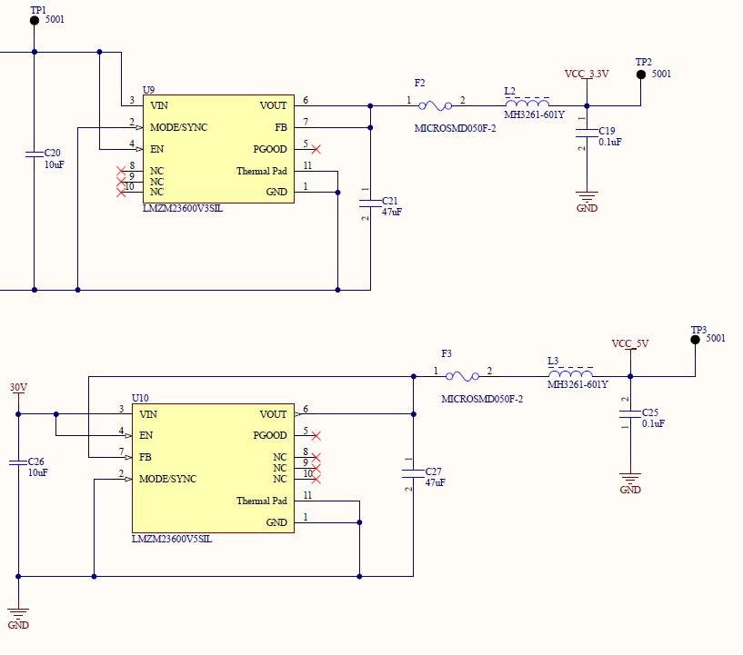5V regulator (U11) test point TP3 nominal voltage 5V tolerance +/- 1.5% Below is the part of the schematic diagram showing test points TP1, TP2, and TP3.

Figure 23: Transmitter Voltage Regulator Circuits

After power modules are verified the test firmware can be loaded using a JTAG connection on the board. The firmware sets all parameters in the default state for testing. The coil driver is disabled and all peripherals are turned off.

1. *Transmitter Coil Driver Tests*

After the firmware is loaded the board is turned off and the transmitter coil is connected to the terminals J3 and J4. The coil driver circuit is tested using a variable voltage supply. To perform this test PPTC fuse, F1 is removed and the bench power supply is connected to the TP1 (positive terminal) and the negative terminal is connected to the ground. The oscilloscope probe is attached to the drain of Q1 (GaN FET transistor). The second probe is connected to the output of the 13.56MHz temperature compensated oscillator (TP4).

After the test equipment is attached the power supply is turned on and the output voltage is gradually increased. When the power supply is higher than 5V voltage regu- lators (3.3V and 5V) are enabled and they provide power to the transmitter subcircuits. The temperature compensated oscillator (TXCO) enable line is controlled by push but- tons. When the oscillator enable line is set to a high level a 13.56MHz signal is enabled and 13.56MHz is fed into the Class E amplifier driver (U11). The expected voltage from the TXCO on TP4 is 3.3Vpp. After the oscillator subcircuit is verified the oscilloscope probe is placed on one of the terminals of jumper R32 to verify the functionality of U11. The expected amplitude on the output of the Class E amplifier driver is 5Vpp.

The figure below presents the subcircuit wherein the transmission signal is generated and tested.

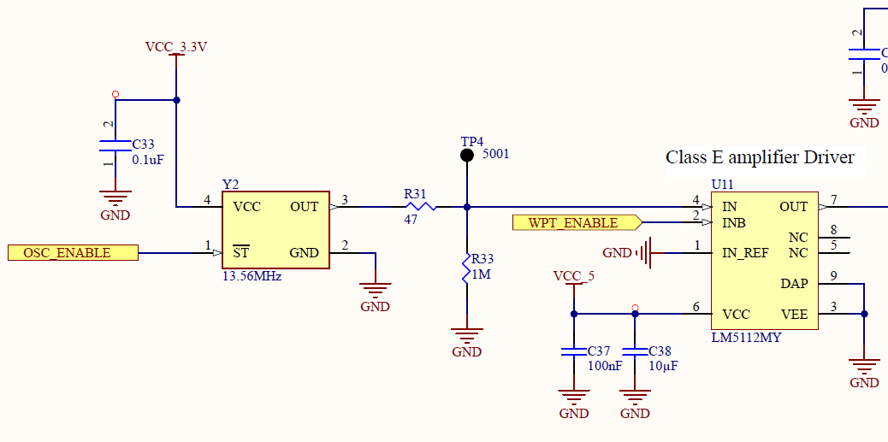

Figure 24: Oscillator and Buffer Subcircuit

The GaN FET switching is verified by observing the GaN FET drain voltage wave- form that will have a voltage swing from 0V to 117V if the power supply voltage is set to 30 V. For lower supply voltages the swing will be lower but it always should swing from 0V to some positive voltage. After the GaN FET switching is verified the transmitter coil resonance will be adjusted.

To set transmitter coil resonance a variable capacitor (C28) must be adjusted while the voltage across the coil is monitored using a 100X oscilloscope probe attached to J4 (transmitter board coil terminal). The trimmer capacitor must be adjusted until the voltage across the transmitter coil reaches the maximum value. After the resonance is achieved the power supply voltage is gradually increased to 30V while the supply current is constantly monitored. The expected voltage on the drain of the GaN FET is 117Vpp. The measured voltage is recorded. The 30V power supply current should be 120mA if there is no load present (no receiver coil in the front of the transmitter coil).

The figure below presents the subcircuit wherein the transmission signal is amplified and observed by a Class E amplifier.

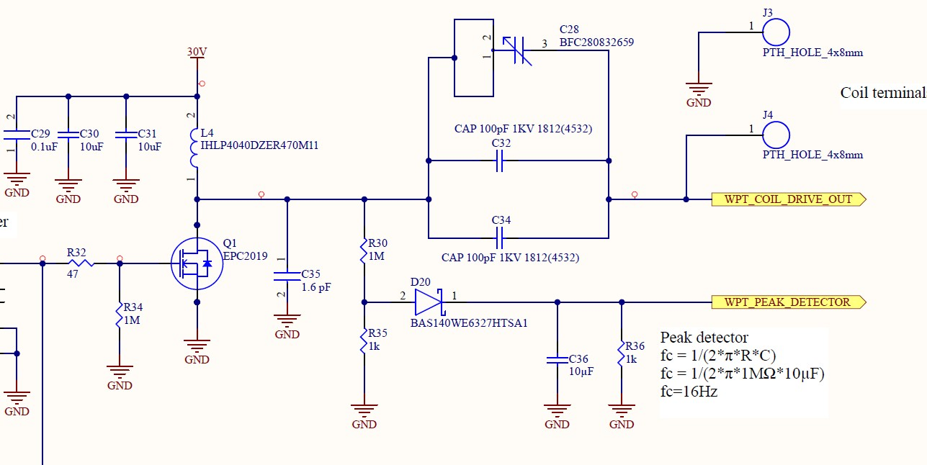

Figure 25: Transmission Signal Class E Amplifier Subcircuit

Transmitter power output is measured when the class E amplifier is verified and the amplifier power supply voltage is 30V. The specified transmitter power output is 30W. The power output is measured by placing receiving LC circuit loaded with a 50D high power resistor in the front of the transmitter coil at a distance of 5 cm. The peak to peak voltage across the load is measured using the oscilloscope and recorded in the table. This process is repeated for distances of 4 cm, 3 cm, 2 cm, and 1 cm.

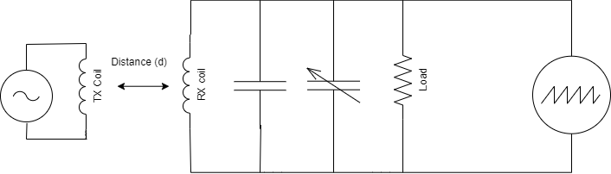

Figure 26: Received Power vs. Distance Test Setup

1. *Transmitter Firmware Tests*

The figure below is a reference for the transmitter part numbers and pin numbers. The part numbers can be found adjacent to the part outline with a prefix of P, J, U, Q, F, D, R, C, or L. Pin numbers are found without a prefix adjacent to the first and last pin with their respective number in any part denoted by the prefix P where space provides.

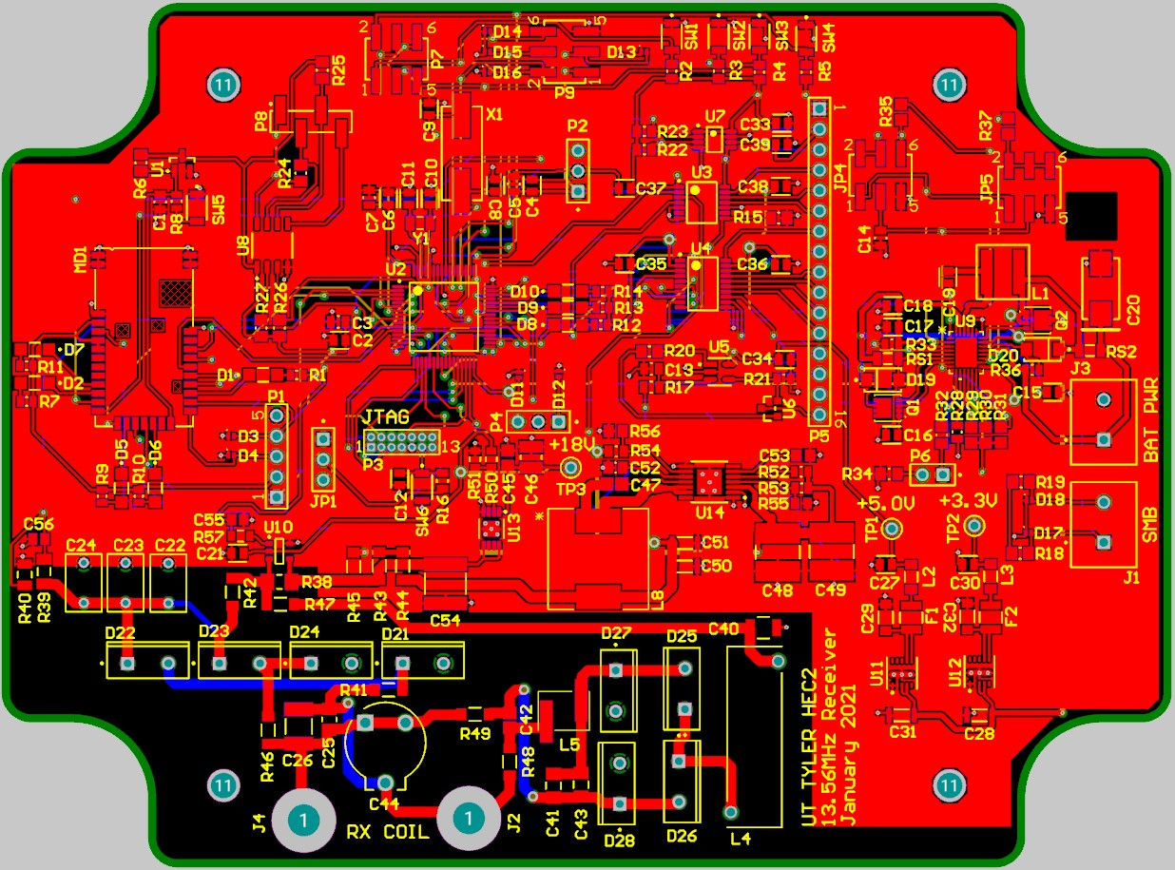

Figure 27: Reference Layout for Part and Pin Numbers

1. *Transmitter Firmware Tests*

The first recommendation in any trouble rise of troubleshooting of quality assurance is to check the mcu setup.c and mcu setup.h files. Additionally, it is good to note that a unit test is a type of software test that only requires building a small portion of the codebase in order to test a set of specific modules. Unit testing reduces the total amount of time dedicated into the development of any software.

*The MCU Clock On LED* (MCU Clock on or D8 by the microcontroller) should be blink- ing at a rate of approximately twice every second **(This rate is subject to change)**. If this is not occurring, the clock interrupt routine is not operating properly. Investigate for over-polling at the UART RX Pins (P2.0 and P2.5) is occurring. Alternatively, the TX Pins could be written out of turn (P2.1 and P2.6) which would thus initiate the UART Interrupts EUSCI A0 VECTOR (located at P2.0 and P2.1) or EUSCI A1 VECTOR (lo- cated at P2.5 and P2.6). If this is not the case, the next step would be to troubleshoot the ADC (Analog to Digital Converter) Pins (P3.0, P3.1, P3.2, and P3.3). If this issue where the ADC12 B VECTOR interrupt contravenes the clock interrupt is detected, the error is likely caused by a breakdown in the hierarchy of interrupts. In such a case, the code must be provided additional logic on how to handle specific interrupts in the scheduler’s run method.

*The LCD Ticker Panel* should display some coherent statement or acronym. If it does not, running of a “Hello World” unit test to the LCD is required for appropriate trou- bleshooting. The unit test should utilize the identical function used in the production code. If the unit test passes without errors, the error would reside in the accumulation of text that is meant to be passed into the LCD Ticker Panel. The LCD backlight control may be tested by enabling the BT PWM1 at a 50% duty cycle sending [,1,1,0020,0010 over the Bluetooth UART interface.

*The UART (RX/TX) CON* tests require unit tests. There are four unit tests to be done to test the non-Bluetooth UART ports (P2.5 and P2.6). The first involves transmitting a ‘A’ character to the same PCB’s RX CON Pin (P2.5). The next unit test would involve transmitting a string and acknowledgement TCP handshake. These same unit tests are repeated with a secondary PCB.

*The Bluetooth* validation tests will involve a unit test from the personal computer that connects to the receiver and sweeps through a set of pre-programmed unit tests that provide specific responses and sample data points.

*The Wireless Power Transmission (WPT) Signal Generation* test should be conducted prior to connecting the transmitter’s WPT coil. Press Button 0 at SW1 to turn on the signal generator and measure the voltage at the transmitter WPT Coil Junction points (J3 with J4 as well as J5 with J6). Once the voltage is observed, press Button 1 at SW2 to turn off the signal generator, and a drop off of voltage should be observed. **(NOTE: The button closest to the microcontroller is Button 0 while the button furthest from the microcontroller and closest to the pins of Part P5 is Button 4. The buttons are arranged in sequential order.)**

RECEIVER TESTS

1. *Receiver Power Supply Tests*

The receiver prototype board testing starts by applying DC voltage across coil terminals for power supply verification at the Receiver Coil Junction Points (J2 and J4). The Coil terminal subcircuit is shown in the figure below.

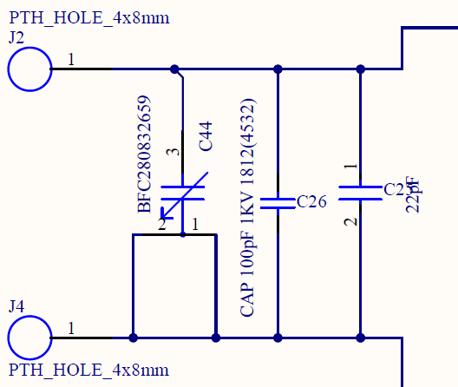

Figure 28: Receiver Coil Terminal Subcircuit

This test is necessary for determining whether the voltage regulators output voltages are matching the design specification.

The following voltage regulators are verified in this test: 3.3V regulator (U12) test point TP2 nominal voltage 3.3V tolerance +/- 1.5%

*·*

* + 5V regulator (U11) test point TP1 nominal voltage 5V tolerance +/- 1.5%
  + 18V regulator (U13A) test point TP3 nominal voltage 18V tolerance +/- 2%

After power module verification the test firmware can be loaded using a JTAG connection on the board. The firmware sets all parameters in the default state for testing.

1. *Receiver Wireless Power Rectifier Tests*

Specification for AC-DC (RF-DC) conversion efficiency is 80%

Conversion efficiency is tested using resistive load and without any other circuit attached to the DC side of the converter (R43 is removed). The load voltage and current are continuously measured. The specified receiver coil distance from the charger coil is 5 cm max.

*Efficiency Test Protocol*

This test is determines the efficiency of the power transfer at various distances:

* + The transmitter RF output is set to output 30W.
  + The receiver coil is placed at a 5 cm distance from the transmitter
  + Current and load voltage are recorded

Previous steps are performed for distances 4 cm, 3 cm 2 cm, and 1 cm. Using collected information load power is calculated. Efficiency is calculated using the following equation:

*Preceiver*

*·P*

*η* = 100% (3)

*transmitter*

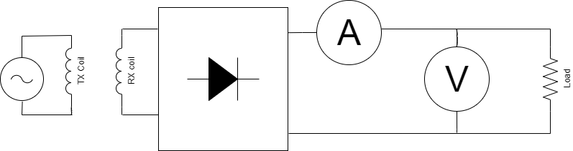

Figure 29: Receiver RF-DC Converter Efficiency Test Setup

1. *Receiver Battery Charger Tests*

The bench power supply current should initially be llimited to 1A and the initial voltage should be set to 20V. There are two diode voltage drops (1.4V) in the full wave rectifier bridge circuit. 18.6V on charger input is high enough for the proper operating voltage for the LTC4162-L battery charger. The charger is functional without the battery pack and according to the datasheet, the voltage on the charger output will rise to the programmed constant-voltage value. By measuring this voltage it is possible to determine whether the charger regulates the proper voltage for a given programmed value.

A 18650 battery with two cells in series discharged to 3.2-3.8V per cell may be used for constant current and constant voltage charge testing. The bench power supply should be connected followed by the battery and no change in MCU behavior should be noted. Constant current charging should begin. The current limit of the bench power supply may be increased and the charging current should increase up to a maximum of 3.2A. The maximum charging current, charging voltage, cell count, and power supply current and voltage should be recorded and efficiency calculated.

Then the power supply should be disconnected and reconnected and there should be no effect on the MCU power state. Charging should automatically resume when the power supply is reconnected. The battery should be allowed to charge until it enters constant voltage mode, which may be recognized by a slowly decreasing charge current that is much lower than the maximum current observed during constant current charging. A 2 ohm load should be connected to the battery under charge for at least 30 seconds and removed without any effect on MCU operation.

1. *Receiver Firmware Tests*

The first recommendation in any trouble rise of troubleshooting of quality assurance is to check the mcu setup.c and mcu setup.h files. Additionally, it is good to note that a unit test is a type of software test that only requires building a small portion of the codebase in order to test a set of specific modules. Unit testing reduces the total amount of time dedicated into the development of any software.

*The MCU Clock On LED* (MCU Clock on or D8 by the microcontroller) should be blink- ing at a rate of approximately twice every second **(This rate is subject to change)**. If this is not occurring, the clock interrupt routine is not operating properly. Investigate for over-polling at the UART RX Pins (P2.0 and P2.5) is occurring. Alternatively, the TX Pins could be written out of turn (P2.1 and P2.6) which would thus initiate the UART Interrupts EUSCI A0 VECTOR (located at P2.0 and P2.1) or EUSCI A1 VECTOR (lo- cated at P2.5 and P2.6). If this is not the case, the next step would be to troubleshoot the ADC (Analog to Digital Converter) Pins (P3.0, P3.1, P3.2, and P3.3). If this issue where the ADC12 B VECTOR interrupt contravenes the clock interrupt is detected, the error is likely caused by a breakdown in the hierarchy of interrupts. In such a case, the code must be provided additional logic on how to handle specific interrupts in the scheduler’s run method.

*The LCD Ticker Panel* should display some coherent statement or acronym. If it does not, running of a “Hello World” unit test to the LCD is required for appropriate trou- bleshooting. The unit test should utilize the identical function used in the production code. If the unit test passes without errors, the error would reside in the accumulation of text that is meant to be passed into the LCD Ticker Panel. The LCD backlight control may be tested by enabling the BT PWM1 at a 50% duty cycle sending [,1,1,0020,0010 over the Bluetooth UART interface.

*The UART (RX/TX) CON* tests require unit tests. There are four unit tests to be done to test the non-Bluetooth UART ports (P2.5 and P2.6). The first involves transmitting a ‘A’ character to the same PCB’s RX CON Pin (P2.5). The next unit test would involve transmitting a string and acknowledgement TCP handshake. These same unit tests are repeated with a secondary PCB.

*The SMbus interface* tests will consist of querying the LTC4162 CHEM_CELLS_REG register. Bits [11:8] should be 1001 to correspond to LTC4162_SAD and bits [3:0] should correspond to 0010 for the 2-cell test battery configuration. The smart battery interface may be unit tested with a SMBus-USB interface if the smart battery is not yet available.

*The Bluetooth* validation tests will involve a unit test from the personal computer that connects to the receiver and sweeps through a set of pre-programmed unit tests that provide specific responses and sample data points. The Bluetooth tests for the receiver should also include data requests pertaining to the voltage from the battery, the battery’s current charge, and any data utilized in the battery charger.

SYSTEM TESTS

1. *Coil Test*

Coil impedance is measured using Vector Network Analyzer (VNA). The impedance mea- surement is obtained by setting the instrument to measure S-parameters (S11) at 13.56 MHz. Before measurements, the instrument must be calibrated using calibration stan- dards (short circuit, open circuit, and 50*ω* load). The measured impedance is in complex form R+jX form.

Specified inductance: 909.66nH

The coil’s inductance is determined using the formula below:

*L* = *XL*

*ω*

(4)

Where *ω* = 2*π*f

The figure below shows the the equivalent circuit of how the transmitter / receiver coils were evaluated using a Vector Network Analyzer.

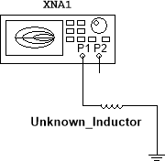

Figure 30: VNA Test Setup

Although VNA is not very precise for quality factor measurements it still can be used for estimation. The quality factor is determined by obtaining S21 parameter (forward voltage gain).

Specified Q factor: 1119

The quality factor also can be determined by dividing reactance by the resistance the

formula is shown below:

1. *System Level Firmware Tests*

*Q* = *XL*

*R*

(5)

*The Bluetooth Localization Test* utilizes the “M” command on the RN4870 BLE chip with 3 prior locations to triangulate which direction is moving towards the transmitter. This test begins with a computer provided unit test that accepts four distances, the first three that are used to triangulate the receiver in reference to the transmitter and a fourth that must be closer than all three triangulating distances to be considered passing.

1. *Test Results Summary*

*1.) Transmitter Evaluations*

*DC Power Test*

30V regulator no-load condition measured output voltage 30.04 V 5V regulator measured output voltage TP3 5.03V

3.3V regulator measured output voltage TP2 3.33V

*Coil Driver Test*

Oscillator output voltage TP4 3.69V*pp*

Oscillator output Frequency (13.56 MHz) measured: 13.56MHz

Class E amplifier driver voltage jumper R32 (nominal 5Vpp) measured 5.80Vpp

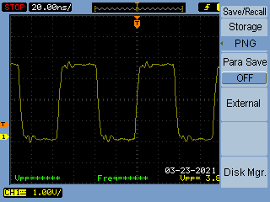

Figure 31: Class E Amplifier Driver Output

Q1 Dran nom. 117 V*pp* (30 V supply) Measured 102V*pp*

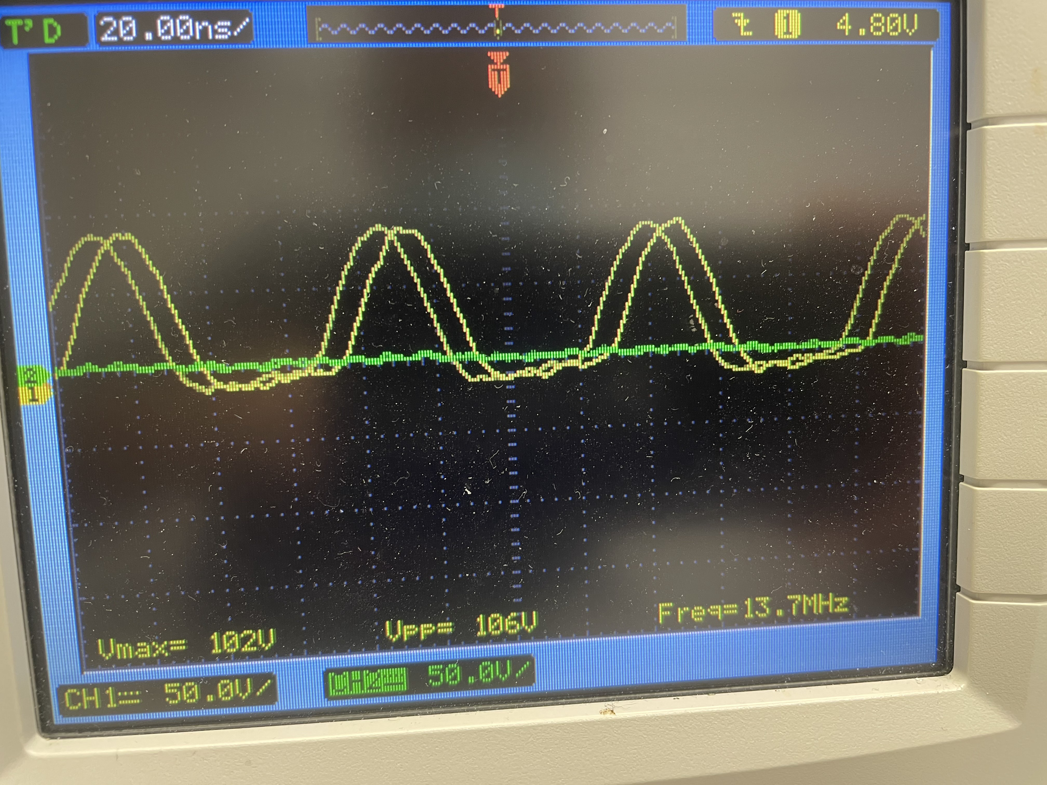

Figure 32: Q1 Drain Voltage Waveform Transmitter coil voltage 117 V*pp* (30 V supply) Measured 204V*pp*

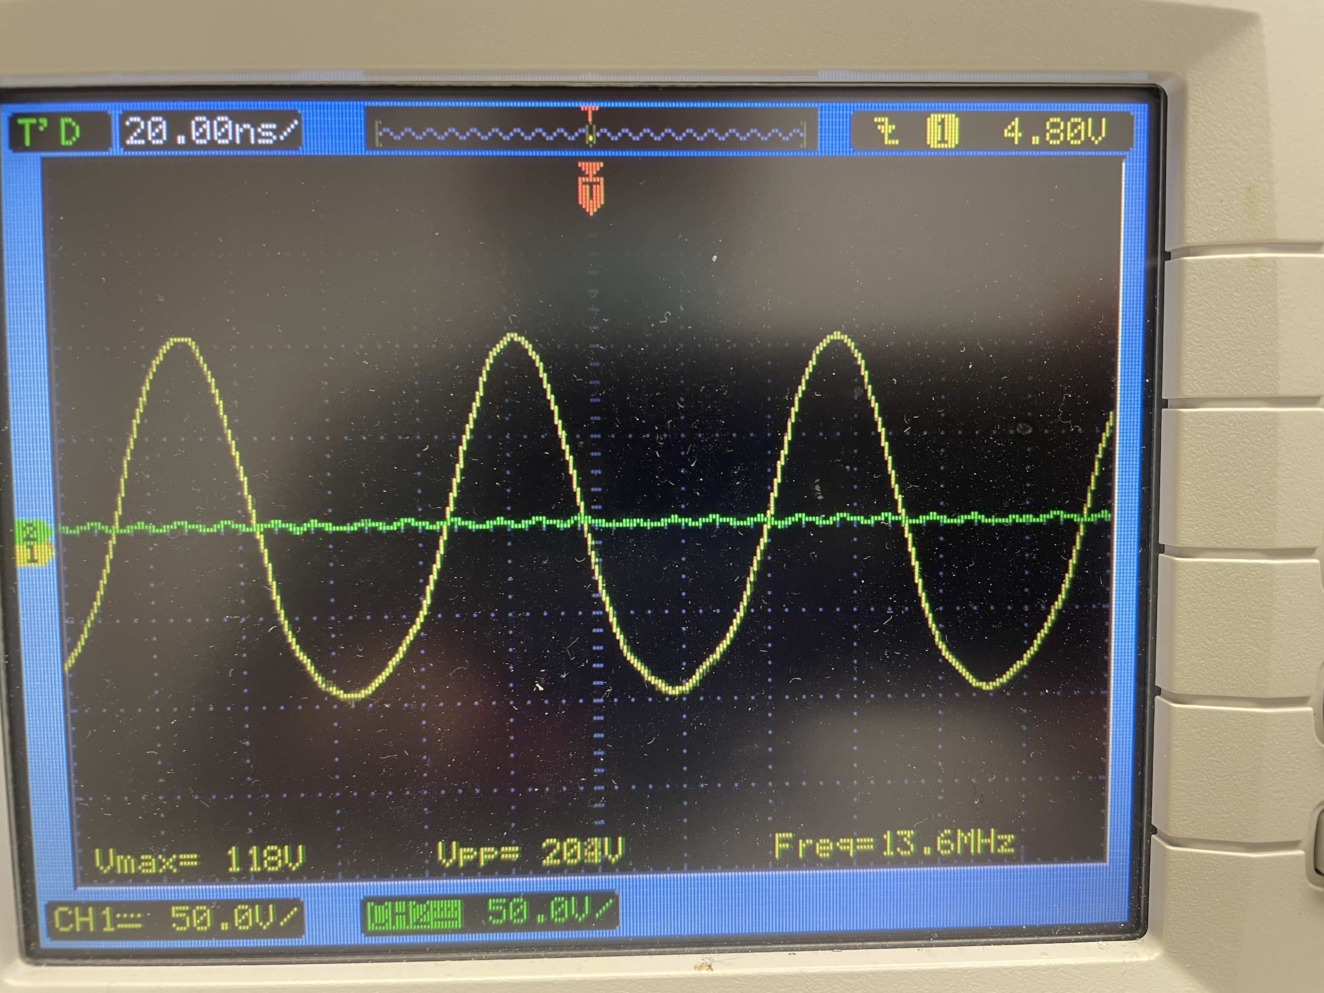Figure 33: Q1 Drain Voltage Waveform

Transmitter subsystem input current at 30V supply (120 mA nom. no laod) Measured 140 mA

Table 20: Transmitted Power vs. Distance Test

|  |  |  |
| --- | --- | --- |
| Distance [cm] | Measured Voltage [V*pp*] | Received Power [W] |
| 5 |  |  |
| 4 |  |  |
| 3 |  |  |
| 2 |  |  |
| 1 |  |  |

*2.) Receiver Evaluations*

*DC Power Test*

5V regulator measured output voltage TP1 5.07V 3.3V regulator measured output voltage TP2 3.33V 18V regulator measured output voltage TP3 18.26V

Table 21: Received Power (DC) vs Distance Test

|  |  |  |  |
| --- | --- | --- | --- |
| Distance [cm] | Measured Voltage [V] | Measured Current [A] | Power Received [W] |
| 5 |  |  |  |
| 4 |  |  |  |
| 3 |  |  |  |
| 2 |  |  |  |
| 1 |  |  |  |

*Coil Design Verification Test*

Specified inductance: 909.66nH

Measured impedance at 13.56MHz: 0.43 +j78.28Ω

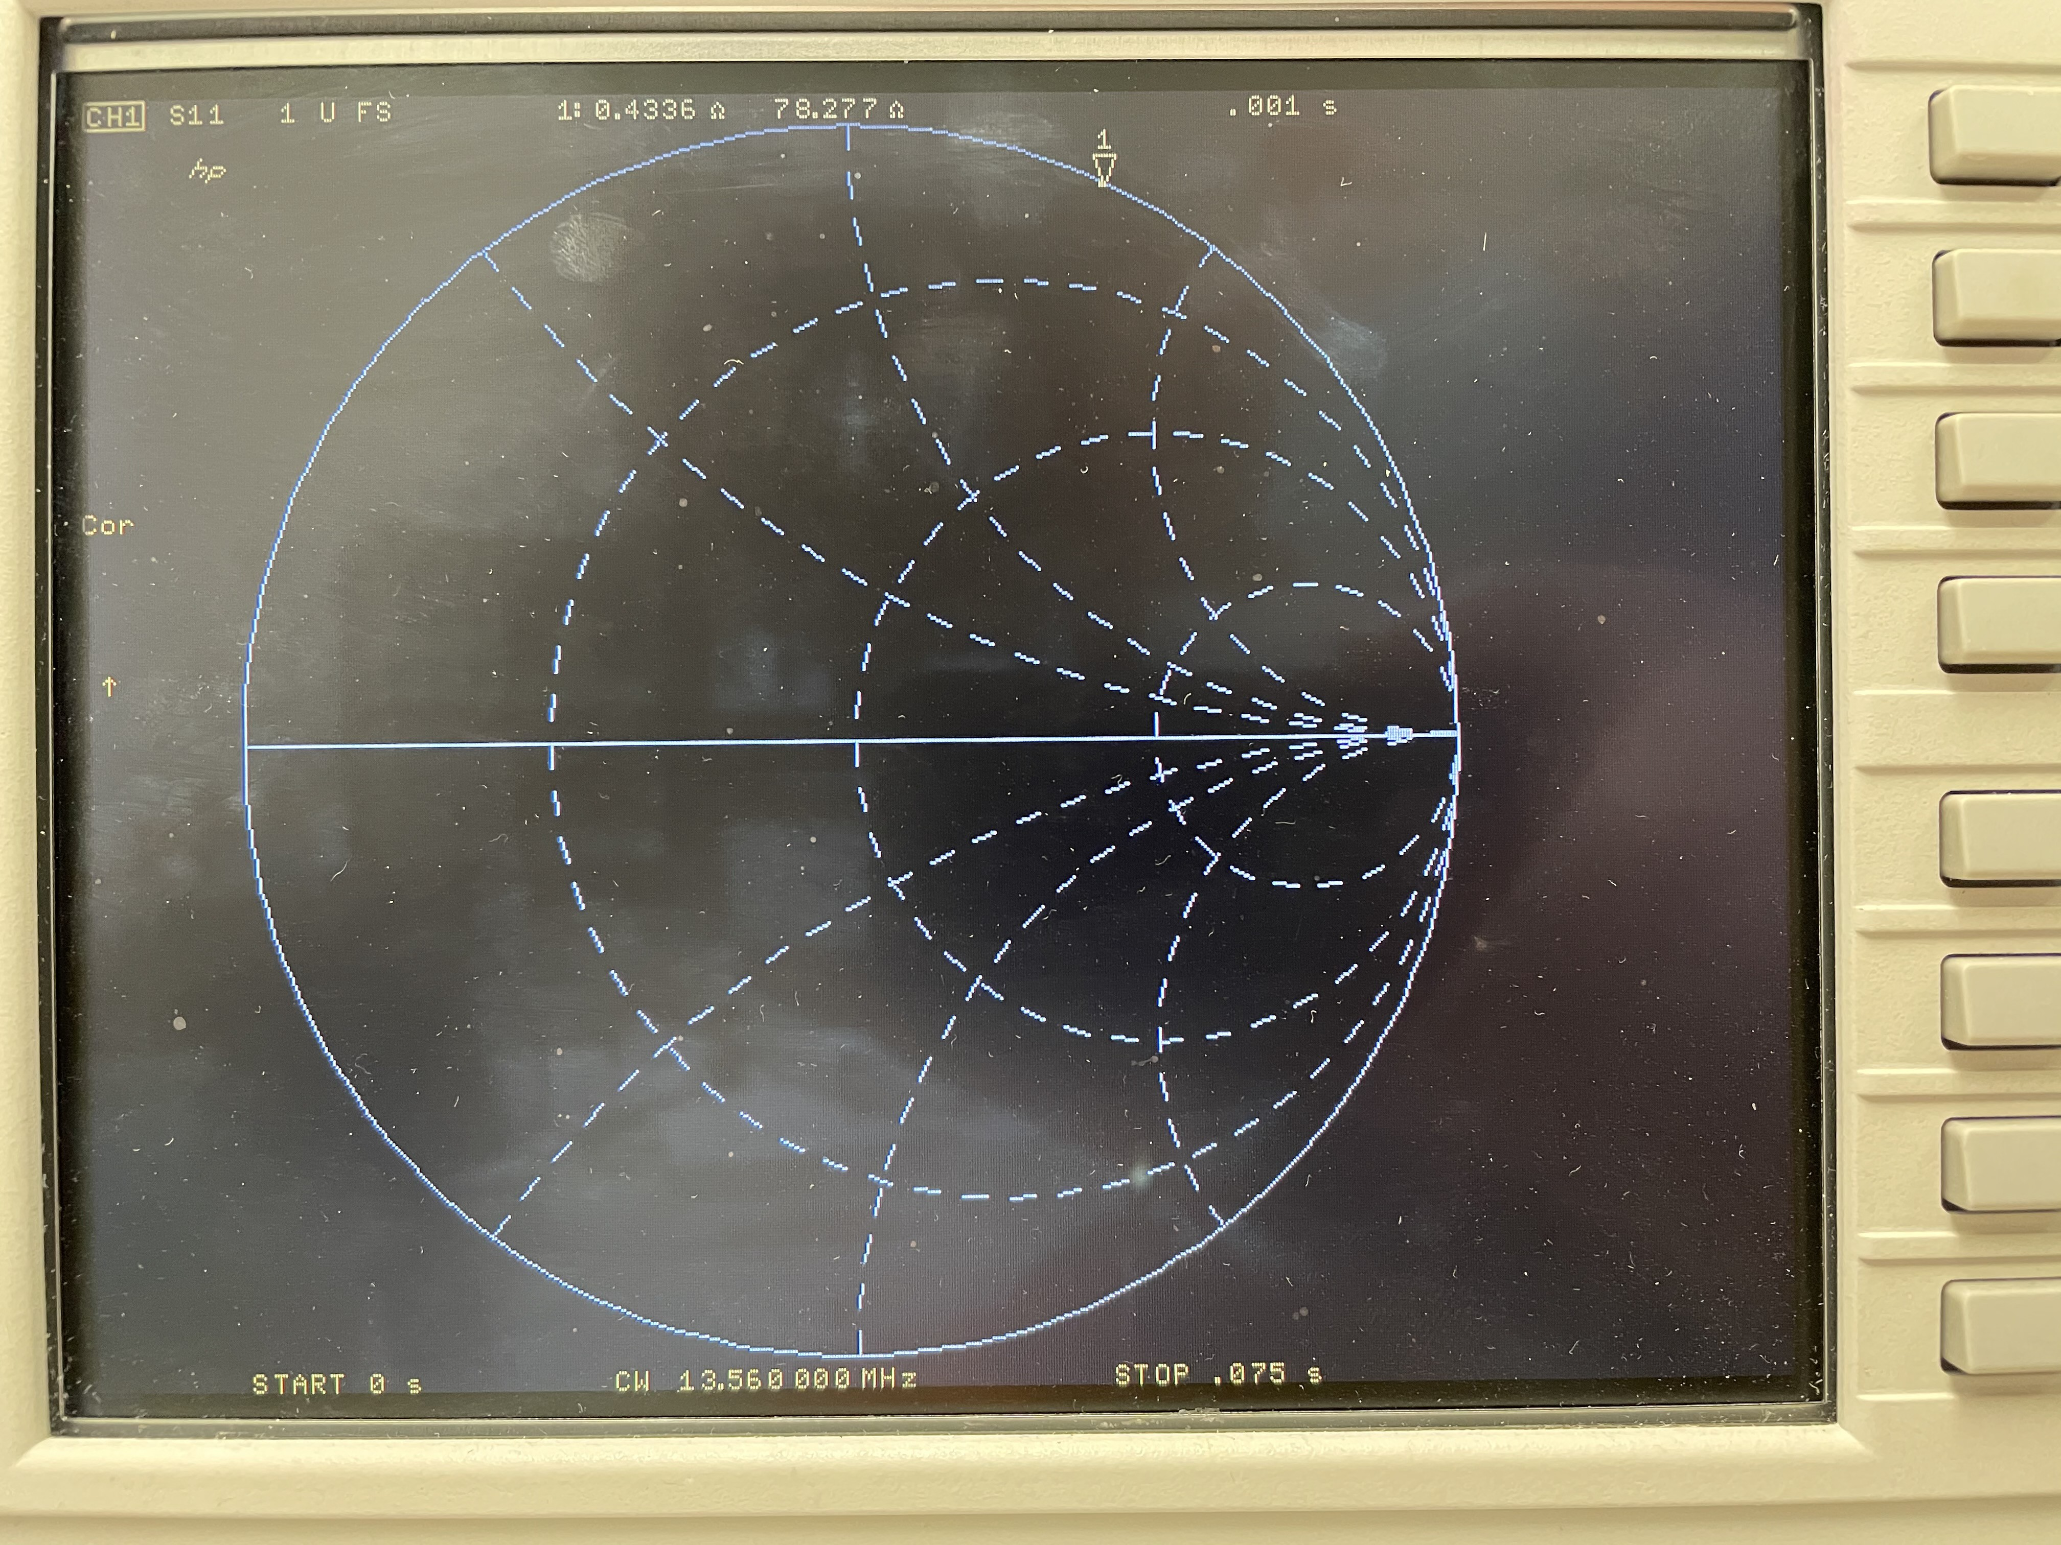

Figure 34: VNA TX/RX Coil Impedance Measurement

Measured inductance using VNA (HP8753E) 0.917 *µ*H Measured inductance using LCR meter (HP4262A) 0.97*µ*H Q factor from VNA impedance measurement: 182

* 1. BROADER IMPACTS OF THE PROJECT

This product follows FDA, IEE, and government safety regulations. A few ethical issues faced by our design include high voltages across the coil, excessive heat generation within the receiver, and electromagnetic field interference. During simulation stages, high volt- ages were observed across the coil which increases the risk of electric shock hazard. In order to lower this risk, the coil insulation will adhere to a wider voltage range. Within the receiver, excessive heat generation along high current levels can cause damage to batteries. Therefore, lower charging currents will be used in order to prevent damage. Excessive heat also increases the cost of the project as fans would need to be added. Electromagnetic field interference caused by the transmitter coil can disrupt the charg- ing circuit and cause battery failure. To prevent this issue, additional shielding will be implemented.

During testing stages, minor ethical issues were faced by the design. Within the re- ceiver board, there was an inductor that was not suited for a frequency of 13.56 MHz board causing failure, and our rectifier circuits caused more loading than expected when tested with a signal generator. Also, the 48V to 30V buck stage microcontroller failed during testing for reasons that are yet to be further investigated by the team. When components get too hot, there’s not only a risk of it failing, but also of leaking its chemi- cals which can be dangerous to human skin and eyes. Therefore, the group will adhere to safety procedures such as wearing Personal Protective Equipment (PPE). Another risk observed here is electrical shock hazard due to the overloading in the circuit. To prevent this, the group will continuously measure the circuit for abnormal values while testing.

Our project’s goal is to provide users a low-cost medium-power wireless charger. There are no products like this one in the market for a few reasons: chargers do not supply more than 5W via inductive charging, an existing industrial unit with same purposes as our product is priced at about $2000 USD, and available wireless chargers are limited for charging a single type of device only. With our product, users will be able to charge a standard battery type and integrate it in their own design or use it for stand-alone operations. Our product communicates electronic circuits, electromagnetic fields, digital systems, and microprocessors concepts to the audience. This product will not only be a low-cost wireless charger option, it will also provide customers with a charger for mobile devices of all shapes and sizes, no wiring exposure, apply greater range of tolerance for misalignment when charging, and provide a compact charging area.

Our product will be useful to robotics hobbyists and inventors who are developing new products that require wireless charging, serve to influence kids and teenagers interested in STEM, can be used for research and development, and capitalized in OEM market.

Ethical and Professional Considerations

|  |  |
| --- | --- |
| Public Health | * Medical Equipment RF Exposure * Electrical Shock * Chemical Exposure |
| Safety and Wellness | * RF Bandwidth Jamming * Electrical Shock * Chemical Exposure |
| Global Factors | * International Governing Bodies * Sourcing Restrictions * Inter-Market Penetrability |
| Societal Factors | * Open-Source Capitalization * STEM Educational Resources * Professional Organizations * Customer Privacy & Security |
| Environmental Factors | * Chemical Pollution * User Environmental Awareness * Emergency Shut Off Cases |
| Economic Factors | * Open-Source Capitalization * Specialty Clientele * Rapid Agile-Deployment * Light-Weight Production |

* 1. CONCLUSION

This conclusion reflects the current state of our testing and troubleshooting process. We expect to continue testing our prototype and resolving issues in order to bring perfor- mance as close as possible to our initial specifications.

The 5V LCD contrast control circuit on both boards failed due to a design error: the digital potentiometer chosen was not capable of controlling a voltage greater than the 3.3V digital supply voltage. The 5V supplied to the potentiometer simply fed into the 3.3V supply through the protection diodes until the circuit was disabled.

The 48V to 30V buck stage control IC on the transmitter board self-destructed for as-yet unknown reasons. No obvious design errors were found. Further diagnosis was postponed pending testing of the remainder of the board using a bench power supply.

Initial tests of the battery charging circuit were successful. A test battery of two fully charged 18650 cells was correctly detected and not charged further. After partial discharge the charger entered a constant-voltage charging mode and charged the battery at a slowly decreasing current of approximately 1A. The receiver board continued to op- erate on battery power when simulated wireless power was removed. Further testing of constant current charging, telemetry, and the SMbus smart battery interface is pending.

Initial testing of the wireless power transfer resulted in a period of successful inductive power transfer and a brief success in achieving a resonant link. A failure on the trans- mitter board was traced to an inductor that was not suitable for operation at 13.56 Mhz. The inductor and damaged components were replaced and testing continued. A resonant link was achieved between the transmitter and receiver, but an unexpected transient de- stroyed the transmitter amplifier transistor. A more robust replacement will be installed for further testing.

In summation, our testing revealed a few avoidable design errors which can be cor- rected or managed until a major revision is possible. The greatest challenge our test- ing has revealed is controlling the high voltages and unexpected transients that even a moderate-power resonant link creates. We hope that the use of more robust components will make it possible to continue testing and characterizing the real-world performance of our wireless power circuit. A further challenge is minimizing the losses from the high- frequency rectification stage. Our initial tests indicate that switching losses in the full wave bridge rectifier are significant. As suggested by our faculty advisor, it is possible that half-wave rectification will prove more efficient than a full-wave bridge.

With the benefit of foresight, we would have made a few minor and one major change in our design process. The wireless power transfer circuit is the most original component of our design and ideally would have been prototyped and tested much earlier in the design process. More minor changes would include accepting the more limited selection of 3.3V LCD’s and deleting the 5V rail and support circuitry. The 48V transmitter power supply and buck stage was chosen to minimize current and provide headroom for adjustments to the wireless transmitter voltage, but further testing may prove that a 30V supply with no further conversion is sufficient.

* 1. REFERENCES SOFTWARE REFERENCES

Block diagrams were rendered in Windows Visio Standard 2019. Multisim circuits simulated in NI Multisim V.14.2 2019.

PCB Schematics rendered in Altium-365. CAD Drawings rendered in NanoCAD.

DESIGN REFERENCES

1. “Standard High Power System”. In: *WIBOTIC Products* (2021). url: [https:// www.wibotic.com/products/high-power-dev-kit/](https://www.wibotic.com/products/high-power-dev-kit/).
2. “Anatomy of a Create 2”. In: *iRobot Education: Create 2: Create* *| Advanced* (2021).
3. “MSP430FR599x, MSP430FR596x Mixed-Signal Microcontrollers”. In: *Texas In- struments Inc. SLASE54C - MARCH 2016 - REVISED AUGUST 2018* (2018), pp. 1–172. url: [https://www.ti.com/lit/ds/symlink/msp430fr5994.pdf?ts= 1604041478538 &ref url=https %253A %252F %252Fwww.ti.com %252Fproduct](https://www.ti.com/lit/ds/symlink/msp430fr5994.pdf?ts=1604041478538\&ref_url=https\%253A\%252F\%252Fwww.ti.com\%252Fproduct\%252FMSP430FR5994)

[*\ \ \ \ \ \ *](https://www.ti.com/lit/ds/symlink/msp430fr5994.pdf?ts=1604041478538\&ref_url=https\%253A\%252F\%252Fwww.ti.com\%252Fproduct\%252FMSP430FR5994)

[%252FMSP430FR5994](https://www.ti.com/lit/ds/symlink/msp430fr5994.pdf?ts=1604041478538\&ref_url=https\%253A\%252F\%252Fwww.ti.com\%252Fproduct\%252FMSP430FR5994).

1. *Texas Instruments MSP430FR5994 Tool Description*. url: [https://www.ti.com/ tool/MSP-EXP430FR5994](https://www.ti.com/tool/MSP-EXP430FR5994).
2. “TPSM265R1 65-V Input, 100-mA Power Module with Ultra-Low IQ”. In: *Texas Instruments Inc. SNVSBF6A - OCTOBER 2019 - REVISED DECEMBER 2019* (2019), pp. 1–32. url: [https://www.ti.com/lit/ds/symlink/tpsm265r1.pdf?ts= 1606735419804&ref url=https*\*%253A*\*%252F*\*%252Fduckduckgo.com*\*%252F](https://www.ti.com/lit/ds/symlink/tpsm265r1.pdf?ts=1606735419804&ref_url=https\%253A\%252F\%252Fduckduckgo.com\%252F).
3. “TPS54160 1.5-A, 60-V, Step-Down DC/DC Converter with Eco-mode”. In: *Texas Instruments Inc. SLVSB56C - MAY 2012 - REVISED FEBRUARY 2014* (2014), pp. 1–58. url: <https://www.ti.com/lit/ds/symlink/tps54160.pdf>.
4. *Conductor Bulk Resistivity & Skin Depths*. RF Cafe. url: [https://www.rfcafe. com/references/electrical/cond-high-freq.htm](https://www.rfcafe.com/references/electrical/cond-high-freq.htm).

APPENDIX A: CODES, STANDARDS, AND CONSTRAINTS

Table 22: Relevant Codes and Standards

|  |  |
| --- | --- |
| Organization | Engineering Standards |
| IEEE | IEEE C95.1-2005  This standard defines exposure limits to the electromagnetic field This standard is adopted in many safety standards.  IEEE 1625-2008  Standard for rechargeable batteries for multicell mobile computing devices.  IEEE 802.15.1 Bluetooth standard |
| Government | FCC Part 15, FCC part 18  RF Power levels and communication links are defined by FCC Part 15 and Part 18.  The RF transmitter power level limits in the US are much higher than in some other countries.  FDA: 21 CFR 1000.15 FCC: KDB 680106 D01  Both standards define exposure limits to electromagnetic fields. The limits will be satisfied if the transmitter power is limited to 5W. Higher power levels are allowed if proper safety measures are implemented. |
| International | EN 55011:2016  This standard defines limits for unwanted emissions in the RF spectrum above 30MHz.  The proposed WPT charger system must follow limitations for unwanted emissions. |

APPENDIX B: USER’S MANUAL AND INSTRUCTIONS

*<*The User’s Manual is not written currently*>*

APPENDIX C: COURSEWORK RELATED KNOWLEDGE AND SKILLS

Table 23: Coursework Related Knowledge and Skills Table

|  |  |
| --- | --- |
| **Courses** | **Knowledge / Skills** |
| EENG 3106 - Circuit Analysis I  Lab | Laboratory Technique |
| EENG 3305 - Linear Circuits  Analysis II | Circuit Analysis (RLC Circuits) |
| EENG 4109 - Electronic Circuit  Analysis II Lab | Laboratory Technique |
| EENG 4309 - Electronic Circuit  Analysis II | Amplifier Design  Electronic circuit-analysis (amplifiers and rectifier circuits) |
| EENG 3303 - Electromagnetic  Fields | Electromagnetic Theory  Inductor parameters (inductance and resis- tance calculations based on shape and wire cross-section area and length. |
| EENG 3302 - Digital Systems | Digital Troubleshooting |
| EENG 3307 - Microprocessors | Microcontroller Programming |
| EENG 4350 - Advanced  Microprocessors | Microcontroller Programming |

APPENDIX D: RECEIVER PCB SCHEMATICS

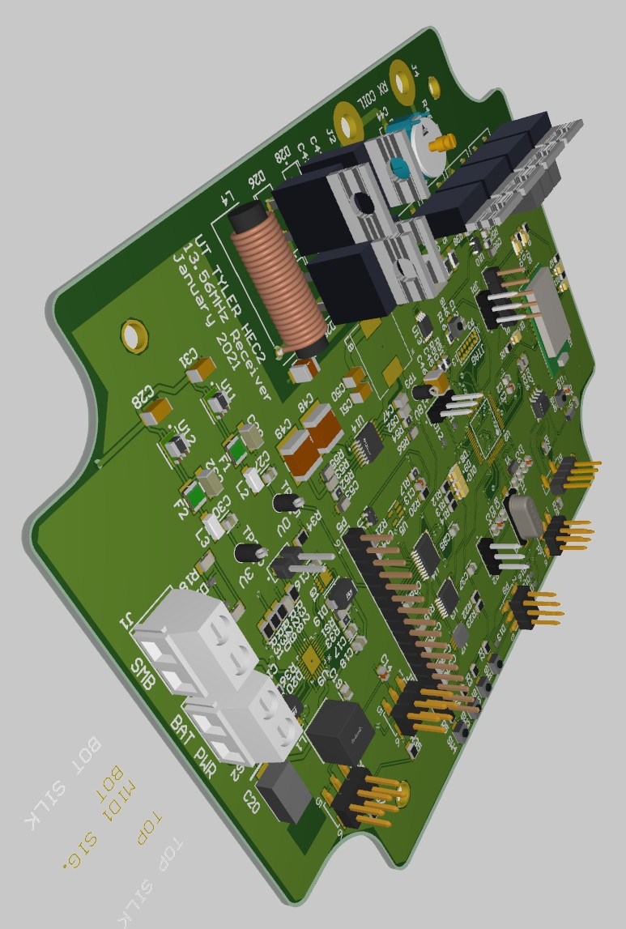

Figure 35: Isometric Image of Receiver PCB

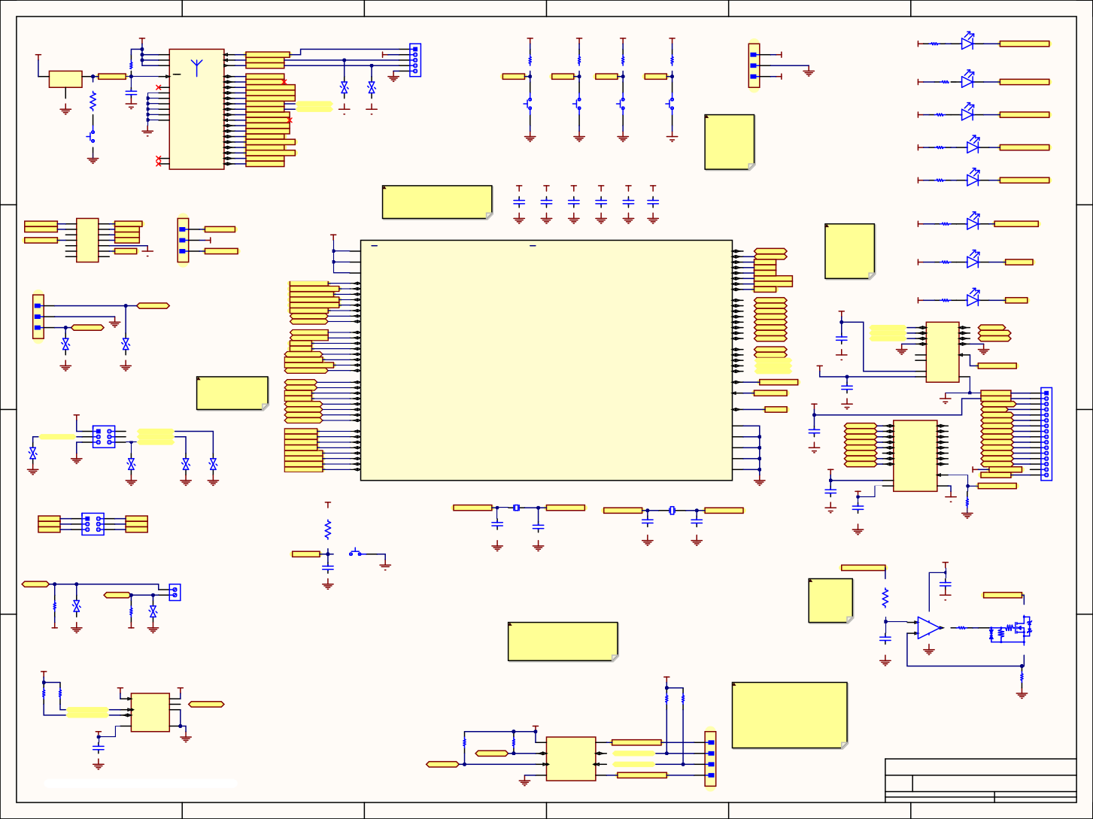

1

6

D1

VCC_3.3V

VCC_3.3V

VCC_3.3V

VCC_3.3V

VCC_3.3V

P1 P2

VCC_3.3V

MD1

4 VBAT 6

P2_0/MODE 18

22

MCP111T-240E/TT U1

3 VDD OUT 1 VSS

R6 4.7K

VDD_IO

7

VDD_IO

UART_RX

23

UART_TX

BT_RST

21 RST

P0_0/CTS 15

30

BT_MODE_IN RX_BT_IN TX_BT_OUT

BT_CTS_IN BT_LED0

BT_Low_Bat_OUT BT_Status_2_OUT

BT_Status_1_OUT BT_SCL SCL_LCD_BL

VCC_3.3V

1

2

3

4

5

R1

VCC_3.3V

470

R2

10k

R3

10k

R4

10k

R5

10k

1 1

2 2

VCC_3.3V

2 1

HSMS-C150

BT_RSSI_OUT

D2

3 3

61300511121

VCC_5V

GND

20

NC

A

R8 20

C1

1uF

GND

1. GND
2. GND
3. GND
4. GND
5. GND
6. GND

P0_7

P1_0 16

P1_1 12

P1_2/SCL 13

P1_3/SDA 14

P2_2 5

P2_3 9

19

P0_2

29

D4 D3 GND

VCC_3.3V

22-28-4030

R7

470

SW1

B3U-1000P

SW2

B3U-1000P

SW3

B3U-1000P

SW4

B3U-1000P

2 1

HSMS-C150 D5

A

GND

BT_SDA SDA_LCD_BL BT_PWM1_OUT

GND

VCC_3.3V

R9

470

2 1

SW5

B3U-1000P

P2_4

11

GND

P2_7/TX_IND

P3_1 24

P3_2 25

P3_3 26

P3_4 27

P3_5 28

P3_6/RTS 17

BT_PWM2_OUT

RF_Active_OUT BT_TX_Ind_OUT BT_RSSI_OUT

BT_Link_Drop_IN BT_LP_IN

BT_Pairing_IN BT_P3_5 BT_RTS_OUT

GND

GND

GND

GND

GND

Resistors for the buttons and LED's can probably be replaced with arrays. Will make revisions.

HSMS-C150

D6

VCC_3.3V

R10

470

2 1

GND

8 ULPC_O

10 BK_O

RN4870

HSMS-C150

D7

VCC_3.3V VCC_3.3V VCC_3.3V VCC_3.3V VCC_3.3V VCC_3.3V

VCC_3.3V

R11

470

2 1

HSMS-C150

BT_TX_Ind_OUT

Franci: Except for P4 (parallel LCD), most pin assignments may be changed as needed for routing provided that peripheral support is available.

C2 0.1uF

C3

1uF

C4 0.1uF

C5

1uF

C6 C7

0.1uF 1uF

D8

VCC_Tool VCC_Target

TST/VPP

P3

2 1

4 3

6 5

8 7

10 9

12 11

14 13

MHDR2X7

JP1

TDO/TDI TDI

TMS TCK

~RST GND

1 1

VCC_3.3V

VCC_Tool

GND

GND

GND

GND GND GND

2

VCC_3.3V

R12 2 1

470

HSMS-C150

MCU_Clock_on

2

U2

3 3

VCC_3.3V

VCC_Target

64

AVCC1

P2.0_TB0.6_UCA0TXD_UCA0SIMO_TB0CLK_ACLK 33 RX_CON

32

22-28-4030

16

P2.2_TB0.2_UCB0CLK 51 B_0

P2.3_T

Selected LED and resistors are arbitrary and can be changed.

(MCU_Clock_on) is an interrupt-driven "hearbeat" to confirm MCU operation.

D9

49

DVCC1

DVCC2

P2.1_TB0.0_UCA0RXD_UCA0SOMI 34 TX_CON

VCC_3.3V

R13 2 1

470

HSMS-C150

LED_0

P2.4_TA1.0_UCA1CLK_A7_C11 28

P2

P4

1 1

2 2

3 3

BT_CTS_IN BT_MODE_IN BT_LP_IN

BT_Pairing_IN BT_Link_Drop_IN BT_P3_5

SDA_Charger SCL_Charger

V_SENSE I_SENSE P3.2

P3.3

~SMBA_OUT BT_RTS_OUT

BT_Low_Bat_OUT MCU_Clock_on

2 P1.0_TA0.1_DMAE0_RTCCLK_A0_C0_VREF-_VeREF-

1

B_2

.5_TB0.0_UCA1TXD_UCA1SIMO 29 BT_IN

A0.0_UCA1STE_A6_C10 52 B_1

RX_

12 P1.2_TA1.1_TA0CLK_COUT_A2_C2

3 P1.1_TA0.2_TA1CLK_COUT_A1_C1_VREF+_VeREF+

P2.6_TB0.1_UCA1RXD_UCA1SOMI 50 TX_BT_OUT

P2.7 B_3

D10

TX_CON

14 P1.4_TB0.1_UCA0STE_A4_C4

13 P1.3_TA1.2_UCB0STE_A3_C3

P4.0_A8 25 P4.0_LCD

24

VCC_3.3V

39 P1.5_TB0.2_UCA0CLK_A5_C5

P4.1_A9 26 P4.1_LCD

VCC_3.3V

R14 2 1

470

HSMS-C150

LED_1

40 P1.6_TB0.3_UCB0SIMO_UCB0SDA_TA0.0

P4.2_A10 27 P4.2_LCD

P1.7_TB0.4_UCB0SOMI_UCB0SCL_TA1.0

RX_CON

P4.4_TB0.5 46 P4.4_LCD

P4.3_A11 45 P4.3_LCD

U3

GND

4

5 P3.0_A12_C12

P4.5 47 P4.5_LCD

2 13

P7.2_LCD_RS 3 A1 B1 12 LCD_RS

22-28-4030 D11

D12

6 P3.1_A13_C13

P4.6 8 P4.6_LCD

C37

P7.3_LCD_RW 4 A2 B2 11 LCD_RW

DESD3V3S1BL-7B DESD3V3S1BL-7B

36 P3.4_TB0.3_SMCLK

35 P3.3_A15_C15

7 P3.2_A14_C14

P7.0_UCB2SIMO_UCB2SDA 10 SDA_Target

P4.7 P4.7_LCD

9

P7.4_LCD_E A3 B3 LCD_E 0.1uF 5 10

A4 B4

37 P3.5_TB0.4_COUT

P7.1_UCB2SOMI_UCB2SCL 21 SCL_Target

P7.2_UCB2CLK 22 P7.2_LCD_RS

VCC_5V GND

GND 9 NC OE

6

8

NC

38 P3.6_TB0.5

GND

LCD_ENABLE

GND

GND

P3.7_TB0.6

P7.3_UCB2STE_TA4.1 23 P7.3_LCD_RW

P7.4 TA4.0_A16 P7.4_LCD_E

14 VCCA

1

7

Franci: If possible, unused pins should have some accessible trace so that jumper wires may be soldered to them if necessary.

VCC_3.3V

UCA2CLK

D13

SPI

SDA_Bat SCL_Bat LED_0 LED_1 UCA2SIMO UCA2SOMI UCA2CLK UCA2STE

TDO/TDI TDI

TMS TCK LXFIN LXFOUT HFXIN HFXOUT

42 P5.1_UCB1SOMI_UCB1SCL

41 P5.0_UCB1SIMO_UCB1SDA

44 P5.3_UCB1STE

43 P5.2_UCB1CLK_TA4CLK

P8.0 11 VCCB GND

TEST_SBWTCK 30

LCD_ENABLE

TST/VPP

C38 0.1uF

TXB0104PWR

P5

53 P5.4_UCA2TXD_UCA2SIMO_TB0OUTH

VCC_5V

54 P5.5_UCA2RXD_UCA2SOMI_ACLK

55 P5.6_UCA2CLK_TA4.0_SMCLK

RST_NMI_SBWTDIO_N 31

~RST

GND

GND

LCD_Vss LCD_Vdd LCD_CCont LCD_RS LCD_RW

P9

56 P5.7_UCA2STE_TA4.1_MCLK

U4

1

20 LCD_E

1

UCA2STE 3

2 UCA2SIMO

AVSS1

63

P4.0_LCD P4.1_LCD

A1

B1

LCD_D0

5

4 UCA2SOMI

17 PJ.0_TDO_TB0OUTH_SMCLK_SRSCG1_C6

6

18 PJ.1_TDI_TCLK_MCLK_SRSCG0_C7

19 PJ.2_TMS_ACLK_SROSCOFF_C8

20 PJ.3_TCK_SRCPUOFF_C9

61 PJ.4_LFXIN

AVSS2 60

AVSS3 57

DVSS1 48

DVSS2 15

C39 0.1uF

3 A2

B2 18 LCD_D1

P4.2_LCD

P4.3_LCD 5 A4

4 A3

B4 16 LCD_D3

B3 17 LCD_D2

GND

P4.4_LCD 6 A5

B5 15 LCD_D4

D14

D15 D16

62 PJ.5_LFXOUT

1

2

3

4

5

6

7

8

9

10

11

12

13

14

GND

58 PJ.6_HFXIN

59 PJ.7_HFXOUT

VCC_3.3V

P4.5_LCD P4.6_LCD P4.7_LCD

7 A6

9 A8

8 A7

B6 14 LCD_D5

B7 13 LCD_D6

B8 12 LCD_D7

VCC_5V

LCD_LED+ 15

GND

OE 10

LCD_LED-

16

MSP430FR5994IPM

19 VCCA

2

11

GND

GND

GND

GND

C35 VCC_5V

0.1uF

VCCB GND

LCD_ENABLE

61301611121

TXB0108PWR

VCC_3.3V

R15

P7

LXFIN

1 2

32.768kHz

C10 12 pF

Y1

LXFOUT

HFXIN

X1

1 2

GND 4.7K

HFXOUT

B_0 B_1 B_2

1

3

5

2

4

6

B_3 P3.2 P3.3

GND

C36 0.1uF

R16 47K

C11 12 pF

C8 8Mhz 39pF

C9 39pF

GND

SPI GND

SW6

1 2

B3U-1000P

C12 2.2nF

GND

GND

~RST

GND

GND

VCC_5V

GND

BT_PWM1_OUT

SDA_Bat

J1

SCL_Bat

1

2

GND

This mosfet has a built in gate resistor and may not need any additional resistance.

R17

30k

C34 0.1uF

GND

LCD_LED-

R18 D17

4.7K DESD3V3S1BL-7B R19 D18

282836-2

4.7K DESD3V3S1BL-7B

VCC 3.3V VCC 3.3V

GND GND

Bidirectional I2C isolator/voltage translator. Our original specs proposed that a target device should be able to query the receiver for charge/battery status and receive instructions to cease/commence charging, etc. Header selections are arbitrary and should be changed to best type/suppliers.

3 +

4 -

U5

MCP6001T-I/OT

1 R20 1

1k

U6 NUD3112LT1G

C13 0.47uF

GND

VCC_3.3V

GND

VCC_3.3V R21

40

VCC_3.3V VCC_5V

R22 R23

10k 10k

U7

1 HVC/A0 P0A 5

P0W 6 LCD_CCont

R24 R25

4.7K 4.7K

To simplify coding, non-critical "amenities" like the LCD contrast control and backlight PWM have been routed to the RN4840 bluetooth controller. They can be set using commands sent to the module.

GND

2

D

SCL_LCD_BL

SDA_LCD_BL

3 SDA

SCL P0B 7

VCC_3.3V

VDD VSS

MCP4531-103E/MS

C33 0.1uF

GND

R26

4.7K

R27

4.7K

VCC_3.3V

U8

1. VCC1
2. SDA1
3. SCL1
4. GND1 ISO1540DR

P8

VCC2 8

VCC_HDR_OUT

SDA_Target

SCL_Target

SDA2 7 SDA_HDR_OUT

SCL2 6 SCL_HDR_OUT

GND

Note: The digital pot MCP4531-103E/MS defaults to mid-position on startup.

GND2 5

GND_HDR_OUT

1 1

2 2

3 3

4 4

The best response seems to be from MOSFETS with a Vgs as low as possible.

They include the DMN61D8LQ SZNUD3112LT1G

SSM3K36

D

8

4

GND TSM-104-01-L-SV-P-TR

1

6

5

4

3

2

Drawn By: D.F./F.F. Verfied By: C.G.

File: C:\Users\..\R_Controller.SchDoc

Sheet2 of 5

Date: 2-21-2021

Revision A

Communication and MCU

Number

Size

C

HEC-2 Receiver

Title

C

C

B

B

5

4

3

2

RF_Active_OUT

BT_Status_2_OUT

BT_Status_1_OUT

B_3

B_2

B_1

B_0

*1.*

*Receiver Controller*

77

1 2

1

2

2

1

2

1

2 1 2

2

1

1

2

1

2

2 1

1

2

1

2

1

2

2

1

1 2

1 2

DESD3V3S1BL-7B

1 2

2 1

2

1

1

2

2 1

2

1

2

1

1

2

2

1

1

2

2

1

2 1

2

1

1

2

2 1

2

1

2 1

2 1

2 1

2 1

2 1 1 2

2 5

2 1

2

3



1

6

Vcc2P5

Vin

VoutA

C14

1 uF

C15 10 uF

C16

0.1 uF

R28 63.4k

C17 0.1uF

A

GND

A

GND

GND

GND

GND

CLP

CLN

NTCBIAS

Q1

R32

10k

Vin

U9

D19

2 1

FDMC8327L

NTC

P6

BOOST

INTVcc VoutA CLN CLP INFET

Vin Vcc2P5 NTCBIAS NTC

RT

1

2

3

4

5

6

7

8

9

10

11

12

13

14

29

28

27

26

25

24

23

22

21

20

19

18

17

16

15

STPS140A R33 10

INFET

1

2

RS1

0.01

Vout

M20-9990246

R34

10k

~SMBA_OUT

SCL_Charger

SDA_Charger

BATFET CSP CSN

BATSENS+ CELLS1 CELLS0

DVCC

C18 10 uF

GND

GND BOOST

LTC4162EUFD-SAD

GND

C19

0.022 uF

J3

BATSENS+

1

2

282836-2

R31 R30 R29

4.7k 4.7k 4.7k

L1

XAL6060-682MEB

GND

Q2

DVCC

VCC_3.3V

FDMC8327L

D20 STPS140A

BATFET

JP4

RS2 0.01

INTVcc Vcc2P5

1

3

5

2

4 1 2

R35

6

R36

100k

CSN

1

2

BATSENS+

61000621121

GND

JP5

1

3

5

10

C20

10 uF

INTVcc Vcc2P5

2

4 1 2

6

R37

100k

GND

61000621121

GND

D

D

1

6

5

4

3

2

Drawn By: D.F./F.F. Verfied By: C.G.

File: C:\Users\..\R_Charger.SchDoc

Sheet 3of 5

Date: 2-21-2021

Revision A

Charger

Number

Size B

HEC-2 Receiver

Title

C

C

B

B

5

4

3

2

CELLS1

CELLS0

Vout

CSP

SW

VoutA

RT

INTVcc

1

2

EP(AGND) VOUT VOUT SW SW PGND PGND

BATFET CSP CSN

BATSENS+ CELLS1 CELLS0 SYNC DVCC

BOOST INTVCC VOUTA CLN CLP INFET VIN VCC2P5

NTCBIAS NTC

RT

*SMBALERT SCL

SDA

Vout Vout SW

*2.*

*Receiver Battery Charger*

78

2

1

1

2

1

2

2

1

2

1

2

1

2

1

2

1

2

1

2

1

1

2

2 1

1

2

2

1

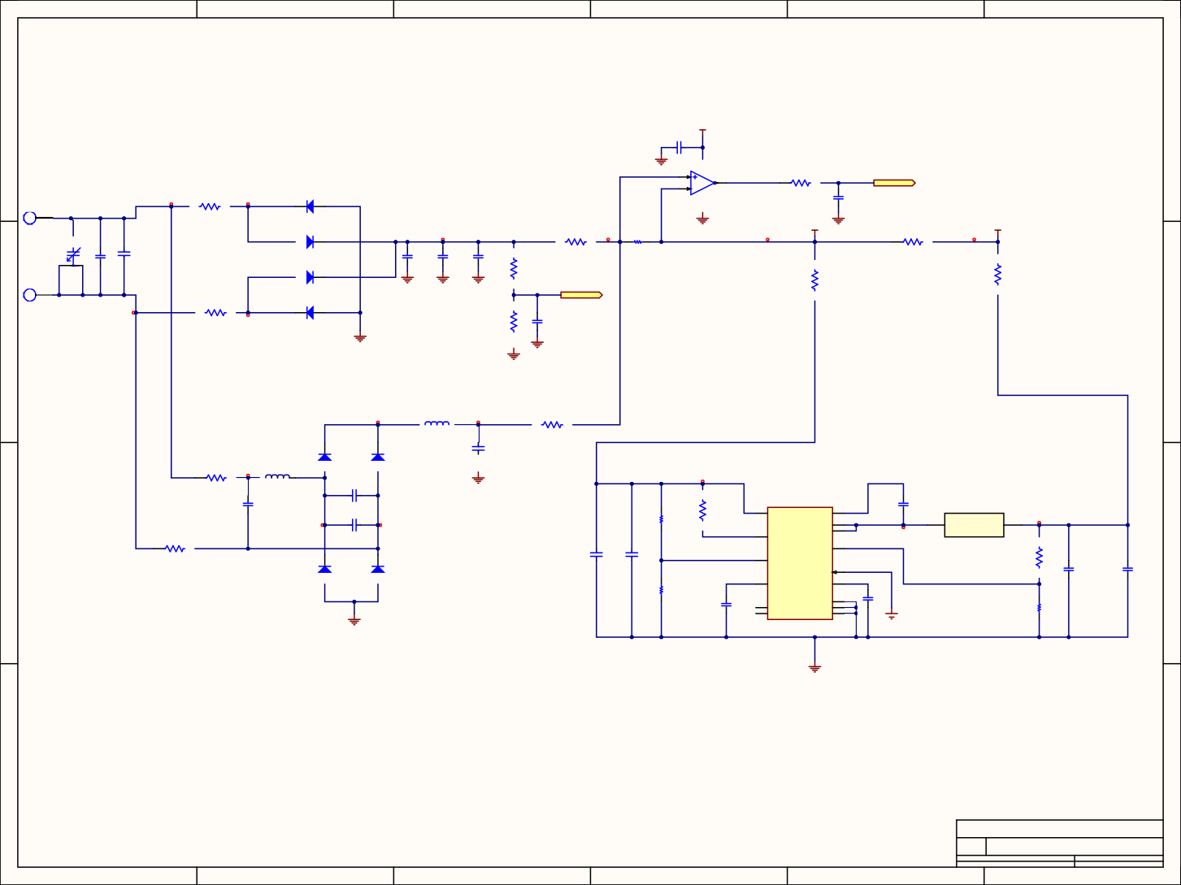

1

6

A

A

+18V

C21

2 1

0.1uF

GND

3

U10 INA194AIDBVT

1

R57

4

1 2

1k

I_SENSE

PTH_HOLE_4x8mm J2

1

1

R41

2

D21

1 2

C55 100pF

0

IDH04SG60C

GND

VUNREG GND

30V

D22

2 1

1

R42

2

R38

WSL1206R0200FEA

R43

IDH04SG60C

C26

C25

2 1

C22

0.47µF

C23

0.47µF

C24

0.47µF

0

1 2

DNP

D23

2 1

IDH04SG60C

R39 158kR

R45 DNP

R44 DNP

J4

GND

GND

GND

1

V_SENSE

PTH_HOLE_4x8mm

1 2

0

R46

D24

1 2

IDH04SG60C

R40

10k

C56 100pF

GND

GND

GND

1 L4

10.0 µH

2

1 R47 2 DNP

D25 IDH04SG60C

D26 IDH04SG60C

C40 GRM32EC72A106KE05L

1 R48 2

DNP

1 2

L5

744912210

C41

1 2

GND

C42 10pF

100pF

C43

1 2

R52 1.1M

R53

75k

U14

3 VIN

BST 11

C47 10nF

SW 12

L8

1 1

100pF

5 RON

SW 13

2 2

1 R49 2

DNP

220uH

FB

9

C48

C49 1.0uF

4

R54

28k

EN/UVLO

D27 IDH04SG60C

D28 IDH04SG60C

FPWM 8

C50 10uF

C51 10uF

6

R55 2.94k

SS

VCC

10

C53 33nF

AGND 1

14 NC

LM5161PWPR

7 NC

EXP PAD 15

PGND 2

C52

CAP 1uF 16V 0805(2012)

GND

R56

2k

GND

GND

D

D

1

6

5

4

3

2

Drawn By: D.F./F.F. Verfied By: C.G.

File: C:\Users\..\R_RF-DC_Conv.SchDoc

Sheet4 of 5

Date: 2-21-2021

Revision A

RF/DC Converter

Number

Size

C

HEC-2 Receiver

Title

C

C

B

B

5

4

3

2

1.0uF

*3.*

*RF/DC Converter*

79

BFC280832659

3

C44

CAP 100pF 1KV 1812(4532)

2 1

22pF

2 1

2 1

2 1

2 1

2 1

1 2 1 2

2

1

2

1

1 2

5 2

1 2

1 2

1

2



1

4

TP1

VCC_5V

F1

1

5001

L2

2

U11

A

MH3261-601Y

MICROSMD050F-2

3

6

A

4

5

C27 0.1uF

C28 10uF

7

2

8

9

10

C29 47uF

GND

11

1

LMZM23600V5SIL

VCC_3.3V

GND

Vout

U12

3 VIN

VOUT

6

F2

1

TP2

5001

L3

2

2 MODE/SYNC

FB 7

MH3261-601Y

MICROSMD050F-2

4 EN

PGOOD

5

Vout_3.3V

C30

0.1uF

C31 10uF

8

9

10

NC NC NC

LMZM23600V3SIL

Thermal Pad

GND

11

1

C32

47uF

GND

+18V

GND

TP3

5001

VUNREG

TPS7A4001DGNT U13A

8 1

C45 0.01uF

5 2

R50 931KΩ

C46 4.7µF

C54

10uF GND

GND

GND

GND

R51 64.9KΩ

D

D

GND

1

4

3

2

Drawn By:D.F./F.F. Verfied By: C.G.

C:\Users\..\R_Power.SchDoc

File:

Sheet5 of5

2-21-2021

Date:

Revision A

DC-DC Converters

Number

Size A

HEC-2 Receiver

Title

C

C

B

B

3

2

Vout_5V

GND

NC NC NC

Thermal Pad

FB

MODE/SYNC

PGOOD

EN

VOUT

VIN

EP GND

FB

EN

IN OUT

Vout

*4.*

*DC/DC Converter*

80

9

4

1

2 1

2

2

1

2

1

1

2

2

1

*5.*

*Top Copper Layer*

81

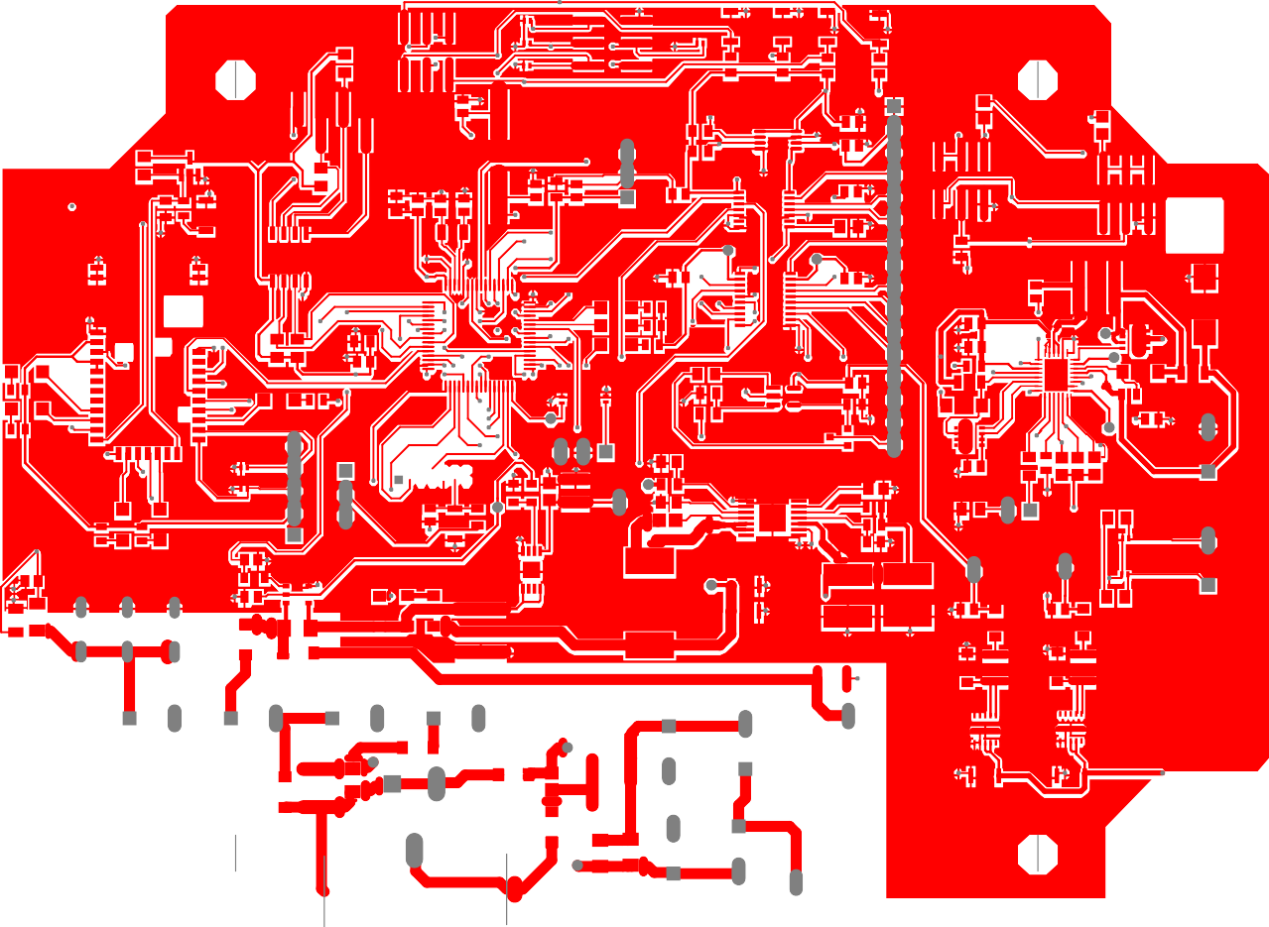 

1. *Top Silk Layer*

0. • •

### • • •

•• • ••.. •• • • •

••

• •

•

• •••• •

### • •

• •• •

.o•••••••••••••••

• • • •

• •

• • • ••

• • •

• ··- •

• •

• •

### • •• •

• • • • •

•• •O• •

••••

* + O O •

• • ..·. *:* •

I

•

•.•o • •

### • • • • ••.•_•••

•.-·.•

•

•• •

### •

•._.·.­.

• •

0

0 .•

•

### • • •

•

• •

•

•

•••

### •

•

#### •

• • •

••• •••

# O••••

•

•

•

### • • •

•

0 •

•

•

•

•

0

0

•

•

•

....

•

### • •

APPENDIX E: TRANSMITTER PCB SCHEMATICS

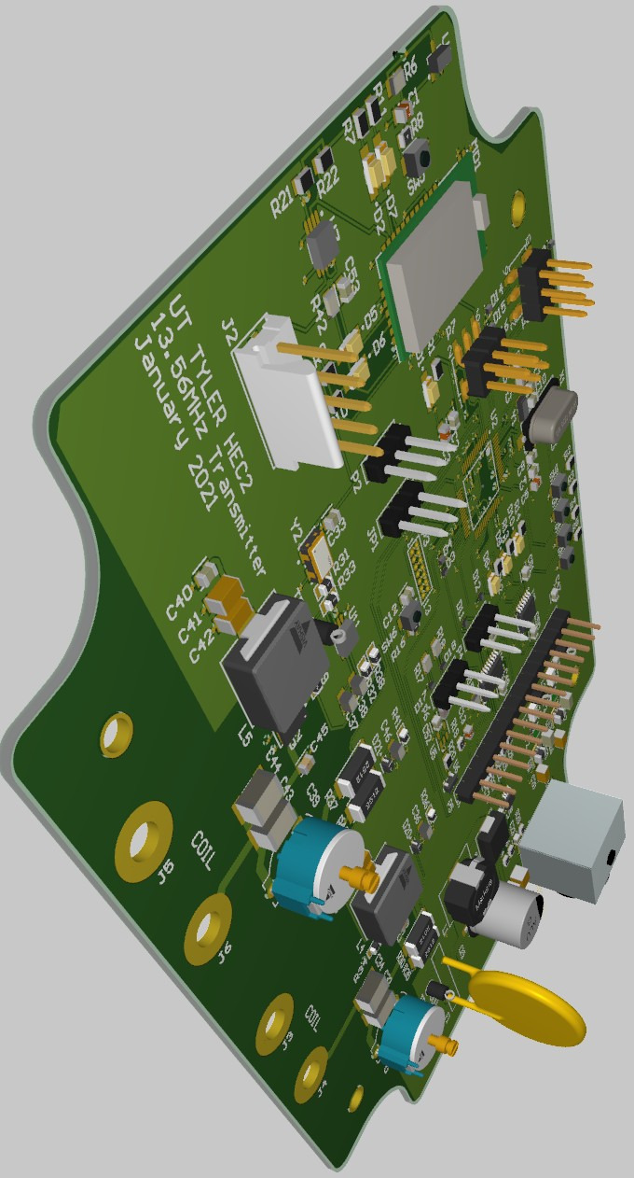

Figure 36: Isometric Image of Transmitter PCB

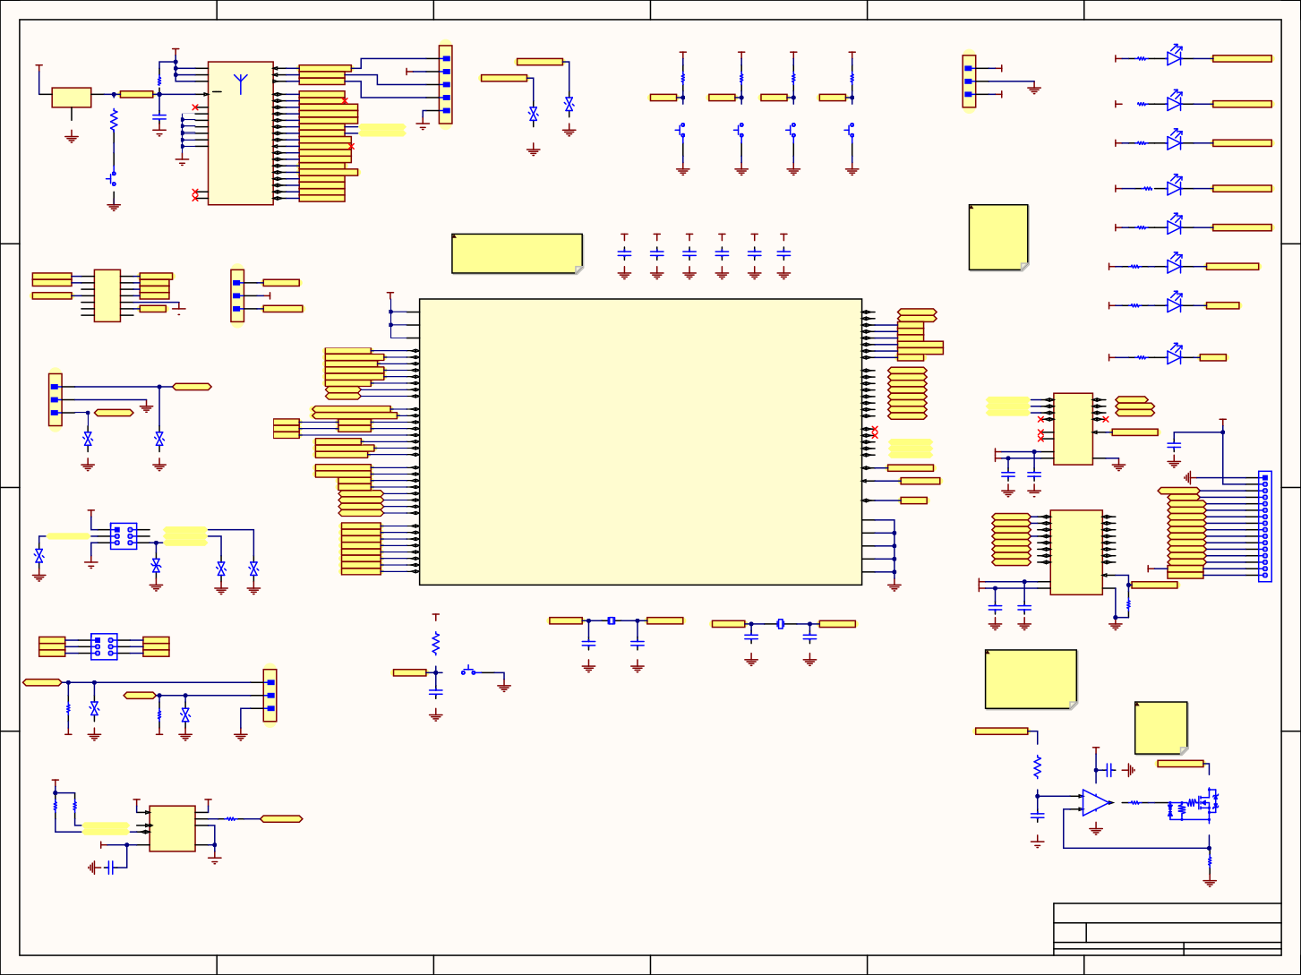

1

6

VCC_3.3V

J2

D1

1 1

VCC_3.3V

VCC_3.3V

VCC_3.3V

VCC_3.3V

P2

VCC_3.3V

MD1

4 VBAT 6

VCC_3.3V

P2_0/MODE 18

22

R1

470

2 1

U1

3 VDD OUT 1 VSS

R6 4.7K

VDD_IO

7

VDD_IO

UART_RX

23

UART_TX

BT_MODE_IN RX_BT_IN TX_BT_OUT

VCC_3.3V

2 2

3 3

4 4

R3

10k

R4

10k

R5

10k

1 1

2 2

VCC_3.3V

R2

10k

HSMS-C150

D2

BT_RST

A

R8 20

21 RST

NC

1 GND 2

P0_0/CTS 15

P0_2

29P0_7

16P1_0

12P1_1

13

30

BT_CTS_IN BT_LED0

BT_Low_Bat_OUT BT_Status_2_OUT

3 3

VCC_5V

D3

GND

20

5 5

VCC_3.3V

D4

R7

470

2 1

MCP111T-240E/TT

C1

1uF

22-28-4030

GND

3

GND

BT_Status_1_OUT

BT_SCL SCL_LCD_BL 3-641215-5

BT_SDA SDA_LCD_BL GND BT_PWM1_OUT

BT_PWM2_OUT

RF_Active_OUT BT_TX_Ind_OUT BT_RSSI_OUT

BT_Link_Drop_IN BT_LP_IN

BT_Pairing_IN BT_P3_5 BT_RTS_OUT

SW1

B3U-1000P

SW2

B3U-1000P

SW3

B3U-1000P

SW4

B3U-1000P

HSMS-C150

D5

A

GND

1. GND
2. GND
3. GND

P1_2/SCL P1_3/SDA 14

P2_2 5

P2_3 9

P2_4 19

P2_7/TX_IND 11

24

GND

GND

VCC_3.3V

R9

470

2 1

HSMS-C150

SW5

B3U-1000P

GND

GND

P3_2

P3_1

25

D6

P3_3 26 GND GND GND

8 ULPC_O

10 BK_O

RN4870

P3_4 27

P3_5 28

P3_6/RTS 17

GND

VCC_3.3V

GND

Selected LED and resistors are arbitrary and can be changed.

R10 2 1

470

HSMS-C150

D7

VCC_3.3V VCC_3.3V VCC_3.3V VCC_3.3V VCC_3.3V VCC_3.3V

VCC_3.3V

R11 2 1

470

HSMS-C150

D8

BT_TX_Ind_OUT

JTAG

P3

VCC_Tool 2 1

VCC_Target 4 3

6 5

TST/VPP 8 7

10 9

12 11

14 13

MHDR2X7

Franci: Except for P4 (parallel LCD), most pin assignments may be changed as needed for routing provided that peripheral support is available.

C2 C3 C4 C5 C6 C7 0.1uF 1uF 0.1uF 1uF 0.1uF 1uF

(MCU_Clock_on) is an interrupt-driven "hearbeat" to confirm MCU operation.

JP1

VCC_3.3V

R12

470

2 1

MCU_Clock_on

TDO/TDI TDI

TMS TCK

~RST

GND

1 1

2 2

3 3

VCC_Tool

VCC_3.3V

GND

GND

GND

GND

GND GND

VCC_3.3V

HSMS-C150

D9

U2

VCC_Target

R13

470

22-28-4030

64 AVCC1

49 DVCC1

16 DVCC2

P2.0_TB0.6_UCA0TXD_UCA0SIMO_TB0CLK_ACLK 32 RX_CON

VCC_3.3V

P2.1_TB0.0_UCA0RXD_UCA0SOMI 33 TX_CON

2 1

HSMS-C150

LED_0

P2.2_TB0.2_UCB0CLK 34 B_0

P2.4_TA1.0_UCA1CLK_A7_C11 52 B_2

P2.3_TA0.0_UCA1STE_A6_C10 51 B_1

1 P1.0_TA0.1_DMAE0_RTCCLK_A0_C0_VREF-_VeREF-

P2.6_TB0.1_UCA1RXD_UCA1SOMI 29 TX_BT_OUT

P2.5_TB0.0_UCA1TXD_UCA1SIMO 28 RX_BT_IN

D10

P4

1 1

2 2

TX_CON

BT_CTS_IN BT_MODE_IN BT_LP_IN

BT_Pairing_IN BT_Link_Drop_IN BT_P3_5

SDA_Aux SCL_Aux

3

1 P1.2_TA1.1_TA0CLK_COUT_A2_C2

2 P1.1_TA0.2_TA1CLK_COUT_A1_C1_VREF+_VeREF+

2 P1.3_TA1.2_UCB0STE_A3_C3

P4.0_A8 P4.0_LCD

P2.7 50 B_3

24

VCC_3.3V

R14

470

2 1

LED_1

HSMS-C150

14 P1.5_TB0.2_UCA0CLK_A5_C5

13 P1.4_TB0.1_UCA0STE_A4_C4

39 P1.6_TB0.3_UCB0SIMO_UCB0SDA_TA0.0

P4.2_A10 26 P4.2_LCD

P4.1_A9 25 P4.1_LCD

3 3 RX_CON

GND

WPT_PEAK_DETECTOR WPT_PEAK_DETECTOR_2

ADC_14 ADC_15

BT_RTS_OUT

BT_Low_Bat_OUT MCU_Clock_on

OSC_ENABLE WPT_ENABLE

LED_0 LED_1 UCA2SIMO UCA2SOMI UCA2CLK UCA2STE

40 P1.7_TB0.4_UCB0SOMI_UCB0SCL_TA1.0 4

P4.4_TB0.5 45 P4.4_LCD

P4.3_A11 27 P4.3_LCD

U3

2 13

5 P3.1_A13_C13

P3.0_A12_C12

P4.6 47 P4.6_LCD

P4.5 46 P4.5_LCD

P7.2_LCD_RS

P4.7 8 P4.7_LCD

P7.3_LCD_RW 4 A2 B2 11 LCD_RW

3 A1 B1 12 LCD_RS

P7.4_LCD_E 5 A3 B3 10 LCD_E

22-28-4030

D11 D12

DESD3V3S1BL-7B DESD3V3S1BL-7B

P3.2 P3.3 P3.4

6 P3.2_A14_C14

A4 B4

VCC_5V

36 P3.5_TB0.4_COUT

35 P3.4_TB0.3_SMCLK

7 P3.3_A15_C15

P7.0_UCB2SIMO_UCB2SDA 9

P7.1_UCB2SOMI_UCB2SCL 10

6

9 NC OE

8

LCD_ENABLE

37 P3.6_TB0.5

P7.2_UCB2CLK 21 P7.2_LCD_RS

NC

38 P3.7_TB0.6

P7.3_UCB2STE_TA4.1 22 P7.3_LCD_RW

P7.4 TA4.0_A16 23 P7.4_LCD_E

VCC_3.3V VCC_5V

14 VCCA

1

C47 0.1uF

VCCB GND

7

41 P5.0_UCB1SIMO_UCB1SDA

GND

GND

42 P5.1_UCB1SOMI_UCB1SCL

P8.0 11

TEST_SBWTCK 30

LCD_ENABLE

TXB0104PWR

C48 C49

GND

GND GND

P5

44 P5.3_UCB1STE

43 P5.2_UCB1CLK_TA4CLK

TST/VPP

54 P5.5_UCA2RXD_UCA2SOMI_ACLK

53 P5.4_UCA2TXD_UCA2SIMO_TB0OUTH

RST_NMI_SBWTDIO_N 31

VCC_3.3V

0.1uF 0.1uF

GND GND

U4

LCD_CONT LCD_RS LCD_RW

56 P5.7_UCA2STE_TA4.1_MCLK

55 P5.6_UCA2CLK_TA4.0_SMCLK

~RST

P9

63

P4.0_LCD 1 A1

B1 20 LCD_E

17 PJ.0_TDO_TB0OUTH_SMCLK_SRSCG1_C6

AVSS1

3

18 LCD_D0

UCA2STE 5

D13

GND

GND

1

3

2 UCA2SIMO

4

6

UCA2SOMI

UCA2CLK

SPI

D14

TDO/TDI TDI

TMS TCK LXFIN LXFOUT HFXIN HFXOUT

19 PJ.2_TMS_ACLK_SROSCOFF_C8

18 PJ.1_TDI_TCLK_MCLK_SRSCG0_C7

62 PJ.5_LFXOUT

61 PJ.4_LFXIN

AVSS2 60

AVSS3 57

DVSS1 48

DVSS2 15

P4.1_LCD 4 A2

P4.2_LCD 5 A3

B2 17 LCD_D1

B3 16 LCD_D2

20 PJ.3_TCK_SRCPUOFF_C9

P4.3_LCD 6 A4

P4.4_LCD 7 A5

B4 15 LCD_D3

P4.5_LCD 8 A6

B5 14 LCD_D4

P4.6_LCD 9 A7

B6 13 LCD_D5

D15 D16

59 PJ.7_HFXOUT

58 PJ.6_HFXIN

P4.7_LCD A8

B8

OE

B7 12 LCD_D6

LCD_D7

10 VCC_5V LCD_LED+

1

2

3

4

5

6

7

8

9

10

11

12

13

14

15

16

MSP430FR5994IPM

VCC_3.3V VCC_5V

2 VCCA

LCD_LED-

LCD_ENABLE

GND

GND

GND

GND

VCC_3.3V

19 VCCB GND 11 TXB0108PWR

C50 C51

0.1uF 0.1uF

61301611121

R15 4.7K

LXFIN

1 Y1 2

32.768kHz

LXFOUT

HFXIN

X1

1 2

HFXOUT

P7

B_0 B_1 B_2

1

3

5

2

4

6

R16 47K

C8 39pF

8Mhz

C9 39pF

GND GND

GND

B_3 P3.2 P3.3

C10 12 pF

C11 12 pF

SPI

P6

1 1

~RST

SW6

1

B3U-1000P

2

GND

GND

GND

GND

SDA_Aux

SCL_Aux

2 2

3 3

C12 2.2nF

GND

To simplify coding, non-critical "amenities" like the LCD contrast control and backlight PWM have been routed to the RN4840 bluetooth controller. They can be set using commands sent to the module.

R17 D17

4.7K DESD3V3S1BL-7B R18 D18

4.7K DESD3V3S1BL-7B

22-28-4030 GND

BT_PWM1_OUT

VCC 3.3V VCC 3.3V

GND GND

GND

VCC_5V

This mosfet has a built in gate resistor and may not need any additional resistance.

R19

30k

C52

VCC_3.3V

2 1 GND LCD_LED-

0.1uF

U5

VCC_3.3V VCC_5V

3 + MCP6001T-I/OT

R21 R22

10k 10k

U6 NUD3112LT1G

U7

1 5

HVC/A0 P0A 6

4 -

1 R20 1

1k

SCL_LCD_BL 3 SCL P0B

2

P0W 7

R42

0

LCD_CONT

C13 0.47uF

SDA_LCD_BL SDA

VCC_3.3V

D

C53

GND 1 2

0.1uF

8 VDD VSS 4 MCP4531-103E/MS

GND

GND

GND

R23 40

D

GND

1

6

5

4

3

2

Drawn By: D.F./F.F.

File: C:\Users\..\T_Controller.SchDoc

Sheet2 of 4

Date: 1-30-2021

Revision A

Communication and MCU

Number

Size

C

HEC2 - 13.56 MHz Receiver

Title

C

C

B

B

5

4

3

2

RF_Active_OUT

BT_Status_2_OUT

BT_Status_1_OUT

B_3

B_2

B_1

B_0

RX_BT_IN

TX_BT_OUT

BT_RSSI_OUT

*1.*

*Transmitter Controller*

84

1 2

2

1

2

1 2

1

2 1 2

1

2

1

2

2 1

1

2

1

2

1

2

2

1

1

2

DESD3V3S1BL-7B

1 2

DESD3V3S1BL-7B

1 2

2

1

2

1

2

1

2

1

1

2

2

1

2

1

1

2

2 1

2

1

2

1

1

2

2 1

1

2

1 2

1 2

1 2

1 2

2 1 1 2

2 5

1

2

2

3



1

6

A

If the 3.3 and 5V are converted from the 30V buck output from the TPS54160 instead of the 48V input, it is possible to use the LMZM2360 instead of the TPSM265R1. They offer a 500mA max output instead of a 100mA output. Yes

A

Since the 5V and 3V supplies will be drawn from the 30V supply, I propose using a TPS54260 design. The cost is similar to the 54160 and the efficiency is slightly greater at average load.

Text

30V

TP1 5001

48V

U8

2 VIN

R24 105k

3

EN

PH 10

1

C14 0.1uF

L1

1 2

330uH

F1

1 2

RXEF250

TP2

VCC_3.3V 5001

VSENSE

BOOT 7

U9

4 SS/TR PWRGD 6

D19

SS3H10-E3/57T

R25 365k

3

6

F2

1

L2

2

5 RT/CLK

MH3261-601Y

C16 2.2uF

C17 2.2uF

C18 2.2uF

8 COMP

GND 9

PP 11

+ C15 68µF

50V

2

4

7

5

MICROSMD050F-2

C19 0.1uF

TPS54260DGQR

GND

R26 3.4k

C20 10uF

R27 28.7K

8

9

10

11

1

C22 36pF

C23 6.8nF

R28 732K

LMZM23600V3SIL

C21 47uF

GND

C24 47nF

R29

10k

GND

VCC_5V

TP3 5001

F3

1 2

L3

30V

MH3261-601Y

U10 MICROSMD050F-2

3 VIN

VOUT 6

4

5

C25 0.1uF

7

C26 10uF

EN

FB

PGOOD

NC

8

2 MODE/SYNC

NC 10

Thermal Pad 11

GND 1

NC 9

C27 47uF

GND

LMZM23600V5SIL

GND

D

D

1

6

5

4

3

2

Drawn By: D.F./F.F.

File: C:\Users\..\T_Power.SchDoc

Sheet3 of 4

Date: 1-30-2021

Revision A

DC-DC Converters

Number

Size

C

HEC2 - 13.56 MHz Receiver

Title

C

C

B

B

5

4

3

2

Thermal Pad

GND

NC NC NC

PGOOD

EN

VOUT

FB

VIN

MODE/SYNC

*2.*

*DC/DC Converter*

85

1 2 1 2

2 1

2 1 1 2

2 1

1 2

1

2

1

2

1 2

1 2

1 2

2

1

2 1

2 1

1 2

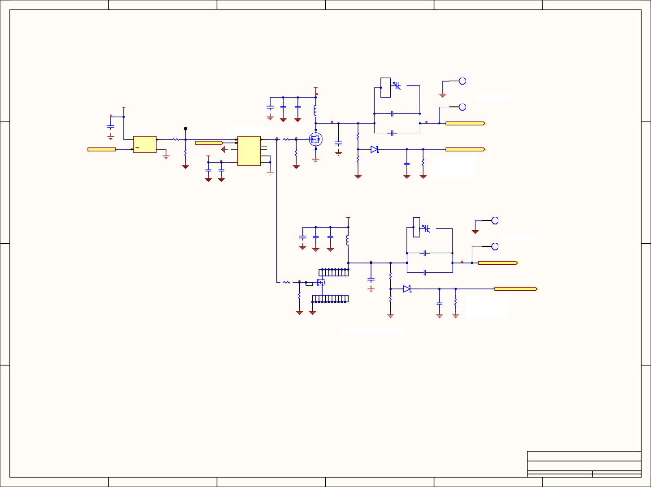

1

6

OSCILLATOR AND COIL DRIVER

A

A

J3

30V

C28

3 BFC280832659

1

PTH_HOLE_4x8mm

GND

Coil terminals

J4

VCC_3.3V

C29 C30 C31

0.1uF 10uF 10uF

L4 IHLP4040DZER470M11

CAP 100pF 1KV 1812(4532)

C32

1

PTH_HOLE_4x8mm

TP4 5001

Y2

4 VCC OUT 3

R31

47

GND GND GND

Class E amplifier Driver

U11

WPT_COIL_DRIVE_OUT

C33 0.1uF

C34

4 IN

OUT 7

8

R32

Q1 EPC2019

GND

WPT_ENABLE

2 INB

47

OSC_ENABLE

1

ST

13.56MHz

GND

2

GND

1

IN_REF NC

NC 5

C35

1.6 pF

R30

1M CAP 100pF 1KV 1812(4532)

D20

2 1

WPT_PEAK_DETECTOR

R33 1M

VCC_5

GND

DAP 9

6 VCC VEE LM5112MY

R34 1M

GND

BAS140WE6327HTSA1

R35

1k

GND

C36 10µF

R36 fc = 1/(2*π*R*C)

Peak detector

1k

GND

C37 C38

100nF 10µF

GND

GND

fc = 1/(2*π*1MΩ*10µF) fc=16Hz

GND GND GND

GND GND

30V

J5

1

C39

3 BFC280832659

PTH_HOLE_4x8mm

C40 C41

0.1uF 10uF

C42 10uF

L5 IHLP4040DZER470M11

GND

Coil terminals

J6

CAP 100pF 1KV 1812(4532)

C43

1

GND GND GND

PTH_HOLE_4x8mm

WPT_COIL_DRIVE_OUT_2

C44

1

R38

Q2 EPC2034C

C45

1.6 pF

DNP

2

R37

1M CAP 100pF 1KV 1812(4532)

D21

2 1

WPT_PEAK_DETECTOR_2

R39 1M

GND

BAS140WE6327HTSA1

R40

1k

R41

Peak detector

C46 10µF

GND GND

GND

GND

1k fc = 1/(2*π*R*C)

fc = 1/(2*π*1MΩ*10µF) fc=16Hz

GND

Alternative Class E amplifier

D

D

1

6

5

4

3

2

Drawn By: D.F./F.F.

File: C:\Users\..\T_CoilDriver.SchDoc

Sheet4 of 4

Date: 1-30-2021

Revision A

Number

Coil Driver

Size

C

HEC2 - 13.56 MHz Receiver

Title

C

C

B

B

5

4

3

2

3

*3.*

*Coil Driver*

86

1 2

1 2

1

2

4

10

11

3

12

13

14

20

21

22

23

24

1 2

9

5

8

7

6

19

18

17

16

15

2 1

1

2

2 1

1 2

1 2

*4.*

*Top Copper Layer*

87

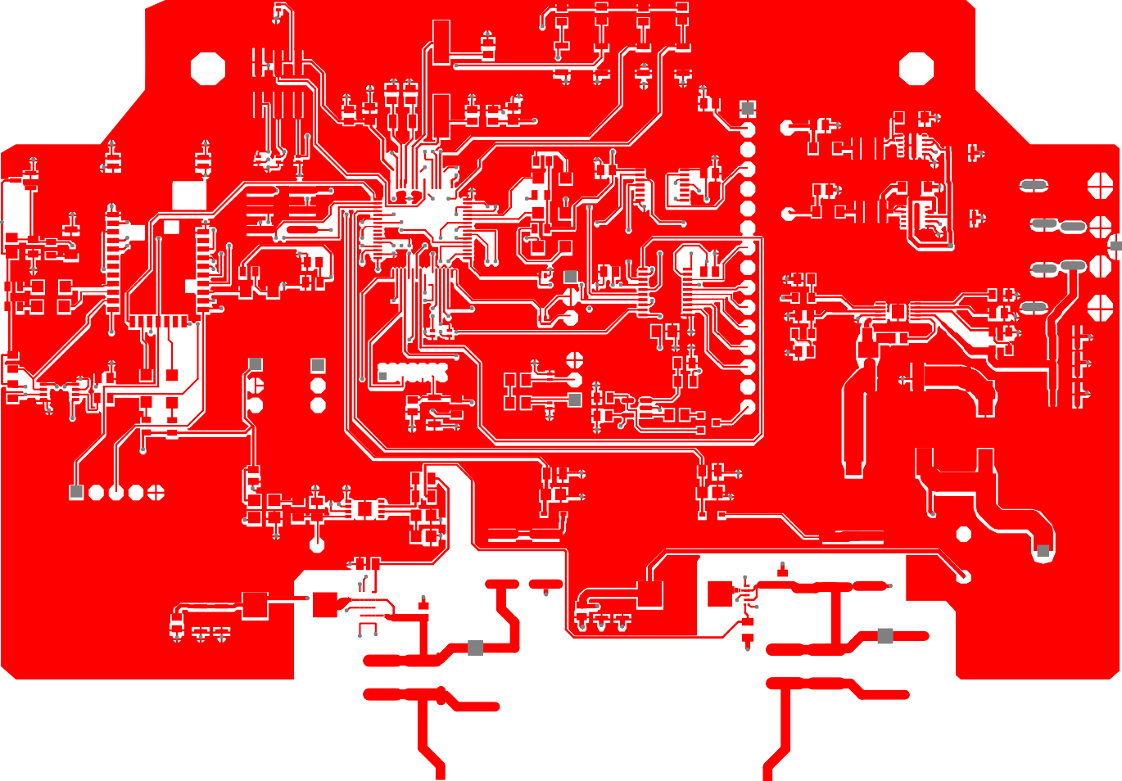

1. *Top Silk Layer*

( ) ( ) ( )

i I

-,I--(I -

,:, . ,:,

I-I I-I

-

I-I

,:,-,:. ,:,

I-I

•

,:, ,:i



•

,:, ,:i-:, ,:, ,:..:,•

,:,:-:. ,:,:,:,

,:, ·=·

:::!: ·=·

,:,

•• •

• •

•

•

•

• • ,:, • ,:, ,:,

o•••••••••••••••

••

•• • •• •• •

•,:, .•. • I •

## • • •

•

•.•

• •

I I

.

•••• •••I

,·,

···•=· •

·-·

## • •• •

• • •

## •

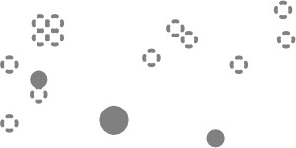•

* + ,:, . ,:,

•••

• .•.•.·•- ••

•

I

·-

•o•

• • •0

## • •

•

-

88

APPENDIX F:

RECEIVER BOM

89

|  |  |  |  |  |  |  |  |  |  |  |
| --- | --- | --- | --- | --- | --- | --- | --- | --- | --- | --- |
|  |  |  |  |  |  |  |  |  |  |  |
|  |  | **ASSEMBLY NO:** |  |  | **DATE:** | 03-02-21 |  |  |  |  |
|  |  | **ASSEMBLY NAME:** | **HEC2 Receiver** |  | **PREPARED BY:** | David Flory |  |  |  |  |
|  |  | **REVISION:** | A |  | **VERIFIED BY:** | Franci Franulovic |  |  |  |  |
|  |  | **SOLDER TYPE:** | Lead-Free |  |  |  |  |  |  |  |
|  |  |  |  |  |  |  |  |  |  |  |
| **ITEM** | **QTY** | **REFERENCE** | **DESCRIPTION** | **MFG** | **MFG P/N** | **VENDOR** | **VENDOR P/N** | **Datasheet URL** | **NOTES** | **Unit Price** |
| 1 | 4 | C1, C3, C5, C7 | Multilayer Ceramic Capacitors MLCC - SMD/SMT Multilayer Ceramic Capacitors MLCC - SMD/SMT  1.0uF 10V X7R 10% | Yageo | CC0805KKX7R6BB105 | Mouser | 603-CC805KKX7R6BB105 | https[://www.mouser.com/datasheet/2/447/UPY-](http://www.mouser.com/datasheet/2/447/UPY-) GPHC_X7R_6.3V-to-50V_18-1154002.pdf |  | $0.25 |
| 2 | 14 | C2, C4, C6, C17, C21, C27, C30, C33, C34, C35, C36, C37, C38, C39 | Multilayer Ceramic Capacitors MLCC - SMD/SMT Multilayer Ceramic Capacitors MLCC - SMD/SMT  50V 0.1uF X7R 0805 10% | KEMET | C0805C104K5RACTU | Mouser | 80-C0805C104K5R | https[://www.mouser.com/datasheet/2/212/KEM_C1002_X7R_S](http://www.mouser.com/datasheet/2/212/KEM_C1002_X7R_S) MD-1102033.pdf |  | $0.13 |
| 3 | 2 | C8, C9 | Multilayer Ceramic Capacitors MLCC - SMD/SMT  Multilayer Ceramic Capacitors MLCC - SMD/SMT 50V 39pF C0G 0805 5% | KEMET | C0805C390J5GACTU | Mouser | 80-C0805C390J5G | https[://www.mouser.com/datasheet/2/212/KEM_C1003_C0G_S](http://www.mouser.com/datasheet/2/212/KEM_C1003_C0G_S) MD-1101588.pdf |  | $0.24 |
| 4 | 2 | C10, C11 | Multilayer Ceramic Capacitors MLCC - SMD/SMT  Multilayer Ceramic Capacitors MLCC - SMD/SMT 50V 12pF C0G 0805 5% | KEMET | C0805C120J5GACTU | Mouser | 80-C0805C120J5G | https[://www.mouser.com/datasheet/2/212/KEM_C1003_C0G_S](http://www.mouser.com/datasheet/2/212/KEM_C1003_C0G_S) MD-1101588.pdf |  | $0.11 |
| 5 | 1 | C12 | Multilayer Ceramic Capacitors MLCC - SMD/SMT Multilayer Ceramic Capacitors MLCC - SMD/SMT  50V 2200pF X8R 0805 5% | KEMET | C0805C222J5HACTU | Mouser | 80-C0805C222J5H | https[://www.mouser.com/datasheet/2/212/KEM_C1007_X8R_](http://www.mouser.com/datasheet/2/212/KEM_C1007_X8R_) ULTRA_150C_SMD-1102703.pdf |  | $0.69 |
| 6 | 1 | C13 | Multilayer Ceramic Capacitors MLCC - SMD/SMT  Multilayer Ceramic Capacitors MLCC - SMD/SMT 470nF 16V X7R 10% | Yageo | CC0805KKX7R7BB474 | Mouser | 603-CC805KKX7R7BB474 | https[://www.mouser.com/datasheet/2/447/UPY-](http://www.mouser.com/datasheet/2/447/UPY-) GPHC_X7R_6.3V-to-50V_18-1154002.pdf |  | $0.23 |
| 7 | 1 | C14 | Multilayer Ceramic Capacitors MLCC - SMD/SMT Multilayer Ceramic Capacitors MLCC - SMD/SMT  1.0uF 10V X7R 10% | Yageo | CC0805KKX7R6BB105 | Mouser | 603-CC805KKX7R6BB105 | https[://www.mouser.com/datasheet/2/447/UPY-](http://www.mouser.com/datasheet/2/447/UPY-) GPHC_X7R_6.3V-to-50V_18-1154002.pdf |  | $0.25 |
| 8 | 2 | C15, C18 | Multilayer Ceramic Capacitors MLCC - SMD/SMT Multilayer Ceramic Capacitors MLCC - SMD/SMT  10volts 10uF X5R 10% | KEMET | C0805C106K8PACTU | Mouser | 80-C0805C106K8P | https[://www.mouser.com/datasheet/2/212/KEM_C1006_X5R_S](http://www.mouser.com/datasheet/2/212/KEM_C1006_X5R_S) MD-1103249.pdf |  | $0.14 |
| 9 | 1 | C16 | Multilayer Ceramic Capacitors MLCC - SMD/SMT  Multilayer Ceramic Capacitors MLCC - SMD/SMT 50V 0.1uF X7R 0805 10% | KEMET | C0805C104K5RACTU | Mouser | 80-C0805C104K5R | https[://www.mouser.com/datasheet/2/212/KEM_C1002_X7R_S](http://www.mouser.com/datasheet/2/212/KEM_C1002_X7R_S) MD-1102033.pdf |  | $0.24 |
| 10 | 1 | C19 | Multilayer Ceramic Capacitors MLCC - SMD/SMT Multilayer Ceramic Capacitors MLCC - SMD/SMT  50V 0.022uF C0G 0805 5% | KEMET | C0805C223J5GACTU | Mouser | 80-C0805C223J5G | https[://www.mouser.com/datasheet/2/212/KEM_C1003_C0G_S](http://www.mouser.com/datasheet/2/212/KEM_C1003_C0G_S) MD-1101588.pdf |  | $0.76 |
| 11 | 1 | C20 | Tantalum Capacitors - Solid SMD Tantalum  Capacitors - Solid SMD 50V 10uf 2917 10% ESR=800mOhms | KEMET | T491D106K050AT | Mouser | 80-T491D106K050 | https[://www.mouser.com/datasheet/2/212/1/KEM_T2005_T49](http://www.mouser.com/datasheet/2/212/1/KEM_T2005_T49) 1-1093550.pdf |  | $1.83 |
| 12 | 1 | C25 | Multilayer Ceramic Capacitors MLCC - SMD/SMT Multilayer Ceramic Capacitors MLCC - SMD/SMT  22pF 1KVolts 5% | Murata | GRM31A7U3A220JW31D | Mouser | 81-GRM31A7U3A220JW1D | https[://www.mouser.com/datasheet/2/281/1/GRM31A7U3A22](http://www.mouser.com/datasheet/2/281/1/GRM31A7U3A22) 0JW31_01-1987629.pdf |  | $0.43 |
| 13 | 1 | C26 | Multilayer Ceramic Capacitors MLCC - SMD/SMT  Multilayer Ceramic Capacitors MLCC - SMD/SMT 100pF 1KV C0G 5% | Vishay | VJ1812A101JXGAT | Mouser | 77-VJ1812A101JXGAT | https[://www.mouser.com/datasheet/2/427/vjcommercialseries-](http://www.mouser.com/datasheet/2/427/vjcommercialseries-) 1764145.pdf |  | $0.76 |
| 14 | 4 | C28, C31, C50, C51 | Multilayer Ceramic Capacitors MLCC - SMD/SMT Multilayer Ceramic Capacitors MLCC - SMD/SMT 1206 50V 10uF X5R 10% T: 1.6mm | TDK | C3216X5R1H106K160AB | Mouser | 810-C3216X5R1H106K | https://product.tdk.com/info/en/catalog/datasheets/mlcc_com mercial_general_en.pdf?ref_disty=mouser |  | $0.85 |
| 15 | 2 | C29, C32 | Multilayer Ceramic Capacitors MLCC - SMD/SMT Multilayer Ceramic Capacitors MLCC - SMD/SMT 1206 25VDC 47uF 20% X5R 1.6mm | TDK | C3216X5R1E476M160AC | Mouser | 810-C3216X5R1E476M | https://product.tdk.com/info/en/catalog/datasheets/mlcc_com mercial_general_en.pdf?ref_disty=mouser |  | $1.05 |
| 16 | 1 | C40 | Multilayer Ceramic Capacitors MLCC - SMD/SMT Multilayer Ceramic Capacitors MLCC - SMD/SMT 100Vdc 10uF 10% 1210/2502 | Murata | GRM32EC72A106KE05L | Mouser | 81-GRM32EC72A106KE05 | https[://www.mouser.com/datasheet/2/281/1/GRM32EC72A106](http://www.mouser.com/datasheet/2/281/1/GRM32EC72A106) KE05_01A-1988109.pdf |  | $1.38 |
| 17 | 1 | C42 | Multilayer Ceramic Capacitors MLCC - SMD/SMT  Multilayer Ceramic Capacitors MLCC - SMD/SMT 0805 10pF 1KV C0G 5% | Vishay | VJ0805A100JXGAT5Z | Mouser | 77-VJ0805A100JXGAT5Z | https[://www.mouser.com/datasheet/2/427/vjhvarcguard-](http://www.mouser.com/datasheet/2/427/vjhvarcguard-) 1763127.pdf |  | $0.68 |
| 18 | 1 | C44 | Trimmer / Variable Capacitors Trimmer / Variable  Capacitors TRIMMER CAPACITOR | Vishay | BFC280832659 | Mouser | 594-2222-808-32659 | https[://www.vishay.com/doc?28528](http://www.vishay.com/doc?28528) |  | $7.21 |
| 19 | 1 | C46 | Multilayer Ceramic Capacitors MLCC - SMD/SMT Multilayer Ceramic Capacitors MLCC - SMD/SMT  50V 4.7uF X7R 1210 10% | KEMET | C1210X475K5RACTU | Mouser | 80-C1210X475K5R | https[://www.mouser.com/datasheet/2/212/1/KEM_C1013_X7R](http://www.mouser.com/datasheet/2/212/1/KEM_C1013_X7R)  _FT_CAP_SMD-1103280.pdf |  | $1.81 |
| 20 | 1 | C47 | Multilayer Ceramic Capacitors MLCC - SMD/SMT Multilayer Ceramic Capacitors MLCC - SMD/SMT  16V .01uF C0G 0805 5% | AVX | 0805YA103JAT2A | Mouser | 581-0805YA103J | https[://www.mouser.com/datasheet/2/40/C0GNP0_Dielectric-](http://www.mouser.com/datasheet/2/40/C0GNP0_Dielectric-) 951274.pdf |  | $0.96 |

|  |  |  |  |  |  |  |  |  |  |  |
| --- | --- | --- | --- | --- | --- | --- | --- | --- | --- | --- |
| 21 | 2 | C48, C49 | Multilayer Ceramic Capacitors MLCC - SMD/SMT  Multilayer Ceramic Capacitors MLCC - SMD/SMT 2220 1uF 250volts X7R 10% | Murata | GRM55DR72E105KW01L | Mouser | 81-GRM55RR72E105K | https[://www.mouser.com/datasheet/2/281/1/GRM55DR72E10](http://www.mouser.com/datasheet/2/281/1/GRM55DR72E10) 5KW01_01-1988382.pdf |  | $1.48 |
| 22 | 1 | C52 | Multilayer Ceramic Capacitors MLCC - SMD/SMT  Multilayer Ceramic Capacitors MLCC - SMD/SMT 16V 1uF X7R 0805 10% | KEMET | C0805C105K4RACTU | Mouser | 80-C0805C105K4R | https[://www.mouser.com/datasheet/2/212/KEM_C1002_X7R_S](http://www.mouser.com/datasheet/2/212/KEM_C1002_X7R_S) MD-1102033.pdf |  | $0.13 |
| 23 | 1 | C54 | Multilayer Ceramic Capacitors MLCC - SMD/SMT Multilayer Ceramic Capacitors MLCC - SMD/SMT 100V 10uF X7R 2220 20% Tol HIGH CV | AVX | 22201C106MAT2A | Mouser | 581-22201C106MAT2A | https[://www.mouser.com/datasheet/2/40/X7RDielectric-](http://www.mouser.com/datasheet/2/40/X7RDielectric-) 777024.pdf |  | $1.83 |
| 24 | 8 | D1, D2, D5, D6, D7, D8, D9, D10 | Standard LEDs - SMD Standard LEDs - SMD Red  Diffused 626nm 10mcd | Broadcom Limited | HSMS-C150 | Mouser | 630-HSMS-C150 | https[://www.mouser.com/datasheet/2/678/av02-0551en-ds-](http://www.mouser.com/datasheet/2/678/av02-0551en-ds-)  hsmx-cxxx-05mar2012-1827675.pdf |  | $0.41 |
| 25 | 5 | D3, D11, D12, D17, D18 | ESD Suppressors / TVS Diodes ESD Suppressors / TVS Diodes Low Cap Bi TVS 10pF 3.3V 3.8Vbr 25kV | Diodes Incorporated | DESD3V3S1BL-7B | Mouser | 621-DESD3V3S1BL-7B | https[://www.mouser.com/datasheet/2/115/DESD3V3S1BL-](http://www.mouser.com/datasheet/2/115/DESD3V3S1BL-) 321080.pdf |  | $0.29 |
| 26 | 5 | D4, D13, D14, D15, D16 | ESD Suppressors / TVS Diodes ESD Suppressors / TVS Diodes Low Cap Bi TVS 10pF 3.3V 3.8Vbr 25kV | Diodes Incorporated | DESD3V3S1BL-7B | Mouser | 621-DESD3V3S1BL-7B | https[://www.mouser.com/datasheet/2/115/DESD3V3S1BL-](http://www.mouser.com/datasheet/2/115/DESD3V3S1BL-) 321080.pdf |  | $0.29 |
| 27 | 2 | D19, D20 | Schottky Diodes & Rectifiers Schottky Diodes &  Rectifiers 1.0 Amp 40 Volt | STMicroelectronics | STPS140A | Mouser | 511-STPS140A | https[://www.mouser.com/datasheet/2/389/stps140-](http://www.mouser.com/datasheet/2/389/stps140-)  1851573.pdf |  | $0.44 |
| 28 | 8 | D21, D22, D23, D24, D25, D26, D27, D28 | Schottky Diodes & Rectifiers Schottky Diodes & Rectifiers SIC DIODES | Infineon | IDH04SG60CXKSA2 | Mouser | 726-IDH04SG60CXKSA2 | https[://www.infineon.com/dgdl/Infineon-](http://www.infineon.com/dgdl/Infineon-) ApplicationNote_PFCCCMBoostConverterDesignGuide-AN- v02_00-EN.pdf?fileId=5546d4624a56eed8014a62c75a923b05 |  | $2.64 |
| 29 | 2 | F1, F2 | Resettable Fuses - PPTC Resettable Fuses - PPTC  .5A 13.2V 40A Imax | Littelfuse | MICROSMD050F-2 | Mouser | 650-MICROSMD050F-2 | https[://www.mouser.com/datasheet/2/240/Littelfuse_PTC_MIC](http://www.mouser.com/datasheet/2/240/Littelfuse_PTC_MIC)  ROSMD_Catalog_Datasheet.pdf-1021745.pdf |  | $0.47 |
| 30 | 2 | J1, J3 | Fixed Terminal Blocks Fixed Terminal Blocks 5.0MM PCB MOUNT 2P | TE Connectivity | 282836-2 | Mouser | 571-2828362 | <http://www.te.com/commerce/DocumentDelivery/DDEControll> er?Action=srchrtrv&DocNm=114- 20079&DocType=Specification+Or+Standard&DocLang=English&  PartCntxt=282836-2 |  | $0.80 |
| 31 | 2 | J2, J4 |  |  |  | Mouser |  |  |  |  |
| 32 | 3 | JP1, P2, P4 | Headers & Wire Housings Headers & Wire  Housings 3P VERT HEADER Sn | Molex | 22-28-4030 | Mouser | 538-22-28-4030 | https[://www.mouser.com/datasheet/2/276/0022284030_PCB_](http://www.mouser.com/datasheet/2/276/0022284030_PCB_)  HEADERS-228162.pdf |  | $0.16 |
| 33 | 2 | JP4, JP5 | Headers & Wire Housings Headers & Wire Housings WR-PHD 2.54mm SMT 6P Hdr Dual Strt | Wurth Elektronik | 61000621121 | Mouser | 710-61000621121 | https[://www.mouser.com/datasheet/2/445/61000621121-](http://www.mouser.com/datasheet/2/445/61000621121-) 1717892.pdf |  | $0.93 |
| 34 | 1 | L1 | Fixed Inductors Fixed Inductors 6.8uH Shld 20%  9A 20.8mOhms AECQ2 | Coilcraft | XAL6060-682MEB | Mouser | 994-XAL6060-682MEB | https[://www.mouser.com/datasheet/2/597/xal60xx-270658.pdf](http://www.mouser.com/datasheet/2/597/xal60xx-270658.pdf) |  | $2.58 |
| 35 | 2 | L2, L3 | Ferrite Beads Ferrite Beads 600 ohms 25% HIGH  CURRENT | Bourns | MH3261-601Y | Mouser | 652-MH3261-601Y | https[://www.mouser.com/datasheet/2/54/mh-777565.pdf](http://www.mouser.com/datasheet/2/54/mh-777565.pdf) |  | $0.10 |
| 36 | 1 | L4 | Fixed Inductors Fixed Inductors WE-SD Rod Core  10uH 5A 15.1mOhm | Wurth Elektronik | 744711005 | Mouser | 710-744711005 | https[://www.mouser.com/datasheet/2/445/744711005-](http://www.mouser.com/datasheet/2/445/744711005-)  1722097.pdf |  | $1.83 |
| 37 | 1 | L5 | Fixed Inductors Fixed Inductors WE-CAIR Air Coil  100nH 1.7A 150MHz | Wurth Elektronik | 744912210 | Mouser | 710-744912210 | https[://www.mouser.com/datasheet/2/445/744912210-](http://www.mouser.com/datasheet/2/445/744912210-)  1723335.pdf |  | $1.16 |
| 38 | 1 | L8 | Fixed Inductors Fixed Inductors 220uH Shld 10%  2.1A 245mOhms AECQ2 | Coilcraft | MSS1210-224KEB | Mouser | 994-MSS1210-224KEB | https[://www.mouser.com/datasheet/2/597/mss1210-](http://www.mouser.com/datasheet/2/597/mss1210-)  270677.pdf |  | $2.26 |
| 39 | 1 | MD1 | Bluetooth Modules (802.15.1) Bluetooth Modules (802.15.1) Bluetooth Low Energy BLE Module, Shielded, Antenna, ASCII Interface, 12x22mm | Microchip | RN4870-I/RM140 | Mouser | 579-RN4870-I/RM140 | https[://www.mouser.com/datasheet/2/268/RN4870-71-](http://www.mouser.com/datasheet/2/268/RN4870-71-) Bluetooth-Low-Energy-Module-Data-Sheet-D-1658564.pdf |  | $7.38 |
| 40 | 1 | P1 | Headers & Wire Housings Headers & Wire Housings WR-PHD 2.54mm Hdr 5P Single Str Gold | Wurth Elektronik | 61300511121 | Mouser | 710-61300511121 | https[://www.mouser.com/datasheet/2/445/61300511121-](http://www.mouser.com/datasheet/2/445/61300511121-) 1717845.pdf |  | $0.25 |
| 41 | 1 | P3 | Headers & Wire Housings Headers & Wire Housings WR-PHD1.27mm Hdr 14P Dual Str Gold | Wurth Elektronik | 62201421121 | Mouser | 710-62201421121 | https[://www.mouser.com/datasheet/2/445/62201421121-](http://www.mouser.com/datasheet/2/445/62201421121-) 1718302.pdf |  | $1.48 |
| 42 | 1 | P5 | Headers & Wire Housings Headers & Wire  Housings WR-PHD 2.54mm Hdr 16P Single Str Gold | Wurth Elektronik | 61301611121 | Mouser | 710-61301611121 | https[://www.mouser.com/datasheet/2/445/61301611121-](http://www.mouser.com/datasheet/2/445/61301611121-) 1717958.pdf |  | $0.90 |
| 43 | 1 | P6 | Headers & Wire Housings Headers & Wire  Housings 02 SIL VERTICAL PIN HEADER TIN | Harwin | M20-9990246 | Mouser | 855-M20-9990246 | https[://www.mouser.com/datasheet/2/181/M20-999-](http://www.mouser.com/datasheet/2/181/M20-999-)  1218971.pdf |  | $0.11 |
| 44 | 2 | P7, P9 | Headers & Wire Housings Headers & Wire Housings WR-PHD 2.54mm SMT 6P Hdr Dual Strt | Wurth Elektronik | 61000621121 | Mouser | 710-61000621121 | https[://www.mouser.com/datasheet/2/445/61000621121-](http://www.mouser.com/datasheet/2/445/61000621121-) 1717892.pdf |  | $0.93 |
| 45 | 1 | P8 | Headers & Wire Housings Headers & Wire Housings .100" Surface Mount Terminal Strip | Samtec | TSM-104-01-L-SV-P-TR | Mouser | 200-TSM10401LSVPTR | https[://www.mouser.com/datasheet/2/527/tsm-1344849.pdf](http://www.mouser.com/datasheet/2/527/tsm-1344849.pdf) |  | $1.27 |
| 46 | 2 | Q1, Q2 | MOSFET MOSFET PT8 40V/20V LL NCh  PowerTrench MOSFET | ON Semiconductor | FDMC8327L | Mouser | 512-FDMC8327L | https[://www.mouser.com/datasheet/2/308/FDMC8327L-D-](http://www.mouser.com/datasheet/2/308/FDMC8327L-D-)  1807402.pdf |  | $0.86 |
| 47 | 8 | R1, R7, R9, R10, R11, R12, R13, R14 | Thick Film Resistors - SMD Thick Film Resistors -  SMD 470 OHM 1% | Yageo | RC0805FR-07470RL | Mouser | 603-RC0805FR-07470RL | https[://www.mouser.com/datasheet/2/447/PYu_RC_Group_51](http://www.mouser.com/datasheet/2/447/PYu_RC_Group_51)  _RoHS_L_10-1664068.pdf |  | $0.13 |

|  |  |  |  |  |  |  |  |  |  |  |
| --- | --- | --- | --- | --- | --- | --- | --- | --- | --- | --- |
| 48 | 6 | R2, R3, R4, R5, R22, R23 | Thick Film Resistors - SMD Thick Film Resistors -  SMD 10K OHM 1% | Yageo | RC0805FR-0710KL | Mouser | 603-RC0805FR-0710KL | https[://www.mouser.com/datasheet/2/447/PYu_RC_Group_51](http://www.mouser.com/datasheet/2/447/PYu_RC_Group_51)  _RoHS_L_10-1664068.pdf |  | $0.13 |
| 49 | 8 | R6, R15, R18, R19, R24, R25, R26, R27 | Thick Film Resistors - SMD Thick Film Resistors - SMD 1/8watt 4.7Kohms 5% 200ppm | Vishay | CRCW08054K70JNTA | Mouser | 71-CRCW0805J-4.7K | https[://www.mouser.com/datasheet/2/427/dcrcw-1762150.pdf](http://www.mouser.com/datasheet/2/427/dcrcw-1762150.pdf) |  | $0.12 |
| 50 | 1 | R8 | Thick Film Resistors - SMD Thick Film Resistors -  SMD 1/8watt 20ohms 1% 100ppm | Vishay | CRCW080520R0FKEA | Mouser | 71-CRCW0805-20-E3 | https[://www.mouser.com/datasheet/2/427/dcrcwe3-](http://www.mouser.com/datasheet/2/427/dcrcwe3-)  1762152.pdf |  | $0.10 |
| 51 | 1 | R17 | Thick Film Resistors - SMD Thick Film Resistors - SMD 1/8watt 30Kohms 1% 100ppm | Vishay | CRCW080530K0FKEA | Mouser | 71-CRCW0805-30K-E3 | https[://www.mouser.com/datasheet/2/427/dcrcwe3-](http://www.mouser.com/datasheet/2/427/dcrcwe3-) 1762152.pdf |  | $0.10 |
| 52 | 1 | R20, R57 | Thick Film Resistors - SMD Thick Film Resistors -  SMD 1K OHM 1% | Yageo | RC0805FR-071KL | Mouser | 603-RC0805FR-071KL | https[://www.mouser.com/datasheet/2/447/PYu_RC_Group_51](http://www.mouser.com/datasheet/2/447/PYu_RC_Group_51)  _RoHS_L_10-1664068.pdf |  | $0.13 |
| 53 | 1 | R21 | Thick Film Resistors - SMD Thick Film Resistors - SMD 1/8watt 40.2ohms 1% 100ppm | Vishay | CRCW080540R2FKTA | Mouser | 71-CRCW0805-40.2 | https[://www.mouser.com/datasheet/2/427/dcrcw-1762150.pdf](http://www.mouser.com/datasheet/2/427/dcrcw-1762150.pdf) |  | $0.16 |
| 54 | 1 | R28 | Thick Film Resistors - SMD Thick Film Resistors - SMD 1/8watt 63.4Kohms 1% 100ppm | Vishay | CRCW080563K4FKEA | Mouser | 71-CRCW0805-63.4K-E3 | https[://www.mouser.com/datasheet/2/427/dcrcwe3-](http://www.mouser.com/datasheet/2/427/dcrcwe3-) 1762152.pdf |  | $0.10 |
| 55 | 3 | R29, R30, R31 | Thick Film Resistors - SMD Thick Film Resistors -  SMD 1/8watt 4.7Kohms 1% | Vishay | CRCW08054K70FKEA | Mouser | 71-CRCW0805-4.7K-E3 | https[://www.mouser.com/datasheet/2/427/dcrcwe3-](http://www.mouser.com/datasheet/2/427/dcrcwe3-)  1762152.pdf |  | $0.10 |
| 56 | 2 | R32, R34 | Thick Film Resistors - SMD Thick Film Resistors -  SMD 10K OHM 1% | Yageo | RC0805FR-0710KL | Mouser | 603-RC0805FR-0710KL | https[://www.mouser.com/datasheet/2/447/PYu_RC_Group_51](http://www.mouser.com/datasheet/2/447/PYu_RC_Group_51)  _RoHS_L_10-1664068.pdf |  | $0.13 |
| 57 | 2 | R33, R36 | Thick Film Resistors - SMD Thick Film Resistors -  SMD 1/8watt 10ohms 5% 200ppm | Vishay | CRCW080510R0JNEA | Mouser | 71-CRCW080510R0JNEA | https[://www.mouser.com/datasheet/2/427/dcrcwe3-](http://www.mouser.com/datasheet/2/427/dcrcwe3-)  1762152.pdf |  | $0.10 |
| 58 | 2 | R35, R37 | Thick Film Resistors - SMD Thick Film Resistors -  SMD 100K OHM 1% | Yageo | RC0805FR-07100KL | Mouser | 603-RC0805FR-07100KL | https[://www.mouser.com/datasheet/2/447/PYu_RC_Group_51](http://www.mouser.com/datasheet/2/447/PYu_RC_Group_51)  _RoHS_L_10-1664068.pdf |  | $0.13 |
| 59 | 1 | R38 | Current Sense Resistors - SMD Current Sense  Resistors - SMD 1/4watt .02ohms 1% | Vishay | WSL1206R0200FEA | Mouser | 71-WSL1206R0200FEA | <http://www.vishay.com/doc?30373> |  | $0.89 |
| 60 | 1 | R39 | Thick Film Resistors - SMD Thick Film Resistors -  SMD 1/4watt 158Kohms 1% | Vishay | CRCW1206158KFKEA | Mouser | 71-CRCW1206-158K-E3 | https[://www.mouser.com/datasheet/2/427/dcrcwe3-](http://www.mouser.com/datasheet/2/427/dcrcwe3-)  1762152.pdf |  | $0.10 |
| 61 | 1 | R40 | Thin Film Resistors - SMD Thin Film Resistors - SMD 0.1W 10Kohms 0.1% 1206 25ppm Auto | Vishay | MCA12060D1002BP500 | Mouser | 594-MCA12060D1002BP5 | https[://www.mouser.com/datasheet/2/427/mcx0x0xpre-](http://www.mouser.com/datasheet/2/427/mcx0x0xpre-) 1762843.pdf |  | $0.51 |
| 62 | 3 | R41, R42, R46 | Thick Film Resistors - SMD Thick Film Resistors -  SMD 0ohm Jumper | Bourns | CR1206-J/-000ELF | Mouser | 652-CR1206-J/-000ELF | https[://www.mouser.com/datasheet/2/54/crxxxxx-1858361.pdf](http://www.mouser.com/datasheet/2/54/crxxxxx-1858361.pdf) |  | $0.10 |
| 63 | 6 | R43, R44, R45, R47, R48, R49 | Thick Film Resistors - SMD Thick Film Resistors -  SMD 0ohm Jumper | Bourns | CR1206-J/-000ELF | Mouser | 652-CR1206-J/-000ELF | https[://www.mouser.com/datasheet/2/54/crxxxxx-1858361.pdf](http://www.mouser.com/datasheet/2/54/crxxxxx-1858361.pdf) |  | $0.10 |
| 64 | 1 | R50 | Thin Film Resistors - SMD Thin Film Resistors -  SMD 1/8W 931K ohm .1% 25ppm | Yageo | RT0805BRD07931KL | Mouser | 603-RT0805BRD07931KL | https[://www.mouser.com/datasheet/2/447/PYu_RT_1_to_0_01](http://www.mouser.com/datasheet/2/447/PYu_RT_1_to_0_01)  _RoHS_L_11-1669912.pdf |  | $0.43 |
| 65 | 1 | R51 | Thin Film Resistors - SMD Thin Film Resistors -  SMD 1/8W 64.9K ohm .1% 25ppm | Yageo | RT0805BRD0764K9L | Mouser | 603-RT0805BRD0764K9L | https[://www.mouser.com/datasheet/2/447/PYu_RT_1_to_0_01](http://www.mouser.com/datasheet/2/447/PYu_RT_1_to_0_01)  _RoHS_L_11-1669912.pdf |  | $0.43 |
| 66 | 1 | R52 | Thick Film Resistors - SMD Thick Film Resistors -  SMD 1/8watt 1.1Mohms 1% | Vishay | CRCW08051M10FKEA | Mouser | 71-CRCW08051M10FKEA | https[://www.mouser.com/datasheet/2/427/dcrcwe3-](http://www.mouser.com/datasheet/2/427/dcrcwe3-)  1762152.pdf |  | $0.10 |
| 67 | 1 | R53 | Thick Film Resistors - SMD Thick Film Resistors - SMD 1/8watt 75Kohms 1% 100ppm | Vishay | CRCW080575K0FKEA | Mouser | 71-CRCW0805-75K-E3 | https[://www.mouser.com/datasheet/2/427/dcrcwe3-](http://www.mouser.com/datasheet/2/427/dcrcwe3-) 1762152.pdf |  | $0.10 |
| 68 | 1 | R54 | Thick Film Resistors - SMD Thick Film Resistors - SMD 1/8watt 28Kohms 1% 100ppm | Vishay | CRCW080528K0FKEA | Mouser | 71-CRCW0805-28K-E3 | https[://www.mouser.com/datasheet/2/427/dcrcwe3-](http://www.mouser.com/datasheet/2/427/dcrcwe3-) 1762152.pdf |  | $0.10 |
| 69 | 1 | R55 | Thick Film Resistors - SMD Thick Film Resistors - SMD 0805 2.94Kohms 1% AEC-Q200 | Panasonic | ERJ-6ENF2941V | Mouser | 667-ERJ-6ENF2941V | https[://www.mouser.com/datasheet/2/315/AOA0000C304-](http://www.mouser.com/datasheet/2/315/AOA0000C304-) 1149620.pdf |  | $0.10 |
| 70 | 1 | R56 | Thin Film Resistors - SMD Thin Film Resistors -  SMD 1/10W 2Kohm 0.5% 25ppm | Susumu | RR1220P-202-D | Mouser | 754-RR1220P-202D | https[://www.mouser.com/datasheet/2/392/susumu_RR_Data_](http://www.mouser.com/datasheet/2/392/susumu_RR_Data_)  Sheet-1206438.pdf |  | $0.10 |
| 71 | 2 | RS1, RS2 | Current Sense Resistors - SMD Current Sense  Resistors - SMD 1206 0.010ohm 1% Curr Sense AEC-Q200 | Panasonic | ERJ-8BWFR010V | Mouser | 667-ERJ-8BWFR010V | https[://www.mouser.com/datasheet/2/315/AOA0000C313-](http://www.mouser.com/datasheet/2/315/AOA0000C313-) 1141758.pdf |  | $0.74 |
| 72 | 6 | SW1, SW2, SW3, SW4, SW5, SW6 | Tactile Switches Tactile Switches Top Actuated  w/o boss w/o ground | Omron | B3U-1000P | Mouser | 653-B3U-1000P | https[://www.mouser.com/datasheet/2/307/en-b3u-3615.pdf](http://www.mouser.com/datasheet/2/307/en-b3u-3615.pdf) |  | $0.92 |
| 73 | 3 | TP1, TP2, TP3 | Circuit Board Hardware - PCB Circuit Board  Hardware - PCB TEST POINT BLACK | Keystone Electronics | 5001 | Mouser | 534-5001 | https[://www.mouser.com/datasheet/2/215/000-5004-](http://www.mouser.com/datasheet/2/215/000-5004-)  741181.pdf |  | $0.35 |
| 74 | 1 | U1 | Supervisory Circuits Supervisory Circuits Open  Drain | Microchip | MCP111T-240E/TT | Mouser | 579-MCP111T-240E/TT | https[://www.mouser.com/datasheet/2/268/21889b-64653.pdf](http://www.mouser.com/datasheet/2/268/21889b-64653.pdf) |  | $0.47 |
| 75 | 1 | U2 | 16-bit Microcontrollers - MCU 16-bit  Microcontrollers - MCU | Texas Instruments | MSP430FR5994IPM | Mouser | 595-MSP430FR5994IPM | https[://www.ti.com/lit/pdf/slaa722](http://www.ti.com/lit/pdf/slaa722) |  | $8.11 |
| 76 | 1 | U3 | Translation - Voltage Levels Translation - Voltage Levels 4-Bit Bi-directional V-Level Translator | Texas Instruments | TXB0104PWR | Mouser | 595-TXB0104PWR | https[://www.ti.com/lit/pdf/scea064](http://www.ti.com/lit/pdf/scea064) |  | $0.93 |
| 77 | 1 | U4 | Translation - Voltage Levels Translation - Voltage Levels 8-Bit Bi-directional V-Level Translator | Texas Instruments | TXB0108PWR | Mouser | 595-TXB0108PWR | <http://www.ti.com/general/docs/suppproductinfo.tsp?distId=26>  &gotoUrl=http%3A%2F%2Fwww.ti.com%2Flit%2Fgpn%2Ftxb010 8 |  | $1.29 |

|  |  |  |  |  |  |  |  |  |  |  |
| --- | --- | --- | --- | --- | --- | --- | --- | --- | --- | --- |
| 78 | 1 | U5 | Operational Amplifiers - Op Amps Operational Amplifiers - Op Amps Single 1.8V 1MHz | Microchip | MCP6001T-I/OT | Mouser | 579-MCP6001T-I/OT | https[://www.mouser.com/datasheet/2/268/21733j-740845.pdf](http://www.mouser.com/datasheet/2/268/21733j-740845.pdf) |  | $0.24 |
| 79 | 1 | U6 | Gate Drivers Gate Drivers 12V Industrial Relay  Inductive Load | ON Semiconductor | NUD3112LT1G | Mouser | 863-NUD3112LT1G | <http://www.onsemi.com/pub/Collateral/AND8116-D.PDF> |  | $0.44 |
| 80 | 1 | U7 | Digital Potentiometer ICs Digital Potentiometer  ICs Sngl 7B V I2C POT | Microchip | MCP4531-103E/MS | Mouser | 579-MCP4531-103E/MS | https[://www.mouser.com/datasheet/2/268/DS-22096a-](http://www.mouser.com/datasheet/2/268/DS-22096a-)  36447.pdf |  | $0.70 |
| 81 | 1 | U8 | Digital Isolators Digital Isolators Low-  Power,Bidirec I2C Iso | Texas Instruments | ISO1540DR | Mouser | 595-ISO1540DR | https[://www.ti.com/lit/pdf/slyt403a](http://www.ti.com/lit/pdf/slyt403a) |  | $4.51 |
| 82 | 1 | U9 | Battery Management Battery Management 35V/3.2A Multi-Cell Lithium-Ion Step-Down Battery Charger with PowerPath and I2C  Telemetry | Analog Devices Inc. | LTC4162EUFD-SAD#PBF | Mouser | 584-4162EUFDSADPB | https[://www.mouser.com/datasheet/2/609/LTC4162_S-](http://www.mouser.com/datasheet/2/609/LTC4162_S-) 1398197.pdf |  | $7.33 |
| 83 | 1 | U10 | Current & Power Monitors & Regulators Current & Power Monitors & Regulators Vltg Out Hi-Sd  Msmnt Current Shunt Mntr | Texas Instruments | INA194AIDBVT | Mouser | 595-INA194AIDBVT | https[://www.ti.com/lit/pdf/sloa228](http://www.ti.com/lit/pdf/sloa228) |  | $2.89 |
| 84 | 1 | U11 | Non-Isolated DC/DC Converters Non-Isolated  DC/DC Converters | Texas Instruments | LMZM23601V5SILT | Mouser | 595-LMZM23601V5SILT | https[://www.ti.com/lit/pdf/snva834](http://www.ti.com/lit/pdf/snva834) |  | $6.17 |
| 85 | 1 | U12 | Non-Isolated DC/DC Converters Non-Isolated  DC/DC Converters | Texas Instruments | LMZM23601V3SILT | Mouser | 595-LMZM23601V3SILT | https[://www.ti.com/lit/pdf/slpa015](http://www.ti.com/lit/pdf/slpa015) |  | $6.17 |
| 86 | 1 | U13 | LDO Voltage Regulators LDO Voltage Regulators 50mA,100Vin,Sgl Out put LDO Linear Reg | Texas Instruments | TPS7A4001DGNT | Mouser | 595-TPS7A4001DGNT | <http://www.ti.com/general/docs/suppproductinfo.tsp?distId=26> &gotoUrl=http%3A%2F%2Fwww.ti.com%2Flit%2Fgpn%2Ftps7a4  001 |  | $2.81 |
| 87 | 1 | U14 | Switching Voltage Regulators Switching Voltage  Regulators | Texas Instruments | LM5161PWPR | Mouser | 595-LM5161PWPR | https[://www.ti.com/lit/pdf/snaa137a](http://www.ti.com/lit/pdf/snaa137a) |  | $4.21 |
| 88 | 3 | C22, C23, C24 | Film Capacitors Film Capacitors 100V .47uF 10%  1E=4.5x9.5x7.2 PCM 5 | WIMA | MKS2D034701E00KSSD | Mouser | 505-MKS2.47/100/10 | https[://www.mouser.com/datasheet/2/440/e_WIMA_MKS_2-](http://www.mouser.com/datasheet/2/440/e_WIMA_MKS_2-)  1139871.pdf |  | $0.48 |
| 89 | 1 | R16 | Thick Film Resistors - SMD Thick Film Resistors - SMD 1/8watt 47Kohms 1% 100ppm | Vishay | CRCW080547K0FKEA | Mouser | 71-CRCW0805-47K-E3 | https[://www.mouser.com/datasheet/2/427/dcrcwe3-](http://www.mouser.com/datasheet/2/427/dcrcwe3-) 1762152.pdf |  | $0.10 |
| 90 | 1 | X1 | Crystals Crystals 8MHz 20pF | Fox | FOXSDLF/080-20 | Mouser | 559-FOXSD080-20-LF | https[://www.mouser.com/datasheet/2/160/C4SD-1131563.pdf](http://www.mouser.com/datasheet/2/160/C4SD-1131563.pdf) |  | $0.27 |
| 91 | 2 | C41, C43 | Multilayer Ceramic Capacitors MLCC - SMD/SMT Multilayer Ceramic Capacitors MLCC - SMD/SMT 1206 100pF 1000volt C0G +/-5% | Murata | GRM31A5C3A101JW01D | Mouser | 81-GRM31A5C3A101J01D | https[://www.mouser.com/datasheet/2/281/1/GRM31A5C3A10](http://www.mouser.com/datasheet/2/281/1/GRM31A5C3A10) 1JW01_01-1987513.pdf |  | $0.52 |
| 92 | 1 | C45 | Multilayer Ceramic Capacitors MLCC - SMD/SMT Multilayer Ceramic Capacitors MLCC - SMD/SMT  50V 0.01uF X7R 0805 10% | KEMET | C0805X103K5RAC7210 | Mouser | 80-C0805X103K5R7210 | https[://www.mouser.com/datasheet/2/212/1/KEM_C1013_X7R](http://www.mouser.com/datasheet/2/212/1/KEM_C1013_X7R)  _FT_CAP_SMD-1103280.pdf |  | $0.35 |
| 93 | 1 | C53 | Multilayer Ceramic Capacitors MLCC - SMD/SMT Multilayer Ceramic Capacitors MLCC - SMD/SMT  50V 0.033uF X7R 0805 10% | KEMET | C0805S333K5RACTU | Mouser | 80-C0805S333K5R | https[://www.mouser.com/datasheet/2/212/1/KEM_C1014_X7R](http://www.mouser.com/datasheet/2/212/1/KEM_C1014_X7R)  _FE_CAP_SMD-1102761.pdf |  | $0.41 |
| 94 | 2 | C55, C56 | Multilayer Ceramic Capacitors MLCC - SMD/SMT Multilayer Ceramic Capacitors MLCC - SMD/SMT  50V 100pF C0G 0805 5% | KEMET | C0805C101J5GACTU | Mouser | 80-C0805C101J5G | https[://www.mouser.com/datasheet/2/212/KEM_C1003_C0G_S](http://www.mouser.com/datasheet/2/212/KEM_C1003_C0G_S) MD-1101588.pdf |  | $0.16 |
| 95 | 0 | Y1 | Crystals Crystals 32.768KHZ 10PPM 7PF -40C +85C | ABRACON | ABS07-166-32.768KHZ-T | Mouser | 815-ABS0716632.768KT |  |  | $0.66 |
| 96 | 1 | Alternate Y1 | Crystals 32.768kHz 6pF -40C +85C | ECS | ECS-.327-6-34G-TR | Mouser | 520-.327-6-34GT | https[://www.mouser.com/datasheet/2/122/ECX-34G-](http://www.mouser.com/datasheet/2/122/ECX-34G-)  1064121.pdf |  | $0.74 |

APPENDIX G:

TRANSMITTER BOM

93

|  |  |  |  |  |  |  |  |  |  |  |
| --- | --- | --- | --- | --- | --- | --- | --- | --- | --- | --- |
|  |  |  |  |  |  |  |  |  |  |  |
|  |  | **ASSEMBLY NO:** |  |  | **DATE:** | 03-02-21 |  |  |  |  |
|  |  | **ASSEMBLY** | **Transmitter** |  | **PREPARED BY:** | David Flory |  |  |  |  |
|  |  | **REVISION:** | A |  | **VERIFIED BY:** | Franci Franulovic | |  |  |  |
|  |  | **SOLDER TYPE:** | Lead-Free |  |  |  |  |  |  |  |
|  |  |  |  |  |  |  |  |  |  |  |
| **ITEM** | **QTY** | **REFERENCE** | **DESCRIPTION** | **MFG** | **MFG P/N** | **VENDOR** | **VENDOR P/N** | **Datasheet URL** | **NOTES** | **Unit Price** |
| 1 | 1 | R42 | Thick Film Resistors - SMD Thick Film Resistors - SMD 1/8watt ZEROohm Jumper | Vishay | CRCW08050000Z0EA | Mouser | 71-CRCW0805-0-E3 | https[://www.mouser.com/datasheet/2/427/dcrcwe3-1762152.pdf](http://www.mouser.com/datasheet/2/427/dcrcwe3-1762152.pdf) |  | $0.10 |
| 2 | 1 | R8 | Thick Film Resistors - SMD Thick Film Resistors - SMD 1/8watt 20ohms 1% 100ppm | Vishay | CRCW080520R0FKEA | Mouser | 71-CRCW0805-20-E3 | https[://www.mouser.com/datasheet/2/427/dcrcwe3-1762152.pdf](http://www.mouser.com/datasheet/2/427/dcrcwe3-1762152.pdf) |  | $0.10 |
| 3 | 1 | R23 | Thick Film Resistors - SMD Thick Film Resistors - SMD 1/8watt 40.2ohms 1% 100ppm | Vishay | CRCW080540R2FKTA | Mouser | 71-CRCW0805-40.2 | https[://www.mouser.com/datasheet/2/427/dcrcw-1762150.pdf](http://www.mouser.com/datasheet/2/427/dcrcw-1762150.pdf) |  | $0.16 |
| 4 | 2 | R31, R32 | Thick Film Resistors - SMD Thick Film Resistors - SMD 0805 47.0ohms 1% Tol AEC-Q200 | Panasonic | ERJ-6ENF47R0V | Mouser | 667-ERJ-6ENF47R0V | https[://www.mouser.com/datasheet/2/315/AOA0000C304-](http://www.mouser.com/datasheet/2/315/AOA0000C304-) 1149620.pdf |  | $0.10 |
| 5 | 8 | R1, R7, R9, R10, R11,  R12, R13, R14 | Thick Film Resistors - SMD Thick Film Resistors - SMD 470 OHM  1% | Yageo | RC0805FR-07470RL | Mouser | 603-RC0805FR-07470RL | https[://www.mouser.com/datasheet/2/447/PYu_RC_Group_51_Ro](http://www.mouser.com/datasheet/2/447/PYu_RC_Group_51_Ro)  HS_L_10-1664068.pdf |  | $0.13 |
| 6 | 4 | TP1, TP2, TP3, TP4 | Circuit Board Hardware - PCB Circuit Board Hardware - PCB TEST POINT BLACK | Keystone Electronics | 5001 | Mouser | 534-5001 | https[://www.mouser.com/datasheet/2/215/000-5004-741181.pdf](http://www.mouser.com/datasheet/2/215/000-5004-741181.pdf) |  | $0.35 |
| 7 | 1 | P5 | Headers & Wire Housings Headers & Wire Housings WR-PHD 2.54mm Hdr 16P Single Str Gold | Wurth Elektronik | 61301611121 | Mouser | 710-61301611121 | https[://www.mouser.com/datasheet/2/445/61301611121-](http://www.mouser.com/datasheet/2/445/61301611121-) 1717958.pdf |  | $0.90 |
| 8 | 4 | D13, D14, D15, D16 | ESD Suppressors / TVS Diodes ESD Suppressors / TVS Diodes Low Cap Bi TVS 10pF 3.3V 3.8Vbr 25kV | Diodes Incorporated | DESD3V3S1BL-7B | Mouser | 621-DESD3V3S1BL-7B | https[://www.mouser.com/datasheet/2/115/DESD3V3S1BL-](http://www.mouser.com/datasheet/2/115/DESD3V3S1BL-) 321080.pdf |  | $0.29 |
| 9 | 16 | C2, C4, C6, C14, C19, C25, C29, C33, C37, C40, C47, C48, C49,  C50, C51, C52, C53 | Multilayer Ceramic Capacitors MLCC - SMD/SMT Multilayer Ceramic Capacitors MLCC - SMD/SMT 50V 0.1uF X7R 0805 10% | KEMET | C0805C104K5RACTU | Mouser | 80-C0805C104K5R | https[://www.mouser.com/datasheet/2/212/KEM_C1002_X7R_SM](http://www.mouser.com/datasheet/2/212/KEM_C1002_X7R_SM) D-1102033.pdf |  | $0.13 |
| 10 | 1 | C13 | Multilayer Ceramic Capacitors MLCC - SMD/SMT Multilayer Ceramic Capacitors MLCC - SMD/SMT 470nF 16V X7R 10% | Yageo | CC0805KKX7R7BB474 | Mouser | 603-CC805KKX7R7BB474 | https[://www.mouser.com/datasheet/2/447/UPY-GPHC_X7R_6.3V-](http://www.mouser.com/datasheet/2/447/UPY-GPHC_X7R_6.3V-) to-50V_18-1154002.pdf |  | $0.23 |
| 11 | 2 | C35, C45 | Multilayer Ceramic Capacitors MLCC - SMD/SMT 0805 1.6pF 250volts C0G 0.1pF | Murata | GQM2195C2E1R6BB12D | Mouser | 81-GQM2195C2E1R6BB2D | https[://www.mouser.com/datasheet/2/281/GQM2195C2E1R6BB1](http://www.mouser.com/datasheet/2/281/GQM2195C2E1R6BB1) 2_01-1976051.pdf |  |  |
| 12 | 3 | C36, C38, C46 | Multilayer Ceramic Capacitors MLCC - SMD/SMT 10volts 10uF  X5R 10% | KEMET | C0805C106K8PACTU | Mouser | 80-C0805C106K8P | https[://www.mouser.com/datasheet/2/212/KEM_C1006_X5R_SM](http://www.mouser.com/datasheet/2/212/KEM_C1006_X5R_SM)  D-1103249.pdf |  | $0.14 |
| 13 | 1 | R24 | Thin Film Resistors - SMD Thin Film Resistors - SMD 1/8W 105K ohm .1% 25ppm | Yageo | RT0805BRD07105KL | Mouser | 603-RT0805BRD07105KL | https[://www.mouser.com/datasheet/2/447/PYu_RT_1_to_0_01_R](http://www.mouser.com/datasheet/2/447/PYu_RT_1_to_0_01_R) oHS_L_11-1669912.pdf |  | $0.43 |
| 14 | 6 | R2, R3, R4, R5, R21,  R22 | Thick Film Resistors - SMD Thick Film Resistors - SMD 10K OHM  1% | Yageo | RC0805FR-0710KL | Mouser | 603-RC0805FR-0710KL | https[://www.mouser.com/datasheet/2/447/PYu_RC_Group_51_Ro](http://www.mouser.com/datasheet/2/447/PYu_RC_Group_51_Ro)  HS_L_10-1664068.pdf |  | $0.13 |
| 15 | 1 | R29 | Thick Film Resistors - SMD Thick Film Resistors - SMD 10K 5% | Bourns | CR0805-JW-103ELF | Mouser | 652-CR0805-JW-103ELF | https[://www.mouser.com/datasheet/2/54/crxxxxx-1858361.pdf](http://www.mouser.com/datasheet/2/54/crxxxxx-1858361.pdf) |  | $0.10 |
| 16 | 6 | C20, C26, C30, C31, C41, C42 | Multilayer Ceramic Capacitors MLCC - SMD/SMT Multilayer Ceramic Capacitors MLCC - SMD/SMT 1206 50V 10uF X5R 10% T: 1.6mm | TDK | C3216X5R1H106K160AB | Mouser | 810-C3216X5R1H106K | https://product.tdk.com/info/en/catalog/datasheets/mlcc_comme rcial_general_en.pdf?ref_disty=mouser |  | $0.85 |
| 17 | 2 | C10, C11 | Multilayer Ceramic Capacitors MLCC - SMD/SMT Multilayer Ceramic Capacitors MLCC - SMD/SMT 50V 12pF C0G 0805 5% | KEMET | C0805C120J5GACTU | Mouser | 80-C0805C120J5G | https[://www.mouser.com/datasheet/2/212/KEM_C1003_C0G_SM](http://www.mouser.com/datasheet/2/212/KEM_C1003_C0G_SM) D-1101588.pdf |  | $0.11 |
| 18 | 1 | Y2 | Standard Clock Oscillators Standard Clock Oscillators 13.56MHz 50ppm -40C +85C | Epson | SG5032CAN 13.560000M-TJGA3 | Mouser | 732-5032CAN13.5TJGA3 | https[://www.mouser.com/datasheet/2/137/SG5032CAN_en-](http://www.mouser.com/datasheet/2/137/SG5032CAN_en-) 961596.pdf |  | $1.17 |
| 19 | 1 | R20 | Thick Film Resistors - SMD Thick Film Resistors - SMD 1K OHM  1% | Yageo | RC0805FR-071KL | Mouser | 603-RC0805FR-071KL | https[://www.mouser.com/datasheet/2/447/PYu_RC_Group_51_Ro](http://www.mouser.com/datasheet/2/447/PYu_RC_Group_51_Ro)  HS_L_10-1664068.pdf |  | $0.13 |
| 20 | 2 | R35, R40 | Thick Film Resistors - SMD Thick Film Resistors - SMD 2512 1Kohms 1% Tol AEC-Q200 | Panasonic | ERJ-1TNF1001U | Mouser | 667-ERJ-1TNF1001U | https[://www.mouser.com/datasheet/2/315/AOA0000C304-](http://www.mouser.com/datasheet/2/315/AOA0000C304-) 1149620.pdf |  | $0.63 |
| 21 | 2 | R36, R41 | Thick Film Resistors - SMD Thick Film Resistors - SMD 0805 1Kohms 5% AEC-Q200 | Panasonic | ERJ-6GEYJ102V | Mouser | 667-ERJ-6GEYJ102V | https[://www.mouser.com/datasheet/2/315/AOA0000C301-](http://www.mouser.com/datasheet/2/315/AOA0000C301-) 1488782.pdf |  | $0.10 |

|  |  |  |  |  |  |  |  |  |  |  |
| --- | --- | --- | --- | --- | --- | --- | --- | --- | --- | --- |
| 22 | 2 | R30, R37 | Thick Film Resistors - SMD Thick Film Resistors - SMD 2512 1Mohms 1% Tol AEC-Q200 | Panasonic | ERJ-1TYF105U | Mouser | 667-ERJ-1TYF105U | https[://www.mouser.com/datasheet/2/315/AOA0000C301-](http://www.mouser.com/datasheet/2/315/AOA0000C301-) 1488782.pdf |  | $0.46 |
| 23 | 3 | R33, R34, R39 | Thick Film Resistors - SMD 0805 1.0Mohms 0.5W 1% Tol AEC-  Q200 | Panasonic | ERJ-P06F1004V | Mouser | 667-ERJ-P06F1004V | https[://www.mouser.com/datasheet/2/315/AOA0000C331-](http://www.mouser.com/datasheet/2/315/AOA0000C331-)  1141874.pdf |  | $0.18 |
| 24 | 4 | C1, C3, C5, C7 | Multilayer Ceramic Capacitors MLCC - SMD/SMT Multilayer Ceramic Capacitors MLCC - SMD/SMT 1.0uF 10V X7R 10% | Yageo | CC0805KKX7R6BB105 | Mouser | 603-CC805KKX7R6BB105 | https[://www.mouser.com/datasheet/2/447/UPY-GPHC_X7R_6.3V-](http://www.mouser.com/datasheet/2/447/UPY-GPHC_X7R_6.3V-) to-50V_18-1154002.pdf |  | $0.25 |
| 25 | 1 | C12 | Multilayer Ceramic Capacitors MLCC - SMD/SMT Multilayer Ceramic Capacitors MLCC - SMD/SMT 50V 2200pF X8R 0805 5% | KEMET | C0805C222J5HACTU | Mouser | 80-C0805C222J5H | https[://www.mouser.com/datasheet/2/212/KEM_C1007_X8R_ULT](http://www.mouser.com/datasheet/2/212/KEM_C1007_X8R_ULT) RA_150C_SMD-1102703.pdf |  | $0.69 |
| 26 | 3 | C16, C17, C18 | Multilayer Ceramic Capacitors MLCC - SMD/SMT Multilayer Ceramic Capacitors MLCC - SMD/SMT 1210 100V 2.2uF X7R 10% T: 2.3mm | TDK | C3225X7R2A225K230AB | Mouser | 810-C3225X7R2A225K | https://product.tdk.com/info/en/catalog/datasheets/mlcc_comme rcial_midvoltage_en.pdf?ref_disty=mouser |  | $0.70 |
| 27 | 4 | JP1, P2, P4, P6 | Headers & Wire Housings Headers & Wire Housings 3P VERT  HEADER Sn | Molex | 22-28-4030 | Mouser | 538-22-28-4030 | https[://www.mouser.com/datasheet/2/276/0022284030_PCB_HEA](http://www.mouser.com/datasheet/2/276/0022284030_PCB_HEA)  DERS-228162.pdf |  | $0.16 |
| 28 | 1 | R27 | Thin Film Resistors - SMD Thin Film Resistors - SMD 1/8W 28.7K ohm 1% 50ppm | Yageo | RT0805FRE0728K7L | Mouser | 603-RT0805FRE0728K7L | https[://www.mouser.com/datasheet/2/447/PYu_RT_1_to_0_01_R](http://www.mouser.com/datasheet/2/447/PYu_RT_1_to_0_01_R) oHS_L_11-1669912.pdf |  | $0.12 |
| 29 | 1 | R26 | Thin Film Resistors - SMD Thin Film Resistors - SMD 1/8W 3.4K ohm .1% 25ppm | Yageo | RT0805BRD073K4L | Mouser | 603-RT0805BRD073K4L | https[://www.mouser.com/datasheet/2/447/PYu_RT_1_to_0_01_R](http://www.mouser.com/datasheet/2/447/PYu_RT_1_to_0_01_R) oHS_L_11-1669912.pdf |  | $0.43 |
| 30 | 1 | R19 | Thick Film Resistors - SMD Thick Film Resistors - SMD 1/8watt 30Kohms 1% 100ppm | Vishay | CRCW080530K0FKEA | Mouser | 71-CRCW0805-30K-E3 | https[://www.mouser.com/datasheet/2/427/dcrcwe3-1762152.pdf](http://www.mouser.com/datasheet/2/427/dcrcwe3-1762152.pdf) |  | $0.10 |
| 31 | 0 | Y1 | Crystals Crystals 32.768KHZ 10PPM 7PF -40C +85C | ABRACON | ABS07-166-32.768KHZ-T | Mouser | 815-ABS0716632.768KT |  |  | $0.66 |
| 32 | 1 | Alternate Y1 | Crystals 32.768kHz 6pF -40C +85C | ECS | ECS-.327-6-34G-TR | Mouser | 520-.327-6-34GT | https[://www.mouser.com/datasheet/2/122/ECX-34G-1064121.pdf](http://www.mouser.com/datasheet/2/122/ECX-34G-1064121.pdf) |  | $0.74 |
| 33 | 1 | L1 | Fixed Inductors Fixed Inductors WE-PD 330uH 710mA DCR=750mOhms AECQ200 | Wurth Elektronik | 7447714331 | Mouser | 710-7447714331 | https[://www.mouser.com/datasheet/2/445/7447714331-](http://www.mouser.com/datasheet/2/445/7447714331-) 1722496.pdf |  | $2.17 |
| 34 | 1 | J2 | Headers & Wire Housings Headers & Wire Housings FRICTION LCK HDR 5P Straight Post gold | TE Connectivity | 3-641215-5 | Mouser | 571-3-641215-5 | https[://www.te.com/commerce/DocumentDelivery/DDEController](http://www.te.com/commerce/DocumentDelivery/DDEController)  ?Action=srchrtrv&DocNm=641215&DocType=Customer+Drawing& DocLang=English&PartCntxt=3-641215-5&DocFormat=pdf |  | $1.45 |
| 35 | 1 | R25 | Thin Film Resistors - SMD 365Kohms .1% 25ppm | Vishay | TNPW0805365KBEEN | Mouser | 71-TNPW0805365KBEEN | https[://www.vishay.com/doc?28771](http://www.vishay.com/doc?28771) |  |  |
| 36 | 1 | C22 | Multilayer Ceramic Capacitors MLCC - SMD/SMT Multilayer Ceramic Capacitors MLCC - SMD/SMT 50V 36pF C0G 0805 5% | KEMET | C0805C360J5GACTU | Mouser | 80-C0805C360J5G | https[://www.mouser.com/datasheet/2/212/KEM_C1003_C0G_SM](http://www.mouser.com/datasheet/2/212/KEM_C1003_C0G_SM) D-1101588.pdf |  | $0.29 |
| 37 | 2 | C8, C9 | Multilayer Ceramic Capacitors MLCC - SMD/SMT Multilayer Ceramic Capacitors MLCC - SMD/SMT 50V 39pF C0G 0805 5% | KEMET | C0805C390J5GACTU | Mouser | 80-C0805C390J5G | https[://www.mouser.com/datasheet/2/212/KEM_C1003_C0G_SM](http://www.mouser.com/datasheet/2/212/KEM_C1003_C0G_SM) D-1101588.pdf |  | $0.24 |
| 38 | 4 | R6, R15, R17, R18 | Thick Film Resistors - SMD Thick Film Resistors - SMD 1/8watt 4.7Kohms 5% 200ppm | Vishay | CRCW08054K70JNTA | Mouser | 71-CRCW0805J-4.7K | https[://www.mouser.com/datasheet/2/427/dcrcw-1762150.pdf](http://www.mouser.com/datasheet/2/427/dcrcw-1762150.pdf) |  | $0.12 |
| 39 | 1 | R16 | Thick Film Resistors - SMD Thick Film Resistors - SMD 1/8watt 47Kohms 1% 100ppm | Vishay | CRCW080547K0FKEA | Mouser | 71-CRCW0805-47K-E3 | https[://www.mouser.com/datasheet/2/427/dcrcwe3-1762152.pdf](http://www.mouser.com/datasheet/2/427/dcrcwe3-1762152.pdf) |  | $0.10 |
| 40 | 1 | C24 | Multilayer Ceramic Capacitors MLCC - SMD/SMT Multilayer Ceramic Capacitors MLCC - SMD/SMT 25V 0.047uF C0G 0805 5% | KEMET | C0805C473J3GACTU | Mouser | 80-C0805C473J3G | https[://www.mouser.com/datasheet/2/212/KEM_C1003_C0G_SM](http://www.mouser.com/datasheet/2/212/KEM_C1003_C0G_SM) D-1101588.pdf |  | $0.72 |
| 41 | 2 | C21, C27 | Multilayer Ceramic Capacitors MLCC - SMD/SMT Multilayer Ceramic Capacitors MLCC - SMD/SMT 1206 25VDC 47uF 20% X5R 1.6mm | TDK | C3216X5R1E476M160AC | Mouser | 810-C3216X5R1E476M | https://product.tdk.com/info/en/catalog/datasheets/mlcc_comme rcial_general_en.pdf?ref_disty=mouser |  | $1.05 |
| 42 | 1 | C23 | Multilayer Ceramic Capacitors MLCC - SMD/SMT 0.0068uF  50Volts C0G 1% | Murata | GRM2195C1H682FA01D | Mouser | 81-GRM2195C1H682FA1D | https[://www.mouser.com/datasheet/2/281/murata_03052018_GR](http://www.mouser.com/datasheet/2/281/murata_03052018_GR)  M_Series_1-1310166.pdf |  |  |
| 43 | 1 | R28 | Thin Film Resistors - SMD 0805 732Kohm 0.1% 25ppm | Panasonic | ERA-6AEB7323V | Mouser | 667-ERA-6AEB7323V | https[://www.mouser.com/datasheet/2/315/AOA0000C307-](http://www.mouser.com/datasheet/2/315/AOA0000C307-)  1149632.pdf |  |  |
| 44 | 1 | X1 | Crystals Crystals 8MHz 20pF | Fox | FOXSDLF/080-20 | Mouser | 559-FOXSD080-20-LF | https[://www.mouser.com/datasheet/2/160/C4SD-1131563.pdf](http://www.mouser.com/datasheet/2/160/C4SD-1131563.pdf) |  | $0.27 |

|  |  |  |  |  |  |  |  |  |  |  |
| --- | --- | --- | --- | --- | --- | --- | --- | --- | --- | --- |
| 45 | 6 | SW1, SW2, SW3, SW4,  SW5, SW6 | Tactile Switches Tactile Switches Top Actuated w/o boss w/o  ground | Omron | B3U-1000P | Mouser | 653-B3U-1000P | https[://www.mouser.com/datasheet/2/307/en-b3u-3615.pdf](http://www.mouser.com/datasheet/2/307/en-b3u-3615.pdf) |  | $0.92 |
| 46 | 2 | D20, D21 | Schottky Diodes & Rectifiers Schottky Diodes & Rectifiers Silicon Schottky Didode | Infineon | BAS140WE6327HTSA1 | Mouser | 726-BAS140WE6327HTSA | https[://www.mouser.com/datasheet/2/196/Infineon-](http://www.mouser.com/datasheet/2/196/Infineon-) BAS40_BAS140SERIES-DS-v01_01-en-767893.pdf |  | $0.48 |
| 47 | 2 | C28, C39 | Trimmer / Variable Capacitors Trimmer / Variable Capacitors TRIMMER CAPACITOR | Vishay | BFC280832659 | Mouser | 594-2222-808-32659 | https[://www.vishay.com/doc?28528](http://www.vishay.com/doc?28528) |  | $7.21 |
| 48 | 4 | C32, C34, C43, C44 | Multilayer Ceramic Capacitors MLCC - SMD/SMT Multilayer Ceramic Capacitors MLCC - SMD/SMT 100pF 1KV C0G 5% | Vishay | VJ1812A101JXGAT | Mouser | 77-VJ1812A101JXGAT | https[://www.mouser.com/datasheet/2/427/vjcommercialseries-](http://www.mouser.com/datasheet/2/427/vjcommercialseries-) 1764145.pdf |  | $0.76 |
| 49 | 1 | C15 | Aluminum Organic Polymer Capacitors Aluminum Organic Polymer Capacitors 50volts 68uF ESR 20mohm | Panasonic | 50SVPF68M | Mouser | 667-50SVPF68M | https[://www.mouser.com/datasheet/2/315/AAB8000C177-](http://www.mouser.com/datasheet/2/315/AAB8000C177-) 947360.pdf |  | $2.65 |
| 50 | 6 | D3, D4, D11, D12, D17, D18 | ESD Suppressors / TVS Diodes ESD Suppressors / TVS Diodes Low Cap Bi TVS 10pF 3.3V 3.8Vbr 25kV | Diodes Incorporated | DESD3V3S1BL-7B | Mouser | 621-DESD3V3S1BL-7B | https[://www.mouser.com/datasheet/2/115/DESD3V3S1BL-](http://www.mouser.com/datasheet/2/115/DESD3V3S1BL-) 321080.pdf |  | $0.29 |
| 51 | 1 | R38 | Thick Film Resistors - SMD Thick Film Resistors - SMD 0805 47.0ohms 1% Tol AEC-Q200 | Panasonic | ERJ-6ENF47R0V | Mouser | 667-ERJ-6ENF47R0V | https[://www.mouser.com/datasheet/2/315/AOA0000C304-](http://www.mouser.com/datasheet/2/315/AOA0000C304-) 1149620.pdf |  | $0.10 |
| 52 | 1 | Q1 | N-Channel 200V 8.5A (Ta) Surface Mount Die | EPC | EPC2019 | Digikey | 917-1087-2-ND | https://epc- co.com/epc/Portals/0/epc/documents/datasheets/EPC2019_datas  heet.pdf |  | 3.54 |
| 53 | 1 | Q2 | N-Channel 200V 48A (Ta) Surface Mount Die | EPC | EPC2034C | Digikey | 917-1214-2-ND | https://epc- co.com/epc/Portals/0/epc/documents/datasheets/EPC2034C_data  sheet.pdf |  | 7.32 |
| 54 | 2 | L4, L5 | Fixed Inductors Fixed Inductors 47uH 20% | Vishay | IHLP4040DZER470M11 | Mouser | 71-IHLP4040DZER470M1 | <http://www.vishay.com/doc?34251> |  | $2.58 |
| 55 | 1 | J1 | DC Power Connectors DC Power Connectors 4P JACK SKT SHIELDED SNAP AND LOCK | Kycon | KPJX-4S-S | Mouser | 806-KPJX-4S-S | https[://www.snapeda.com/parts/KPJX-4S-S/Kycon/view-](http://www.snapeda.com/parts/KPJX-4S-S/Kycon/view-) part/?ref=mouser |  | $2.23 |
| 56 | 1 | U11 | Gate Drivers Gate Drivers Tiny 7A MOSFET Gate Dvr | Texas Instruments | LM5112MY/NOPB | Mouser | 926-LM5112MY/NOPB | https[://www.ti.com/lit/pdf/snva606](http://www.ti.com/lit/pdf/snva606) |  | $1.31 |
| 57 | 1 | U9 | Non-Isolated DC/DC Converters Non-Isolated DC/DC  Converters | Texas Instruments | LMZM23600V3SILR | Mouser | 595-LMZM23600V3SILR | https[://www.ti.com/lit/pdf/snva807a](http://www.ti.com/lit/pdf/snva807a) |  | $4.52 |
| 58 | 1 | U10 | Non-Isolated DC/DC Converters Non-Isolated DC/DC  Converters | Texas Instruments | LMZM23600V5SILR | Mouser | 595-LMZM23600V5SILR | https[://www.ti.com/lit/pdf/snva807a](http://www.ti.com/lit/pdf/snva807a) |  | $4.52 |
| 59 | 1 | U1 | Supervisory Circuits Supervisory Circuits Open Drain | Microchip | MCP111T-240E/TT | Mouser | 579-MCP111T-240E/TT | https[://www.mouser.com/datasheet/2/268/21889b-64653.pdf](http://www.mouser.com/datasheet/2/268/21889b-64653.pdf) |  | $0.47 |
| 60 | 1 | U7 | Digital Potentiometer ICs Digital Potentiometer ICs Sngl 7B V  I2C POT | Microchip | MCP4531-103E/MS | Mouser | 579-MCP4531-103E/MS | https[://www.mouser.com/datasheet/2/268/DS-22096a-36447.pdf](http://www.mouser.com/datasheet/2/268/DS-22096a-36447.pdf) |  | $0.70 |
| 61 | 1 | U5 | Operational Amplifiers - Op Amps Operational Amplifiers - Op Amps Single 1.8V 1MHz | Microchip | MCP6001T-I/OT | Mouser | 579-MCP6001T-I/OT | https[://www.mouser.com/datasheet/2/268/21733j-740845.pdf](http://www.mouser.com/datasheet/2/268/21733j-740845.pdf) |  | $0.24 |
| 62 | 2 | L2, L3 | Ferrite Beads Ferrite Beads 600 ohms 25% HIGH CURRENT | Bourns | MH3261-601Y | Mouser | 652-MH3261-601Y | https[://www.mouser.com/datasheet/2/54/mh-777565.pdf](http://www.mouser.com/datasheet/2/54/mh-777565.pdf) |  | $0.10 |
| 63 | 2 | F2, F3 | Resettable Fuses - PPTC Resettable Fuses - PPTC .5A 13.2V 40A Imax | Littelfuse | MICROSMD050F-2 | Mouser | 650-MICROSMD050F-2 | https[://www.mouser.com/datasheet/2/240/Littelfuse_PTC_MICRO](http://www.mouser.com/datasheet/2/240/Littelfuse_PTC_MICRO) SMD_Catalog_Datasheet.pdf-1021745.pdf |  | $0.47 |
| 64 | 1 | U2 | 16-bit Microcontrollers - MCU 16-bit Microcontrollers - MCU | Texas Instruments | MSP430FR5994IPM | Mouser | 595-MSP430FR5994IPM | https[://www.ti.com/lit/pdf/slaa722](http://www.ti.com/lit/pdf/slaa722) |  | $8.11 |
| 65 | 1 | U6 | Gate Drivers Gate Drivers 12V Industrial Relay Inductive Load | ON Semiconductor | NUD3112LT1G | Mouser | 863-NUD3112LT1G | <http://www.onsemi.com/pub/Collateral/AND8116-D.PDF> |  | $0.44 |
| 66 | 1 | F1 | Resettable Fuses - PPTC Resettable Fuses - PPTC Radial Lead 2.5A 72V 40A Imax | Littelfuse | RXEF250 | Mouser | 650-RXEF250 | https[://www.mouser.com/datasheet/2/240/Littelfuse_PTC_Rline_](http://www.mouser.com/datasheet/2/240/Littelfuse_PTC_Rline_) Catalog_Datasheet.pdf-1021735.pdf |  | $0.63 |
| 67 | 2 | P7, P9 | Headers & Wire Housings Headers & Wire Housings WR-PHD 2.54mm SMT 6P Hdr Dual Strt | Wurth Elektronik | 61000621121 | Mouser | 710-61000621121 | https[://www.mouser.com/datasheet/2/445/61000621121-](http://www.mouser.com/datasheet/2/445/61000621121-) 1717892.pdf |  | $0.93 |
| 68 | 1 | D19 | Schottky Diodes & Rectifiers Schottky Diodes & Rectifiers 3.0  Amp 100 Volt | Vishay | SS3H10-E3/57T | Mouser | 625-SS3H10-E3 | https[://www.mouser.com/datasheet/2/427/ss3h9-1768234.pdf](http://www.mouser.com/datasheet/2/427/ss3h9-1768234.pdf) |  | $0.60 |
| 69 | 1 | U8 | Switching Voltage Regulators Switching Voltage Regulators 3.5- 60V 2.5A 2.5MHz Step Down Converter | Texas Instruments | TPS54260DGQR | Mouser | 595-TPS54260DGQR | https[://www.ti.com/lit/pdf/slva464e](http://www.ti.com/lit/pdf/slva464e) |  | $3.50 |
| 70 | 1 | U3 | Translation - Voltage Levels Translation - Voltage Levels 4-Bit Bi-directional V-Level Translator | Texas Instruments | TXB0104PWR | Mouser | 595-TXB0104PWR | https[://www.ti.com/lit/pdf/scea064](http://www.ti.com/lit/pdf/scea064) |  | $0.93 |
| 71 | 1 | U4 | Translation - Voltage Levels Translation - Voltage Levels 8-Bit Bi-directional V-Level Translator | Texas Instruments | TXB0108PWR | Mouser | 595-TXB0108PWR | <http://www.ti.com/general/docs/suppproductinfo.tsp?distId=26&g> otoUrl=http%3A%2F%2Fwww.ti.com%2Flit%2Fgpn%2Ftxb0108 |  | $1.29 |

|  |  |  |  |  |  |  |  |  |  |  |
| --- | --- | --- | --- | --- | --- | --- | --- | --- | --- | --- |
| 72 | 1 | L1A | Fixed Inductors Fixed Inductors 330uH Shld 10% 1.7A  360mOhms AECQ2 | Coilcraft | MSS1210-334KED | Mouser | 994-MSS1210-334KED | https[://www.mouser.com/datasheet/2/597/mss1210-270677.pdf](http://www.mouser.com/datasheet/2/597/mss1210-270677.pdf) |  | $2.26 |
| 73 | 1 | L1B | Fixed Inductors Fixed Inductors WE-PD 330uH 1.5A  DCR=430mOhms AECQ200 | Wurth Elektronik | 7447709331 | Mouser | 710-7447709331 | https[://www.mouser.com/datasheet/2/445/7447709331-](http://www.mouser.com/datasheet/2/445/7447709331-)  1722838.pdf |  | $2.41 |
| 74 | 1 | L1C | Fixed Inductors Fixed Inductors PA4320 12x12mm 330uH 1.7A 340mOhms | Pulse | PA4320.334NLT | Mouser | 673-PA4320.334NLT | https[://www.mouser.com/datasheet/2/336/P787-1526943.pdf](http://www.mouser.com/datasheet/2/336/P787-1526943.pdf) |  | $2.57 |
| 75 | 8 | D1, D2, D5, D6, D7, D8, D9, D10 | Standard LEDs - SMD Standard LEDs - SMD Red Diffused 626nm 10mcd | Broadcom Limited | HSMS-C150 | Mouser | 630-HSMS-C150 | https[://www.mouser.com/datasheet/2/678/av02-0551en-ds-hsmx-](http://www.mouser.com/datasheet/2/678/av02-0551en-ds-hsmx-) cxxx-05mar2012-1827675.pdf |  | $0.41 |
| 76 | 1 | MD1 | Bluetooth Modules (802.15.1) Bluetooth Modules (802.15.1) Bluetooth Low Energy BLE Module, Shielded, Antenna, ASCII Interface, 12x22mm | Microchip | RN4870-I/RM140 | Mouser | 579-RN4870-I/RM140 | https[://www.mouser.com/datasheet/2/268/RN4870-71-Bluetooth-](http://www.mouser.com/datasheet/2/268/RN4870-71-Bluetooth-) Low-Energy-Module-Data-Sheet-D-1658564.pdf |  | $7.38 |
| 77 | 1 | P3 | Headers & Wire Housings Headers & Wire Housings WR- PHD1.27mm Hdr 14P Dual Str Gold | Wurth Elektronik | 62201421121 | Mouser | 710-62201421121 | https[://www.mouser.com/datasheet/2/445/62201421121-](http://www.mouser.com/datasheet/2/445/62201421121-) 1718302.pdf |  | $1.48 |

APPENDIX H:

WIRELESS POWER TRANSFER MODULE BOM

97

|  |  |  |  |  |  |  |  |  |  |  |
| --- | --- | --- | --- | --- | --- | --- | --- | --- | --- | --- |
|  |  |  |  |  |  |  |  |  |  |  |
|  |  | **ASSEMBLY NO:** |  |  | **DATE:** | 03-02-21 |  |  |  |  |
|  |  | **ASSEMBLY NAME:** | **Wireless Charger System** |  | **PREPARED BY:** | Franci Franulovic |  |  |  |  |
|  |  | **REVISION:** | A |  | **VERIFIED BY:** | David Flory |  |  |  |  |
|  |  | **SOLDER TYPE:** | Lead-Free |  |  |  |  |  |  |  |
|  |  |  |  |  |  |  |  |  |  |  |
| **ITEM** | **QTY** | **REFERENCE** | **DESCRIPTION** | **MFG** | **MFG P/N** | **VENDOR** | **VENDOR P/N** | **Datasheet URL** | **NOTES** | **Unit Price** |
| 1 | 1 | RECEIVER | Desktop AC Adapters 65W 48Vout  1.36A | TDK-Lambda | DT62PW480D | Mouser | 967-DT62PW480D | https://[www.mouser.com/datasheet/2/400/dt62-](http://www.mouser.com/datasheet/2/400/dt62-)  80-d_e-1825770.pdf |  | $53.00 |
| 2 | 1 | RECEIVER / TRANSMITTER | Electrical Enclosures IP68/NEMA 6P Plastic Enclosure 5.88" x 4.38" x 2.19"  Opaque | Bud Industries | PU-16537 | Mouser | 967-DT62PW480D | https://[www.mouser.com/catalog/specsheets/Bud_](http://www.mouser.com/catalog/specsheets/Bud_)  PU%20Series_NEMA_6PIP68_PC_Enclosure.pdf |  | $25.30 |
| 3 | 1 | RECEIVER | Printed Circuit Board | JLC PCB |  | JLC PCB |  |  | Custom made | $6.68 |
| 4 | 1 | TRANSMITTER | Printed Circuit Board | JLC PCB |  | JLC PCB |  |  | Custom made | $6.69 |
| 5 | 0.1 | COIL RECEIVER | Hook-up Wire 14AWG 19/27 PTFE Spool  304.8 m | Alpha Wire | 5859 RD005 | Mouser | 602-5859-100-03 | https://[www.mouser.com/datasheet/2/14/AW_Pro](http://www.mouser.com/datasheet/2/14/AW_Pro)  duct_Specification-1837536.pdf |  | $1.98 |
| 6 | 0.1 | COIL TRANSMITTER | Hook-up Wire 14AWG 19/27 PTFE  Spool 304.8 m | Alpha Wire | 5859 RD005 | Mouser | 602-5859-100-03 | https://[www.mouser.com/datasheet/2/14/AW_Pro](http://www.mouser.com/datasheet/2/14/AW_Pro)  duct_Specification-1837536.pdf |  | $1.98 |
| 7 | 4 | COIL RECEIVER / TRANSMITTER | Terminals SOLIS DIN 0.5-1.0 | TE Connectivity | 165291 | Mouser | 571-165291 | https://[www.te.com/commerce/DocumentDelivery](http://www.te.com/commerce/DocumentDelivery)  /DDEController?Action=srchrtrv&DocNm=165291&  DocType=Customer+Drawing&DocLang=English&Pa  rtCntxt=165291&DocFormat=pdf |  | $0.45 |
| 8 | 0.67 | COIL RECEIVER | Super-Conductive 101 Copper TubesCopper Tubing 1/8" 3ft spool | Mcmaster-Carr | 8965K22 | Mcmaster-Carr | 8965K22 | https://[www.mcmaster.com/tubing/od~1-](http://www.mcmaster.com/tubing/od~1-)  8/material~copper/ |  | $6.94 |
| 9 | 0.67 | COIL TRANSMITTER | Super-Conductive 101 Copper TubesCopper Tubing 1/8" 3ft spool | Mcmaster-Carr | 8965K22 | Mcmaster-Carr | 8965K22 | https://[www.mcmaster.com/tubing/od~1-](http://www.mcmaster.com/tubing/od~1-)  8/material~copper/ |  | $6.94 |
| 10 | 1 | Receiver | RRC-SMBus Cable | RRC | RRC-SMBus Cable | Mouser | 328-RRCSMBUSCABLE | https://[www.mouser.com/datasheet/2/836/DS_SM](http://www.mouser.com/datasheet/2/836/DS_SM)  Bus_Battery_Cable_B-1360935.pdf |  | $22.35 |
| 11 | 2 | COIL RECEIVER / TRANSMITTER | Enclosures, Boxes, & Cases SENSOR CUBE WHITE | New Age Enclosures | 789-S1A-404012 | Mouser | 789-S1A-404012 | https://[www.mouser.com/datasheet/2/290/NewAg](http://www.mouser.com/datasheet/2/290/NewAg)  eEnclosures_12092019_404012_cube_r1_0-  1673104.pdf | Coil enclosure | $5.70 |

APPENDIX I: DIMENSIONAL COIL DRAWING

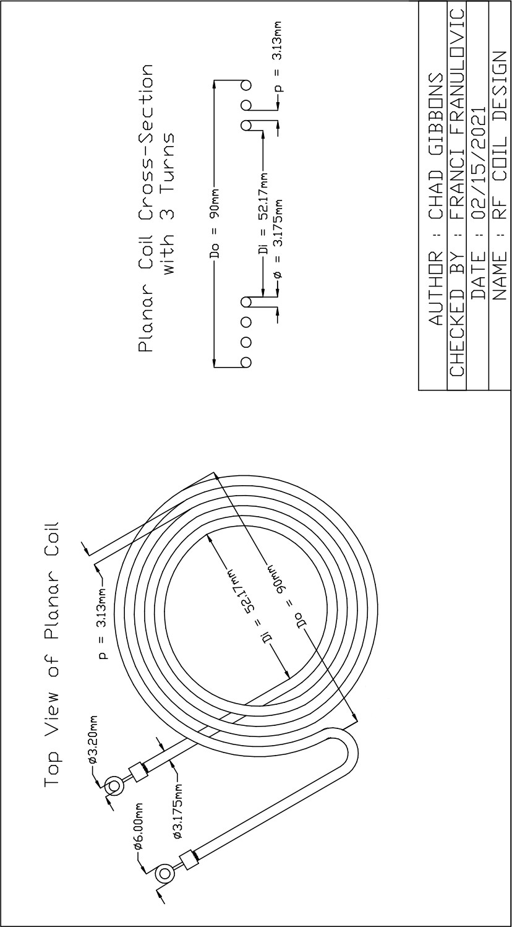

Figure 37: Dimensional Coil Drawing

APPENDIX J: GUI WIREFRAME DIAGRAM

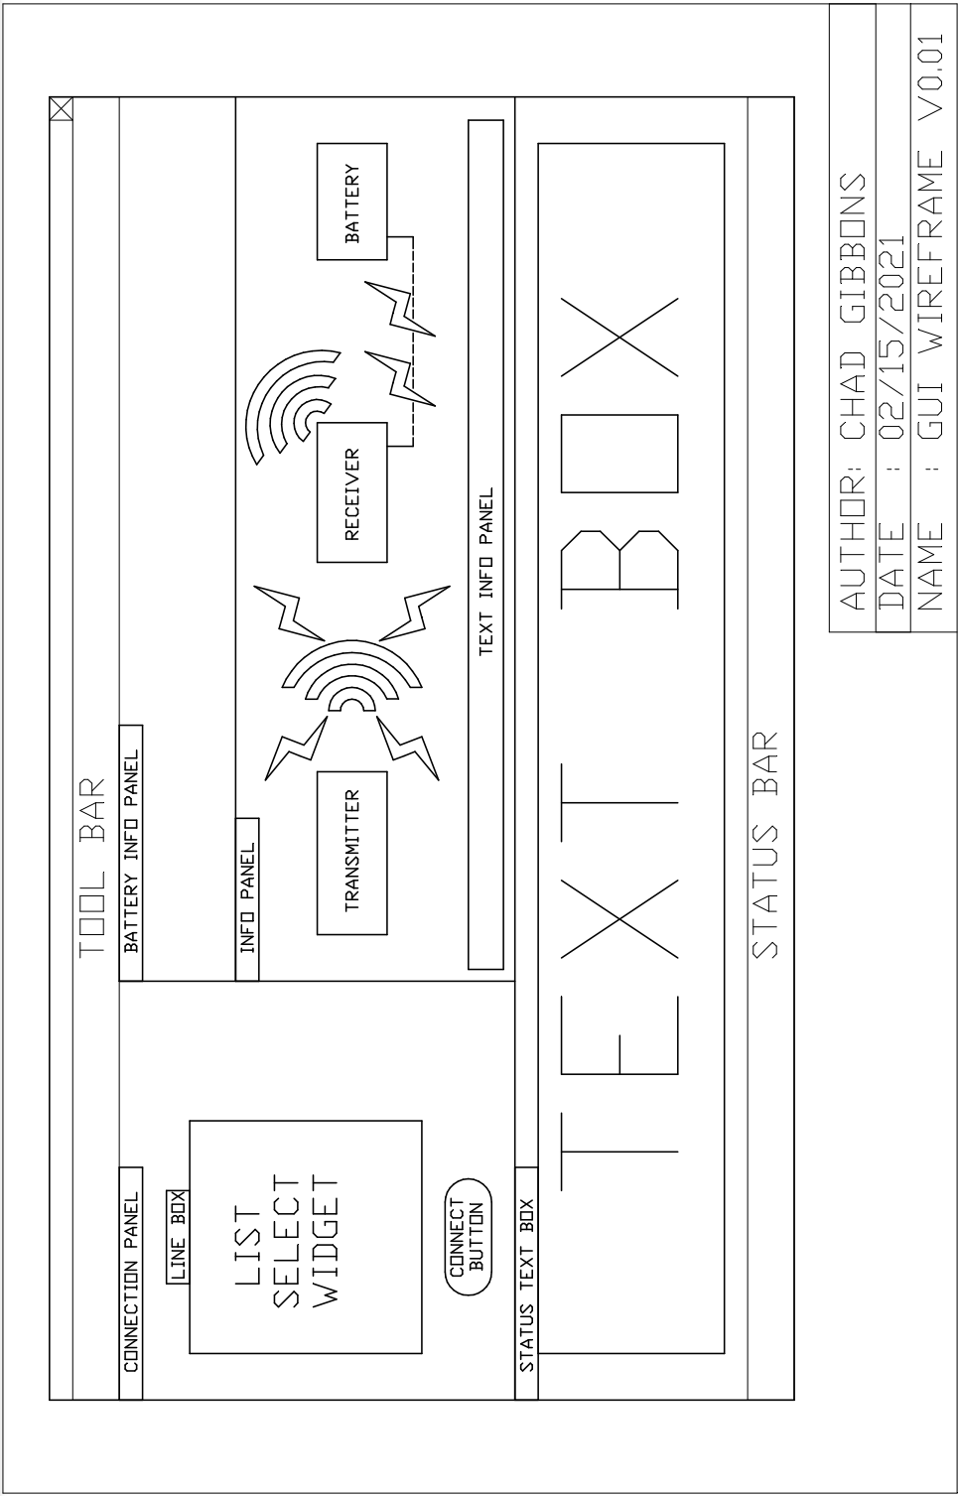

Figure 38: GUI Wireframe Diagram

APPENDIX K: EXPERIMENTAL DATA COLLECTION SHEETS

1. *Transmitter Subsystem Data*

Transmitter Subsystem Data

|  |  |
| --- | --- |
| **Power Supply Verification** | **Pass or Fail** |
| 30V power supply voltage nominal 30V  +/-2% Measured (TP1) | V Pass / Fail |
| 3.3V regulator (U11) test point TP2  nominal voltage 3.3V tolerance +/- 1.5% | V Pass / Fail |
| 5V regulator (U11) test point TP3 nominal  voltage 5V tolerance +/- 1.5% | V Pass / Fail |
| Coil driver Circuit Test | V Pass / Fail |
| Verify functionality of Transmitter Sub-circuits | V Pass / Fail |
| Verify Functionality of U11 | V Pass / Fail |
| Voltage test for drain of the GaN FET | V Pass / Fail |
| Test Peak to Peak Voltage across load | V Pass / Fail |
| Test Transmitter Power Output | V Pass / Fail |

##### This process is repeated for distances of 5 cm, 4 cm, 3 cm, 2 cm, and 1 cm.

1. *Receiver Regulators Subsystem Data*

Receiver Regulators Subsystem Data

|  |  |
| --- | --- |
| **Power Supply Verification** | **Pass or Fail** |
| DC voltage across coil terminals (J2 & J4) | V Pass / Fail |
| 5V regulator (U11) test point TP3 nominal  voltage 5V tolerance +/- 1.5% | V Pass / Fail |
| 3.3V regulator (U11) test point TP2  nominal voltage 3.3V tolerance +/- 1.5% | V Pass / Fail |
| Firmware Test Successful Load | V Pass / Fail |

1. *Receiver Rectifier Subsystem Data*

Receiver Rectifier Subsystem Data

|  |  |
| --- | --- |
| **Efficiency Test Protocols** | **Parameters** |
| The transmitter RF output | 30 W |
| The receiver coil placement (parallel) | 5 cm |
| Current measured | A Pass / Fail |
| Load Voltage measured | V Pass / Fail |
| Load Power | W Pass / Fail |
| Efficiency | % Pass / Fail |

##### This process is repeated for distances of 5 cm, 4 cm, 3 cm, 2 cm, and 1 cm.

1. *Charger Subsystem Data*

Charger Subsystem Data

|  |  |
| --- | --- |
| **Test Protocols** | **Parameters** |
| Set bench power supply current limit | 1 A |
| Set initial voltage | 20 V |
| Verify Charger Input Voltage | 18.6 V |
| Voltage Charger Output | V Pass / Fail |

1. *SMBus Subsystem Test Data*

SMBus Subsystem Test Data

|  |  |
| --- | --- |
| **Test Protocols** | **Parameters** |
| Verify Interface Functionality | Pass / Fail |
| Input Undervoltage Setting | V Pass / Fail |
| Final Charge Voltage | V Pass / Fail |
| Target Charge Current | A Pass / Fail |
| Input Current Limit Target | A Pass / Fail |

1. *Coil Subsystem Test Data*

Coil Subsystem Test Data

|  |  |
| --- | --- |
| **Test Protocols** | **Parameters** |
| Calibration Test for Short Circuit | *µ*H Pass / Fail |
| Calibration Test for Open Circuit | *µ*H Pass / Fail |
| Calibration Test with 50Ω Resistive Load | *µ*H Pass / Fail |
| Inductive Reactance | jΩ Pass / Fail |
| Impedance | Ω Pass / Fail |
| Quality Factor Estimation | Pass / Fail |
| S21 parameter (Forward Voltage Gain) | Pass / Fail |